*Florida International University*

*School of Computing and Information Sciences*

Software Engineering Focus

Final Deliverable

VIP Website 7.0

**Team Members:** Leon Liang, Dale Keith, Andres Moser, Steve Hirabayashi, Adam Levy

**Product Owner(s)**: Masoud Sadjadi

Francisco Ortega

**Mentor(s)**: Jose Ponce

**Instructor**: Masoud Sadjadi

The MIT License (MIT)

Copyright (c) *2017 Florida International University*

*Permission is hereby granted, free of charge, to any person obtaining a copy of this software and associated documentation files (the "Software"), to deal in the Software without restriction, including without limitation the rights to use, copy, modify, merge, publish, distribute, sublicense, and/or sell copies of the Software, and to permit persons to whom the Software is furnished to do so, subject to the following conditions:*

*The above copyright notice and this permission notice shall be included in all copies or substantial portions of the Software.*

*THE SOFTWARE IS PROVIDED "AS IS", WITHOUT WARRANTY OF ANY KIND, EXPRESS OR IMPLIED, INCLUDING BUT NOT LIMITED TO THE WARRANTIES OF MERCHANTABILITY, FITNESS FOR A PARTICULAR PURPOSE AND NONINFRINGEMENT. IN NO EVENT SHALL THE AUTHORS OR COPYRIGHT HOLDERS BE LIABLE FOR ANY CLAIM, DAMAGES OR OTHER LIABILITY, WHETHER IN AN ACTION OF CONTRACT, TORT OR OTHERWISE, ARISING FROM, OUT OF OR IN CONNECTION WITH THE SOFTWARE OR THE USE OR OTHER DEALINGS IN THE SOFTWARE.*

***Abstract***

*The Vertically Integrated Projects web application (“VIP”) builds upon its predecessors by expanding existing functionality of the site, and increasing value through the addition of new features. This document presents the changes made during the seventh version of the project (release 7.0).   
  
This document contains a brief overview of the current system, followed by a detailed catalogue of the user stories upon which this application cycle focuses. The goal of this application cycle is to introduce semester awareness into the application.  
  
The software development process is discussed through the provision a brief summary of VIP’s system architecture, design, and deployment. In addition, sample test-cases are included, which test VIP’s actual functionality against expected outcomes. The appendices contain additional materials including: screenshots, diagrams, and manuals.*

# **Table of Contents**

**Table of Contents** **4**

**INTRODUCTION** **6**

Current System 6

Purpose of New System 6

**User Stories** **8**

Implemented User Stories 8

Non-Feature User Stories 15

Pending User Stories 16

**Project Plan** **17**

Hardware and Software Resources 17

Sprint 2 18

Sprint 3 19

Sprint 4 20

Sprint 5 21

Sprint 6 21

**System Design** **22**

Architectural Patterns 22

3 Tier Architecture: 22

MVC 23

System and Subsystem Decomposition 24

Web Client Subsystem 24

Business Logic Subsystem 24

Data Subsystem 24

Deployment Diagram 25

Design Patterns 25

Facade 25

Repository 25

**System Validation** **26**

Unit Testing 26

Integration Testing 51

**Appendix A: UML Diagrams** **59**

**Appendix B - User Interface Design** **135**

**Appendix C - Sprint Review Reports** **160**

Sprint 2 Review Meeting Minutes 160

Sprint 3 Review Meeting Minutes 160

Sprint 4 Review Meeting Minutes 161

Sprint 5 Review Meeting Minutes 162

Sprint 6 Review Meeting Minutes 162

**Appendix D - User Manuals, Installation/Maintenance Document, Shortcomings/Wishlist Document and other documents** **164**

User Manuals 164

Installation/Maintenance Document 170

**References** **177**

# 

# 

# **INTRODUCTION**

The VIP Web Application facilitates the operation of the Vertically Integrated Projects (VIP) Program at FIU. This system is designed to support most of the day-to-day operations for the students and faculty involved with the VIP Program. The web application’s functionality includes: project proposals by faculty members, proposal approval or denial by a PI/administrator, and student applications to participate in the accepted available projects. Student applications will also need to be reviewed by either the staff member in charge of a particular project or the system administrator.

## Current System

The current web application (as of the beginning of this semester and version 6.0 of the project) consisted of a website with the following major features broken down by actor/user. Students are allowed to login to the website using their FIU Google-authenticated credentials without creating an additional username and password. Students can apply to join projects in the system and remove themselves from projects they have already joined. Faculty users can propose projects to work on with students as well as accept/reject students who join projects that they own. Faculty members must manually register in the system and get approval from a PI or system administrator.

The PI/administrator role manages both the projects and the users in the system, including the following operations: creating faculty or PI accounts, review faculty proposal submissions, review student applications to join projects, disable/enable previous projects, generate a list of user information, and modify some user information.

## Purpose of New System

Several shortcomings were identified with the final release of version 6.0 that were addressed in the new version 7.0. The new version of the web application will address all of these shortcomings, continue building on the features of the previous release, and add some all new features. The updates in version 7.0 mainly consist of: making the website aware of multiple semesters, redesigning and adding new functionality to the admin panel, adding additional filtering tools throughout the site, added the ability to manage and upload courses for students, connected the website to the Mobile Judge app, added support for additional media (documents and videos), redesigned large portions of the user interface, and several bug fixes. The exact details of the changes in this release can be found under the User Stories -> Implemented User Stories section of this document. However, some of the main changes/improvements are listed below. The two main problems with the existing system were:

1. The system had no awareness of multiple semesters. When a project was created, it was automatically entered into the overall system and not grouped by semesters. The only options available to the system administrator for managing project visibility was to activate and/or disable certain projects. Since there was no way to group anything by semester, students who had already graduated were still shown as enrolled in currently available projects. Therefore, if a project was to be continued in a future semester and start out with an empty list of students, the project usually had to be completely deleted and recreated for the new semester. There was no functionality for dynamically creating new semesters based on user needs, only a minimal sense of history for previous semesters or projects, and no functionality for separating users between enrolled courses.
2. The administrative panel and user interface of the website was poorly designed to meet the long-term needs of the system. The existing administration panel did not support full management of projects or users and was not easily extendable to support large-scale new features, such as course and semester management. The website only featured minimal filters for administrators to sort through large amounts of data and the existing filters sometimes did not function properly. On the project side of the user interface, each project was restricted to a single video and each project card gave no indication of additional media associated with a project. Projects did not allow attachments or documents to be uploaded, which does not establish a history for projects that may have continued across multiple semesters. Finally, project cards do not display enough information at-a-glance for a user to make an informed decision about a project without navigating through the website.

The purpose of the new system was to address the problems described above that were present in the past release (version 6.0) and add missing functionality to meet the user’s needs.

# **User Stories**

The following section provides the detailed user stories that were implemented in this iteration of the VIP website project. These user stories served as the basis for the implementation of the project’s features. This section also shows the user stories that can be considered for future development.

## **Implemented User Stories**

**[vip/#1176] Search users and projects based on properties in the admin panel**

* **Description**: As an PI/CoPI, I would like to search students/faculty and projects based on properties (such as semester) in the admin panel so that I can look for information regarding users and projects more easily.
* **Acceptance Criteria**:

1. Admin panel should be open without any errors.
2. Users panel and project panel filters should result in finding the students/faculty/projects based on the selected property/properties if they exist.

**[vip/#1298] Set Active Semester**

* **Description**: As a PI/Co-PI, I would like to be able to choose the active semester among all defined semesters, so that I can see and work with all the information related to the selected semester.
* **Acceptance Criteria**:

1. After choosing the active semester, every where in the system, by default if a semester is needed for filtering, etc. the active semester is used.

**[vip/#1299] Manage proposed projects**

* **Description**: As a PI/CoPI, I would like to see proposed but not yet accepted project proposals, so that I can either accept or deny the proposed project as PI, or see what projects have been proposed as Student/Faculty.
* **Acceptance Criteria**:

1. Pl/CoPl can see for which semester the project was proposed.

**[vip/#1300] Manage users in admin panel**

* **Description**: As a PI/CoPI, I would like to be able to make changes to a user’s properties, so that I can easily modify/update the information of users.
* **Acceptance Criteria**:

1. After selecting the option to change the user’s properties and entering the new properties for the project, the user’s updated information will be displayed to the user.
2. Need to add ability to change the semester of user’s so that PI/CoPI can move users to future semesters.
3. Merge the Admin Panel UI for searching and filtering with the ability to modify the user’s properties.

**[vip/#1301] Notify members if a project is deactivated**

* **Description**: As a student/faculty/project leader, I should be notified if a project I am participating is disabled. This notification will help students who are enrolled in the project to quickly find a new one.
* **Acceptance Criteria**:

1. Users are notified by email when their project is disabled, so they may choose a new one.
2. Project owners/faculty members are notified when a new semester opens and are asked if they want to continue a previous project in the new semester.

**[vip/#1302] Create/Delete Semesters**

* **Description**: As an Pi/CoPi I would like to be able to add a new semester with relevant information in the Semester Maintenance Panel.
* **Acceptance Criteria**:

1. Ability to choose Start/End Date (MM/DD/YYYY)
2. Admin can set name to what they deem appropriate (input is a string)
3. Admin can set properties for new Semester(Current, Viewable, Applicable, Proposable)

**[vip/#1305] Re-propose projects from previous semester**

* **Description**: As an Faculty member, I want the ability to re-propose a project from previous semester in order to save time and to keep track of all related projects.
* **Acceptance Criteria**:

1. Upon proposing project, an user can choose from a drop down list of previous projects that they have proposed and re-propose it with a new semester.
2. Description of the project should be repopulate with existing information and user may change the description if they like.

**[vip/#1313] Manage projects in admin panel**

* **Description**: As a PI/CoPI, I would like to be able to make changes to a project’s properties, so that I can easily modify/update the information of projects.
* **Acceptance Criteria**:

1. After selecting the option to change the project’s properties and entering the new properties for the project, the project’s updated information will be displayed to the user.
2. Need to add ability to change the semester of projects so that PI/CoPI can move pending and proposed projects to a better time frame.
3. Merge the Admin Panel UI for searching and filtering with the ability to modify the project’s properties.

**[vip/#1314] Create Admin Panel Tabs**

* **Description**: As a PI/Co-PI, I want to be able to navigate to different admin functionality through tabs so that I would not have to manually scroll down to the bottom in order to access functionality.
* **Acceptance Criteria**:

1. The tabs should directly take user to functionality corresponding to the tab in one click
2. Tabs should contain all functionality from before
3. Admin panel should be reduced in size and have the drop down functionalities removed

**[vip/#1315] View Past Projects**

* **Description**: As a student, faculty or Pi/CoPi, I can visit the Projects page and view projects from past semesters so that I can educate myself about the types of projects that have been done in the past.
* **Acceptance Criteria**:

1. The Projects page will present past projects upon user request.
2. The past projects presented can be filtered by semester and year.

**[vip/#1322] Paginating Tables**

* **Description**: As PI/Co-PI, I want to be able to have paging in User Maintenance and Project Maintenance Table in order to increase readability and increase page loading speed.
* **Acceptance Criteria**:

1. Upon entering each tab, the pages should already be paged with 10 entries per page
2. All filtering functionality should still work with the pagination

**[vip/#1329] Add infinitely many YouTube videos to a project**

* **Description**: As a user, I want to be able to add as many YouTube videos to a project as possible, exceeding the three video maximum that currently exists.
* **Acceptance Criteria**:

1. The videos should be displayed in as a gallery on the page.
2. Fix the YouTube playlist field, as it does not currently have any functionality implemented
3. Add the number of YouTube videos to the project’s card

**[vip/#1331] Add General Attachments to Projects**

* **Description**: As a user, I want to see any documents so that I can see any relevant material associated with a project.
* **Acceptance Criteria**:

1. A user should be able to upload relevant attachments in PDF format
2. The number of documents associated with the project should show on the project details page.

**[vip/#1332] Search functionality for inbox and student review**

* **Description**: As an user, I want to be able to search based on keywords for student project reviews, general messages, user registration review, and student application review in order to find individual requests
* **Acceptance Criteria**:

1. User must have a search box on the page section to search for individual keyword
2. Inbox should return all messages if the search box is empty

**[vip/#1343] Remove and Converge Obsolete Pages**

* **Description**: As an admin, I would like to have a centralize interface for user and project maintenance, in order to have a more coherent workflow as well as to reduce redundant data
* **Acceptance Criteria**:

1. All user maintenance capabilities from notifications should be implemented into the user maintenance panels
2. All project maintenance capabilities from notifications should be implemented into the project maintenance panels
3. Clicking on the notification should redirect user to the maintenance panels

**[vip/#1345] Manage Course information**

* **Description**: As a PI/CoPI, I would like to be able to view, add, and remove a course, so that I can easily modify/update the information of current courses and users that are currently in a course.
* **Acceptance Criteria**:

1. After selecting the option to add/remove a course, PI/CoPi will be able to see the addition/removal of the course. If a user is associated with that course, that user is also updated in the system.
2. After selecting the option to change the user’s properties and changing the course of that user, the user’s updated course information will be displayed to the PI/CoPI.
3. Need to have ability to filter users by their course.

**[vip/#1346] Synchronize Users Database with Panthersoft Data**

* **Description**: As a Pi/CoPi, I want to synchronize the VIP Users database using Panthersoft course enrolled data, so that I can update the database with changes to the students that are enrolled in a given course.
* **Acceptance Criteria**:

1. Students that are removed from a given course are updated so that they are no long assigned that course
2. Students that are added to a given course and do not exist in the database are added to the database
3. Students that already exist in the database will be updated with data provided by pathersoft

**[vip/#1351] Redesign Project Cards to show more information**

* **Description**: As a user, I want to see project cards that show information that is relevant and entices me to join a project.
* **Acceptance Criteria**:

1. Show skills on the project card
2. Restrict the amount of description text to ensure continuity among the cards
3. Use the space for the title and semester name more effectively

**[vip/#1352] Add Enroll feature for Users and Semester for Courses**

* **Description**: As a Pi/CoPi, I would like to be able to confirm a user has been enrolled/dropped out from a course, so that I can better keep track of the history for a course’s enrollment. Also as a Pi/CoPi, I would like to separate courses by semester, so that I can keep track of students have have previously enrolled in a course.
* **Acceptance Criteria**:

1. In the User Panel, the Admin should be able to see the status of a user in regards to its course enrollment.
2. Must give option to enter a semester for a course when the course is created.
3. Must be able to filter users by course and whether they are confirmed to be enrolled or not
4. Must be able to filter courses by semester

**[vip/#1355] Connect Mobile Judge to VIP Website**

* **Description**: The Mobile Judge application currently uses the API from the old senior project website project. Reconfigure VIP website API so that Mobile Judge can make requests and receive information from the VIP website API.
* **Acceptance Criteria**:

1. The Mobile Judge application will can make its requests from the VIP Website API.
2. The Mobile Judge application will function as it did when making its requests to the SPWS API.

**[vip/#1356] Approve student registrations via admin panel**

* **Description**: As an admin, I want to approve student registrations from within the admin panel so that I would not have to access a separate page and improve workflow efficiency
* **Acceptance Criteria**:

1. Admin will be able to approve each non-approved student will have an approve button enabled
2. Admin will not be able to re-approve, already approved students

**[vip/#1360] Choosing Selected Semester**

* **Description**: As a Pi/CoPi I would like to be able to have a semester chosen as my selected Semester, so that whenever I am modifying any user/project, it will be related to that semester.
* **Acceptance Criteria**:

1. In the Semester Maintenance Page, have the ability to choose a semester.
2. Inputs that are related to Semester should default to the Selected Semester

**[vip/#1361] Redesign student review page**

* **Description**: As an admin, I want faculty to only see students they are responsible for in order to improve security and reduce user errors.
* **Acceptance Criteria**:

1. Upon entering the student review page, the page should pre-populate with only student that registered for the projects the user is responsible for
2. History log of student should only show projects related to the user

**[vip/#1362] Add Edit Course Feature in Course Panel**

* **Description**: As a PI/CoPI, I would like to be able to edit a course, so that I can easily modify/update the information of current courses and users that are associated with that course.
* **Acceptance Criteria**:

1. After selecting the option to edit a course, PI/CoPi will be able to see the changes made to the course in the course panel. If a user is associated with that course, that user is also updated in the system.

**[vip/#1363] Sort tables by column header**

* **Description**: As an user, I want to be able to sort any tables by table headers in order to find the information I need more efficiently and group similar entries together
* **Acceptance Criteria**:

1. User can click on table header to sort the columns by descending or ascending
2. Table should contain same information as non-sorted table

**[vip/#1364] Add Deliverable Uploads on Project Details**

* **Description**: As a user, I want to see the documents (papers, diagrams) associated with a project so that I can see the final deliverables and the a project’s successful completion.
* **Acceptance Criteria**:

1. A user should be able to upload the final deliverables as a PDF format.
2. The deliverables associated with the project should show on the project details page.
3. The deliverables shown be shown in a collapsable list near the list of students.

**[vip/#1365] Manage Project's Faculty/Mentors in Projects Panel**

* **Description**: As a PI/CoPI, I would like to be able to edit a project’s faculty members and mentors, so that I can easily modify/update the information of current projects and users that are associated with that course.
* **Acceptance Criteria**:

1. After selecting the option to add/remove a projects members, PI/CoPi will be able to add/remove faculty and mentors. Then after saving the changes, the Pi/CoPi will see the changes made to the project in the projects panel.

**[vip/#1368] Fix MJ Route to Include ProjectID**

* **Description**: The Mobile Judge Application requires a ProjectID field in the return values from the VIP API
* **Acceptance Criteria**:

1. The VIP api will return the user’s projectID along with the rest of the user’s data

**[vip/#1369] Add course functionality to VIP api endpoint for MJ**

* **Description**: As Mobile Judge admin user, I would like to be able to view the course to which the student is enrolled when viewing his/her data in Mobile Judge
* **Acceptance Criteria**:

1. The VIP api will return the student’s associated course along with the other data when Mobile Judge calls this endpoint

## **Non-Feature User Stories**

**[vip/#1328] Update user and project updating features**

* **Description**: As a User, I want to ensure that when I update my user information, all of my information is properly stored and updated, so that data integrity is kept between the users database and the projects database.
* **Acceptance Criteria**:

1. When a User changes their personal information: first name, last name or email, that information must be updated in any projects the User is currently associated with.
2. When a Pi/CoPi changes a User’s personal information in the admin users panel, that information must be updated in any projects the User is currently associated with.
3. When a Pi/CoPi changes a Project’s personal information in the admin projects panel, that information must be updated in any Users currently associated with that project.
4. When a Project owner or Pi/CoPi changes a Project’s personal information in the edit projects page, that information must be updated in any Users currently associated with that project.
5. When a User leaves a project in the projects-detailed page, the User’s project must be updated to reflect this change.
6. When a Pi/CoPi deletes a project in the projects-detailed page, the users associated with this project must be updated to reflect this change.

**[vip/#1342] Fix expired SSL certificate**

* **Description**: The SSL certificates for both the production and vip-dev sites expired and neither the automatic nor manual renewal process is working. This needs to be fixed/renewed so any user can browse/interact with the website securely and confidently.
* **Acceptance Criteria**:

1. Renew the SSL certificates for both the production and dev sites (I believe the renewal term is 3 months)
2. Ensure the automatic renewal cron job is working for the future.

## **Pending User Stories**

**[vip/#1304] Review Projects Proposals By Semesters**

* **Description**: As a PI/Co-PI, I would like to be able to filter project proposal by semesters in order to correctly approve projects per semester.
* **Acceptance Criteria**:

1. Upon entering the Review Projects Proposal page, the projects should show in descending order of semester.
2. After selecting a specific semester, table should display only proposal that are for that selected semester.

**[vip/#1330] Add GitHub commit and contributor statistics for each project**

* **Description**: As a user, I want to view statistics for each project’s GitHub repository to show how a project progressed through a semester.
* **Acceptance Criteria**:

1. The number of commits and the number of contributors should be shown on the details page.
2. The number of commits should be shown on the project card.

# **Project Plan**

This section describes the hardware and software components chosen for this project.

This section also describes the planning that went into this project, incorporating agile development techniques of diving our work sessions into sprints. The sprint plannings used for the projects are shown below.

## **Hardware and Software Resources**

The following is a list of all hardware and software resources that were used in this project:

**Hardware:**

Development:

* 2 x Dual core 2.5GHz CPU, 8GB RAM, 200GB RAM: approximate specs for development laptops used in the project.
* Quad core 2GHz CPU, 200GB HDD, 4GB RAM: for hosting both the web server and mongo server in the main test environment.
* 3 x 8-core AMD FX-8300 , 320GB HDD, 8GB RAM: for hosting other testing environments in Docker containers in a Kubernetes cluster.

Production Server:

* Quad core 2GHz CPU, 200GB HDD, 4GB RAM: for hosting both the web server and mongo server in production.

Client:

* Any device running the latest version of Google Chrome, Safari, Mozilla Firefox or Microsoft Edge with an internet connection with a minimum download speed of 1Mbps should be enough to use the website/system.

**Software:**

Development:

* NodeJS v4.3.2: NodeJS interpreter
* NPM v2.14.12: NodeJS package manager
* MongoDB v3.4.10: database server
* Kubernetes v1.6: container orchestration engine
* Docker v17.06.0-ce: container engine
* Teamcity v2017.1.1: build server
* Robo 3T: v1.1.1 Mongo client with a GUI
* Mingle (web): project management software
* Github (web): git repository posting
* Google Drive (web): file sharing

Production:

* Ubuntu 14.04.3 LTS: production server OS
* NodeJS v4.3.2: NodeJS interpreter
* NPM v2.14.12: NodeJS package manager
* MongoDB v3.4.10: database server

**Sprint Planning**

### **Sprint 2**

Attendees: Leon Liang, Andres Moser, Dale Keith, Steve Hirabayashi, Adam Levy

Start time:9/25/17, 4:00 pm

End time: 9/25/17 5:00 pm

After discussion, the velocity of the team were estimated to be 80

The product owner chose the following user stories to be done during the next sprint. They are ordered based on their priority.

* User Story #1298 Set Active Semester
* User Story #1305 Re-propose projects from previous semester
* User Story [#1176](https://fiu-scis-seniorproject.mingle.thoughtworks.com/projects/vip/cards/1176) Search users and projects based on semester in the admin panel
* User Story #1299 Manage proposed projects
* User Story #1301 Notify members if a project is deactivated

The team members indicated their willingness to work on the following user stories.

* Andres Moser
* User Story #1298 Set Active Semester
* Leon Liang
  + User Story #1305 Re-propose projects from previous semester
* Steve Hirabayashi
  + User Story [#1176](https://fiu-scis-seniorproject.mingle.thoughtworks.com/projects/vip/cards/1176) Search users and projects based on semester in the admin panel
* Dale Keith
  + User Story #1301 Notify members if a project is deactivated
* Adam Levy
  + User Story #1299 Manage proposed projects

### **Sprint 3**

Attendees: Leon Liang, Andres Moser, Dale Keith, Steve Hirabayashi, Adam Levy

Start time: 10/2/2017, 4:00 pm

End time: 10/2/2017, 5:00 pm

After discussion, the velocity of the team were estimated to be 160

The product owner chose the following user stories to be done during the next sprint. They are ordered based on their priority.

* User Story [#1300](https://fiu-scis-seniorproject.mingle.thoughtworks.com/projects/vip/cards/1300) Manage Users in Admin Panel
* User Story [#1313](https://fiu-scis-seniorproject.mingle.thoughtworks.com/projects/vip/cards/1313) Manage Projects in Admin Panel
* User story #1322 Paginating Tables
* User Story #1314 Create admin panel tabs
* User Story #1315 View Past Projects
* User Story #1298 Set Active Semester

The team members indicated their willingness to work on the following user stories.

* Steve Hirabayashi
* User Story [#1300](https://fiu-scis-seniorproject.mingle.thoughtworks.com/projects/vip/cards/1300) Manage Users in Admin Panel
* User Story [#1313](https://fiu-scis-seniorproject.mingle.thoughtworks.com/projects/vip/cards/1313) Manage Projects in Admin Panel

Leon Liang

* User story #1322
* User story #1314

Adam Levy and Dale Keith

* User story #1315 View Past Projects

Andres Moser

* User Story #1298 Set Active Semester

### **Sprint 4**

Attendees: Leon Liang, Andres Moser, Dale Keith, Steve Hirabayashi, Adam Levy

Start time: 10/2/2017, 9:10 pm

End time: 10/2/2017, 9:20 pm

After discussion, the velocity of the team were estimated to be 160

The product owner chose the following user stories to be done during the next sprint. They are ordered based on their priority.

* User Story #1328 Update user and project updating features
* User Story #1329 Add infinitely many YouTube videos to a project
* User Story #1330 GitHub Statistics for each project
* User Story #1331 Document/Deliverable Uploads on Projects
* User Story #1332 Search functionality for messages inbox

The team members indicated their willingness to work on the following user stories.

* Steve Hirabayashi
* User Story #1328 Update user and project updating features
* Dale Keith
* User Story #1329 Add infinitely many YouTube videos to a project
* User Story #1330 GitHub Statistics for each project
* User Story #1331 Document/Deliverable Uploads on Projects
* Leon Liang
  + User Story #1332 Search functionality for messages inbox

### **Sprint 5**

Attendees: Leon Liang, Andres Moser, Dale Keith, Steve Hirabayashi, Adam Levy

Start time: 10/30/2017, 4:10 pm

End time: 10/30/2017, 4:30 pm

After discussion, the velocity of the team were estimated to be 160

The product owner chose the following user stories to be done during the next sprint. They are ordered based on their priority.

* User Story #1343 - Remove and Converge Obsolete Pages
* User Story #1351 - Redesign Project Cards to show more information
* User Story #1331 - Add General Attachments to Projects
* User Story #1302 - Add New Semesters
* User Story [#1346](https://fiu-scis-seniorproject.mingle.thoughtworks.com/projects/vip/cards/1346) - Synchronize Users Database with Panthersoft Data
* User Story #1355 - Connect Mobile Judge to VIP Website

The team members indicated their willingness to work on the following user stories.

* Steve Hirabayashi
  + User Story [#1346](https://fiu-scis-seniorproject.mingle.thoughtworks.com/projects/vip/cards/1346) - Synchronize Users Database with Panthersoft Data
* Dale Keith
* User Story #1351 - Redesign Project Cards to show more information
* User Story #1331 - Add General Attachments to Projects
* Leon Liang
  + User Story #1343 - Remove and Converge Obsolete Pages
* Andres Moser
  + User Story #1302 - Add New Semesters
  + User Story #1360 - Choosing Selected Semester
* Adam Levy
  + User Story #1355 - Connect Mobile Judge to VIP-Website

### **Sprint 6**

Attendees: Leon Liang, Andres Moser, Dale Keith, Steve Hirabayashi, Adam Levy

Start time: 11/13/2017, 4:10 pm

End time: 11/13/2017, 4:30 pm

After discussion, the velocity of the team were estimated to be 80

The product owner chose the following user stories to be done during the next sprint. They are ordered based on their priority.

* User Story #1363 - Sort columns in VIP website tables
* User Story #1362 - Add Edit Course Feature in Course Panel
* User Story #1365 - Manage Project's Faculty/Mentors in Projects Panel
* User Story #1364 - Add Deliverable Uploads on Project Details

The team members indicated their willingness to work on the following user stories.

* Steve Hirabayashi
  + User Story #1362 - Add Edit Course Feature in Course Panel
  + User Story #1365 - Manage Project's Faculty/Mentors in Projects Panel
* Dale Keith
* User Story #1364 - Add Deliverable Uploads on Project Details
* Leon Liang
  + User Story #1363 - Sort columns in VIP website tables
* Andres Moser
  + User Story #1371 - Email Product Owners about New Semester
* Adam Levy
  + User Story #1368 - Fix Mobile Judge api route to provide project IDs
  + User Story #1369 - Add course functionality to Mobile Judge api route

# **System Design**

## **Architectural Patterns**

### **3 Tier Architecture:**

Our website is based on an overarching three tier architecture. These three tiers is composed of presentation, applications, and data. A user will interact with the presentation layer in the form of the physical website whether it be through their personal computers of mobile devices. All interactions will send information into our applications layer, where we handle all business logics and algorithms. The results of these business logic and algorithms will eventually pass into our data layer, which is our mongoDB. Data layer will hence relay information back to the application layer. From the application layer, information can be extracted, transformed, and packaged back to the presentation layer. The benefit of such architecture is that it allows for clear and defined subsystems. This allows for easier debugging due to the capability to trace back errors and bugs. Scalability can also be benefited from this architecture, by componentizing the data layer. Developer is free to enhance and scale databases horizontally, reducing workload on one single database without the worry about the effect on other tiers.

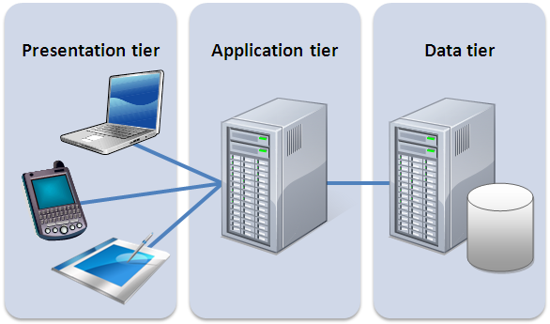

### **MVC**

The pattern of choice for front-end MVC. This concept involve a circular and bidirectional flow and data and presentation. Data that originates from the model will reflect changes in controller which in turns, modify the view in which user interact with. Ability to have bidirectional data flow allow for flexibility when designing the front end. Working in our favor, is the asynchronous calls and operations that is possible due to the well separated and well defined views and controller.

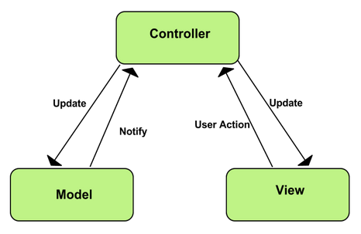

## **System and Subsystem Decomposition**

The VIP Website employs the 3-tier architecture, meaning it is composed of three major subsystems: The Presentation tier is represented by the Web Client Subsystem, The Application Tier is represented by the Business Logic Subsystem, and the Data Tier is represented by the Data Subsystem.

### **Web Client Subsystem**

The Web Client Subsystem is responsible for providing the interface for our customers and clients to interact with the system. Since this subsystem was developed using Angular JS, this subsystem was also implemented using the MVC architectural pattern.

As part of the Presentation tier, this subsystem is also responsible for communicating with the Business Logic Subsystem when the Web Client System needs to either query or update the system data managed in the Data Subsystem. As far as management of the presentation layer logic goes, it is all self-contained and independent of the other subsystems.

### **Business Logic Subsystem**

The Business Logic Subsystem is responsible for all of the core logic of the system, and acts as the intermediary between the Data Subsystem and the Web Client Subsystem.

This subsystems lives completely on a backend server running on our NodeJS-Express web server whose main concern is to host a web application. In general this subsystem is primarily concerned with processing requests given by the Web Client Subsystem and making the necessary queries to the Data Subsystem to accomplish those requests. Therefore, it is the sole determinator for when the state of the system changes and how.

### **Data Subsystem**

The Data Subsystem is responsible for the management, access and storage of the system’s database, involving the database access logic/API and the database server itself. This is a backend “service” and should only be accessible by the Business Logic Subsystem for security/data integrity reasons. Therefore, the database access logic must be deployed with the Business Logic Subsystem, while the database server can be on a separate directory or server, even though as of this moment, they are located on the same server.

## 

## **Deployment Diagram**

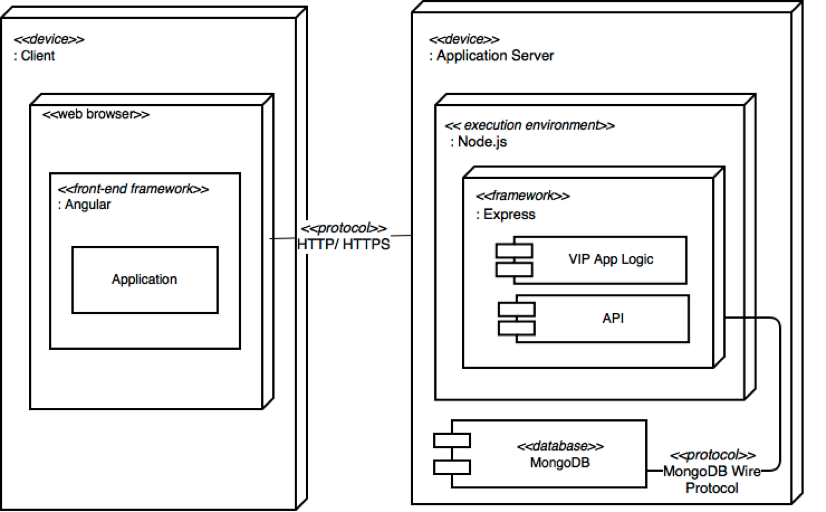

## **Design Patterns**

### **Facade**

This design pattern is used in a project in order to simplify changes made to a complex system. In VIP Website 7.0, the facade design pattern is used to simplify the interactions between the Web Client Subsystem and the Business Logic Subsystem. This is implemented in any portion of the Web Client Subsystem that is handling any interaction between the Business Logic Subsystem and the API layer. This is done by creating Services that handle any interaction with the API, while also abstracting all http protocol details away from our controllers for the front end. Additional benefits to using the Facade Design Pattern are that it speeds up development time and onboarding as the Services act as boilerplate code allowing developers to interact with the API without needing a deep understanding of the API route.

### **Repository**

This design pattern is used to allow data access logic to be accessed in an organized manner, preventing access from unneeded controllers in the code. The pattern is used in the Data Subsystem, particularly in the sections that interact with the Business Logic Subsystem. It allows the Business Logic Subsystem a simple interface to access and modify the Data Subsystem.

# **System Validation**

## **Unit Testing**

* Test case ID: VIP-1176-U1
* Description: Admin filters users
* Summary of Test:

1. Tester selects project ‘Test Project’ in projects selection box
2. Tester enters test data into First Name filter input box
3. Vip.fiu.edu responds by filtering the Users

* Test Data:
* Input Data: Test
* Pre-Conditions:

1. Admin with Pi/CoPi privileges has logged into the VIP website
2. Admin is at the admin panel page - users maintenance tab
3. Users ‘Test User’, ‘Test User2’, ‘New User’ are in the database
4. Project ‘Test Project’ is in the database
5. User ‘Test User’ and ‘New User’ is in project ‘Test Project’

* Expected Results:

1. Only User ‘Test User’ will be shown

* Actual Result:

1. Only User ‘Test User’ was shown

* Status (Fail/Pass): PASS
* Test case ID: VIP-1176-U2
* Description: Admin filters projects
* Summary of Test:

1. Tester selects semester ‘Fall 2017’ from semester selection box
2. Tester enters test data into Title filter input box
3. Vip.fiu.edu responds by filtering the projects

* Test Data
* Input Data: Test
* Pre-Conditions:

1. Admin with Pi/CoPi privileges has logged into the VIP website
2. Admin is at the admin panel page - projects maintenance tab
3. Projects ‘Test Project 1’, ‘Test Project 2’, ‘New Project’ is present in the Projects Database
4. Semesters ‘Fall 2017’, ‘Summer 2017’ is present in the Courses Database
5. Project ‘Test Project 1’ semester is set to ‘Summer 2017’; ‘Test Project 2’, ‘New Project’ semester is set to ‘Fall 2017’

* Expected Results:

1. Only Project ‘Test Project 2’ will be shown

* Actual Result:

1. Only Project ‘Test Project 2’ was shown

* Status (Fail/Pass): PASS
* Test case ID: VIP-1300-U1
* Description: Admin adds a new user (Sunny Day Scenario)
* Summary of Test:

1. Tester selects ‘add new user’ button
2. Tester enters user data into add user dialog
3. Tester selects ‘add user’ button

* Test Data:
* First Name: testF
* Last Name: testL
* Email: test@testing.edu
* Password: Password#123
* Pre-Condition:

1. User with Pi/CoPi privileges has logged into the VIP website
2. User is at the admin panel page - user maintenance tab

* Expected Results:

1. User will be added to the database
2. Users panel table will be updated with user at the bottom
3. Tester will be notified of success

* Actual Result:

1. User will be added to the database
2. Users panel table will be updated with user at the bottom
3. Tester will be notified of success

* Status (Fail/Pass): PASS
* Test case ID: VIP-1300-U2
* Description: Admin adds a new user (Rainy Day Scenario)
* Summary of Test:

1. Tester selects ‘add new user’ button
2. Tester enters user data into add user dialog
3. Tester selects ‘add user’ button

* Test Data:
* First Name: testF
* Last Name: testL
* Email: test
* Password: pass
* Pre-Condition:

1. User with Pi/CoPi privileges has logged into the VIP website
2. User is at the admin panel page - user maintenance tab

* Expected Results:

1. User will not be added to database
2. Users panel table will not be updated with user at the bottom
3. Tester will be notified of error

* Actual Result:

1. User will not be added to database
2. Users panel table will not be updated with user at the bottom
3. Tester will be notified of error

* Status (Fail/Pass): PASS
* Test case ID: VIP-1300-U3
* Description: Admin edits user (Sunny Day Scenario)
* Summary of Test:

1. Tester selects ‘edit user’ button for user ‘testF’
2. Tester modifies user with user data into edit user dialog
3. Tester selects ‘save changes’ button

* Test Data:
* First Name: editF
* Last Name: editL
* Email: edit@testing.edu
* Gender: Male
* User Type: Student
* Rank: Senior
* PI Approval: true
* Project: VIP Website 7.0
* Pre-Condition:

1. User with Pi/CoPi privileges has logged into the VIP website
2. User is at the admin panel page - user maintenance tab
3. Test VIP-1300-U1 has been executed
4. Project ‘VIP Website 7.0’ exists in projects database

* Expected Results:

1. User will be updated in the database
2. Users panel table will be updated
3. Project will be updated in the database
4. Projects panel table will be updated
5. Tester will be notified of success

* Actual Result:

1. User will be updated in the database
2. Users panel table will be updated
3. Project will be updated in the database
4. Projects panel table will be updated
5. Tester will be notified of success

* Status (Fail/Pass): PASS
* Test case ID: VIP-1300-U4
* Description: Admin edits user (Rainy Day Scenario)
* Summary of Test:

1. Tester selects ‘edit user’ button for user ‘testF’
2. Tester modifies user with user data into edit user dialog
3. Tester selects ‘save changes’ button

* Test Data:
* First Name: editF
* Last Name: editL
* Email: edit@testing
* Gender: Male
* User Type: Student
* Rank: Senior
* PI Approval: true
* Project: VIP Website 7.0
* Pre-Condition:

1. User with Pi/CoPi privileges has logged into the VIP website
2. User is at the admin panel page - user maintenance tab
3. Test VIP-1300-U1 has been executed
4. Project ‘VIP Website 7.0’ exists in projects database

* Expected Results:

1. User will not be updated in the database
2. Users panel table will not be updated
3. Project will not be updated in the database
4. Projects panel table will not be updated
5. Tester will be notified of error

* Actual Result:

1. User will not be updated in the database
2. Users panel table will not be updated
3. Project will not be updated in the database
4. Projects panel table will not be updated
5. Tester will be notified of error

* Status (Fail/Pass): PASS
* Test case ID: VIP-1300-U5
* Description: Admin removes user (Sunny Day Scenario)
* Summary of Test:

1. Tester selects ‘remove user’ button for user ‘testF’
2. Tester selects ‘Yes’ button

* Pre-Condition:

1. User with Pi/CoPi privileges has logged into the VIP website
2. User is at the admin panel page - user maintenance tab
3. Test VIP-1300-U1 has been executed

* Expected Results:

1. User will be removed from the database
2. Users panel table will be updated with user removed from it
3. Tester will be notified of success

* Actual Result:

1. User will be removed from the database
2. Users panel table will be updated with user removed from it
3. Tester will be notified of success

* Status (Fail/Pass): PASS
* Test case ID: VIP-1313-U1
* Description: Admin edits project properties (Sunny Day Scenario)
* Summary of Test:

1. Tester selects ‘edit project properties’ button
2. Tester modifies project with project data into edit project dialog
3. Tester selects ‘save changes’ button

* Test Data:
* Project Title: Test Project
* Description: desc
* Max Students: 10
* Status: Active
* Pre-Condition:

1. User with Pi/CoPi privileges has logged into the VIP website
2. User is at the admin panel page - project maintenance tab

* Expected Results:

1. Project will be updated in the database
2. Projects panel table will be updated
3. Tester will be notified of success

* Actual Result:

1. Project will be updated in the database
2. Projects panel table will be updated
3. Tester will be notified of success

* Status (Fail/Pass): PASS
* Test case ID: VIP-1313-U2
* Description: Admin edits project properties (Rainy Day Scenario)
* Summary of Test:

1. Tester selects ‘edit project properties’ button
2. Tester modifies project with project data into edit project dialog
3. Tester selects ‘save changes’ button

* Test Data:
* Project Title: (empty)
* Description: desc
* Max Students: -1
* Status: Active
* Pre-Condition:

1. User with Pi/CoPi privileges has logged into the VIP website
2. User is at the admin panel page - project maintenance tab

* Expected Results:

1. Project will not be updated in the database
2. Projects panel table will not be updated
3. Tester will be notified of error

* Actual Result:

1. Project will not be updated in the database
2. Projects panel table will not be updated
3. Tester will be notified of error

* Status (Fail/Pass): PASS
* Test case ID: VIP-1313-U3
* Description: Admin adds/removes project’s users (Sunny Day Scenario)
* Summary of Test:

1. Tester selects ‘add/remove users’ button
2. Tester finds and selects user ‘testF’ in add user
3. Tester selects ‘add user’ button
4. Tester selects ‘remove user’ button for a user other than ‘testF’
5. Tester selects ‘save changes’ button

* Pre-Condition:

1. User with Pi/CoPi privileges has logged into the VIP website
2. User is at the admin panel page - project maintenance tab
3. Project selected already has users assigned to it as current members
4. Test VIP-1300-U1 has been executed

* Expected Results:

1. Project will be updated in the database
2. Projects panel table will be updated
3. Users will be updated in the database
4. Users panel table will be updated
5. Tester will be notified of success

* Actual Result:

1. Project will be updated in the database
2. Projects panel table will be updated
3. Users will be updated in the database
4. Users panel table will be updated
5. Tester will be notified of success

* Status (Fail/Pass): PASS
* Test case ID: VIP-1313-U4
* Description: Admin removes project (Sunny Day Scenario)
* Summary of Test:

1. Tester selects ‘remove project’ button for project
2. Tester selects ‘Yes’ button

* Pre-Condition:

1. User with Pi/CoPi privileges has logged into the VIP website
2. User is at the admin panel page - project maintenance tab

* Expected Results:

1. Project will be removed from the database
2. Projects panel table will be updated with project removed from it
3. Tester will be notified of success

* Actual Result:

1. Project will be removed from the database
2. Projects panel table will be updated with project removed from it
3. Tester will be notified of success

* Status (Fail/Pass): PASS
* Test case ID: VIP-1328-U1
* Description: User updates their name at profile page
* Summary of Test:

1. Tester modifies first name and last name with test data
2. Tester selects ‘update’ button
3. Tester selects ‘projects’ button in navigation bar
4. Tester selects the project the user is a current member of

* Test Data:
* First Name: FirstNameTest
* Last Name: LastNameTest
* Pre-Condition:

1. User has logged into the VIP website
2. User is at the profile page
3. User must be a current member of an active project

* Expected Results:

1. User will be updated in the database
2. Project will be updated in the database
3. Projects page will be updated with user name change

* Actual Result:

1. User will be updated in the database
2. Project will be updated in the database
3. Projects page will be updated with user name change

* Status (Fail/Pass): PASS
* Test case ID: VIP-1328-U2
* Description: Admin edits user’s name in users admin panel
* Summary of Test:

1. Tester selects ‘edit user’ button
2. Tester modifies user with test data in edit user dialog
3. Tester selects ‘save changes’ button
4. Tester selects ‘project maintenance’ tab
5. Tester finds the project the user is a current member of

* Test Data:
* First Name: FirstNameTest
* Last Name: LastNameTest
* Pre-Condition:

1. Admin with Pi/CoPi privileges has logged into the VIP website
2. Admin is at the admin panel page - user maintenance tab
3. User must be a current member of an active project

* Expected Results:

1. User will be updated in the database
2. Project will be updated in the database
3. User and Projects panel will be updated with user name change

* Actual Result:

1. User will be updated in the database
2. Project will be updated in the database
3. User and Projects panel will be updated with user name change

* Status (Fail/Pass): PASS
* Test case ID: VIP-1328-U3
* Description: Admin edits project’s title in projects admin panel
* Summary of Test:

1. Tester selects ‘edit project properties’ button
2. Tester modifies project with test data into edit project dialog
3. Tester selects ‘save changes’ button

* Test Data:
* Project Title: TestTitle
* Pre-Condition:

1. Admin with Pi/CoPi privileges has logged into the VIP website
2. Admin is at the admin panel page - project maintenance tab
3. Project must have either/or: an owner, a mentor, a faculty, a member

* Expected Results:

1. User will be updated in the database
2. Project will be updated in the database
3. User and Projects panel will be updated with user name change

* Actual Result:

1. User will be updated in the database
2. Project will be updated in the database
3. User and Projects panel will be updated with user name change

* Status (Fail/Pass): PASS
* Test case ID: VIP-1345-U1
* Description: Admin adds a new course
* Summary of Test:

1. Tester enters Test Data into course fields
2. Tester selects ‘add course’ button

* Test Data:
* Course Subject: TST
* Course Number: 1234
* Course Section: 01
* Pre-Conditions:

1. Admin with Pi/CoPi privileges has logged into the VIP website
2. Admin is at the admin panel page - course maintenance tab

* Expected Results:

1. Course will be added to the database
2. Course maintenance page will be updated with new course

* Actual Result:

1. Course will be added to the database
2. Course maintenance page will be updated with new course

* Status (Fail/Pass): PASS
* Test case ID: VIP-1345-U2
* Description: Admin removes an existing course
* Summary of Test:

1. Tester selects ‘delete course’ button next to course ‘TST1234-U01’

* Pre-Conditions:

1. Admin with Pi/CoPi privileges has logged into the VIP website
2. Admin is at the admin panel page - user maintenance tab
3. VIP-1345-U1 has been executed

* Expected Results:

1. Course will be removed from the database
2. Course maintenance page will be updated with course removed

* Actual Result:

1. Course will be removed from the database
2. Course maintenance page will be updated with course removed

* Status (Fail/Pass): PASS
* Test case ID: VIP-1345-U3
* Description: Admin updates a user’s course
* Summary of Test:

1. Tester selects ‘edit user’ button for user ‘testF testL’
2. Tester selects course ‘TST1234-U01’ from course combo box
3. Tester selects ‘save changes’ button

* Pre-Conditions:

1. Admin with Pi/CoPi privileges has logged into the VIP website
2. Admin is at the admin panel page - users maintenance tab
3. VIP-1300-U1 has been executed
4. VIP-1345-U1 has been executed

* Expected Results:

1. User will be updated in the database
2. Users panel will be updated with user course change

* Actual Result:

1. User will be updated in the database
2. Users panel will be updated with user course change

* Status (Fail/Pass): PASS
* Test case ID: VIP-1346-U1
* Description: Admin syncs Users database using course data for a course registered in the system
* Summary of Test:

1. Tester selects ‘Sync Database’ button
2. Tester selects ‘choose file’ button
3. Vip.fiu.edu responds by presenting a file dialog
4. Tester selects xls file ‘TST 1234-U01’ in file dialog
5. Vip.fiu.edu responds by updating course combo box with matching course ‘TST 1234-U01’
6. Tester selects ‘add course file’ button
7. Tester selects ‘Sync Database’ button
8. Vip.fiu.edu responds with notification of success or failure

* Test Data:
* XLS File Name: TST 1234-U01
* User: Test User

- panther ID: 0000001

- email: t@u.edu

- name: User, Test

* User: Q W

- panther ID: 0000002

- email: q@w.edu

- name: W, Q

* User: first1 last1 last2

- panther ID: 0000003

- email: f@l.edu

- name: last1 last2, first1

* Pre-Conditions:

1. Admin with Pi/CoPi privileges has logged into the VIP website
2. Admin is at the admin panel page - course maintenance tab
3. Users ‘Test User’, ‘Q W’, ‘first1 last1 last2’ are present in the Users Database
4. Course ‘TST 1234-U01’ is present in the Courses Database

* Expected Results:

1. Users ‘Test User’, ‘Q W’, ‘first1 last1 last2’ will be updated to be enrolled in course ‘TST 1234-U01’
2. Users panel will be updated with users course changes

* Actual Result:

1. Users ‘Test User’, ‘Q W’, ‘first1 last1 last2’ is updated to be enrolled in course ‘TST 1234-U01’
2. Users panel is updated with users course changes

* Status (Fail/Pass): PASS
* Test case ID: VIP-1352-U1
* Description: Admin filters users by course and enrollment using selection box and checkbox
* Summary of Test:

1. Tester selects ‘Complex Layout’ button in user panel
2. Tester selects course name from course selection box
3. Tester selects the Enrolled checkbox
4. Vip.fiu.edu responds by filtering the Users by those currently confirmed to be enrolled in the selected course

* Test Data:
* Course Name: TST 1234-U01
* Pre-Conditions:

1. Admin with Pi/CoPi privileges has logged into the VIP website
2. Admin is at the admin panel page - users maintenance tab
3. VIP-1346-U1 has been executed
4. Course ‘TST 1234-U01’ is present in the Courses Database

* Expected Results:

1. Users ‘Test User’, ‘Q W’, ‘first1 last1 last2’ will be shown

* Actual Result:

1. Users ‘Test User’, ‘Q W’, ‘first1 last1 last2’ were shown

* Status (Fail/Pass): PASS
* Test case ID: VIP-1352-U2
* Description: Admin filters courses by semester
* Summary of Test:

1. Tester selects semester from semester selection box
2. Vip.fiu.edu responds by filtering the courses that are part of the selected semester

* Pre-Conditions:

1. Admin with Pi/CoPi privileges has logged into the VIP website
2. Admin is at the admin panel page - courses maintenance tab
3. Course ‘TST 1234-U01’ is present in the Courses Database is part of the ‘Fall 2017’ semester
4. Semester ‘Fall 2017’ is present in the Courses Database

* Expected Results:

1. Course ‘TST 1234-U01’ will be present, only courses with semester property set to ‘Fall 2017’ will be shown

* Actual Result:

1. Course ‘TST 1234-U01’ will be present, only courses with semester property set to ‘Fall 2017’ will be shown

* Status (Fail/Pass): PASS
* Test case ID: VIP-1362-U1
* Description: Admin updates a course
* Summary of Test:

1. Tester selects edit course’ button for course ‘TST 1234-U01’
2. Tester enters Test Data into course fields
3. Tester selects ‘save changes’ button
4. Tester selects ‘continue’ button
5. Tester selects ‘close’ button

* Test Data:
* Course Subject: NEW
* Course Number: 1000
* Course Section: 01
* Course ID: 10000
* Pre-Conditions:

1. Admin with Pi/CoPi privileges has logged into the VIP website
2. Admin is at the admin panel page - course maintenance tab
3. VIP-1345-U1 has been executed (creates course ‘TST 1234-U01’)

* Expected Results:

1. Course will be updated in the database
2. Course maintenance page will be updated with new course

* Actual Result:

1. Course will be updated in the database
2. Course maintenance page will be updated with new course

* Status (Fail/Pass): PASS
* Test case ID: VIP-1365-U1
* Description: Admin adds/removes project’s faculty members
* Summary of Test:

1. Tester selects ‘add/remove users’ button for project ‘Test Project’
2. Tester finds and selects user ‘Test User’ in add faculty drop down box
3. Tester selects ‘add faculty’ button
4. Tester selects ‘remove faculty’ button for user ‘Test User’
5. Tester finds and selects user ‘Q W’ in add faculty drop down box
6. Tester selects ‘add faculty’ button
7. Tester selects ‘save changes’ button

* Pre-Condition:

1. Admin with Pi/CoPi privileges has logged into the VIP website
2. Admin is at the admin panel page - project maintenance tab
3. Project ‘Test Project’ exists in the database
4. Users ‘Test User’, ‘Q W’ exists in the database

* Expected Results:

1. Project ‘Test Project’ will be updated in the database with user ‘Q W’ added as a faculty member
2. Projects panel table will be updated with ‘Test Project’ updated

* Actual Result:

1. Project ‘Test Project’ will be updated in the database with with user ‘Q W’ added as a faculty member
2. Projects panel table will be updated with ‘Test Project’ updated

* Status (Fail/Pass): PASS
* Test case ID: VIP-1365-U2
* Description: Admin adds/removes project’s mentors
* Summary of Test:

1. Tester selects ‘add/remove users’ button for project ‘Test Project’
2. Tester finds and selects user ‘New User’ in add mentor drop down box
3. Tester selects ‘add mentor’ button
4. Tester selects ‘remove mentor’ button for user ‘New User’
5. Tester finds and selects user ‘A B’ in add mentor drop down box
6. Tester selects ‘add mentor’ button
7. Tester selects ‘save changes’ button

* Pre-Condition:

1. Admin with Pi/CoPi privileges has logged into the VIP website
2. Admin is at the admin panel page - project maintenance tab
3. Project ‘Test Project’ exists in the database
4. Users ‘New User’, ‘A B’ exists in the database

* Expected Results:

1. Project ‘Test Project’ will be updated in the database with user ‘A B’ added as a mentor
2. Projects panel table will be updated with ‘Test Project’ updated

* Actual Result:

1. Project ‘Test Project’ will be updated in the database with user ‘A B’ added as a mentor
2. Projects panel table will be updated with ‘Test Project’ updated

* Status (Fail/Pass): PASS
* Test case ID: VIP-1329-U1
* Description: Add a new video to a project
* Summary of Test:

1. Tester enters YouTube URL or YouTube playlist URL into Video Link field.
2. Tester clicks Add Video button.
3. Tester observes that the new video is added to video list.
4. Tester presses Submit button to save changes/create a new project.

* Test Data
  + Video URL: https://www.youtube.com/watch?v=iqMpy8oxNws
* Pre-condition:
  + Admin must be logged with proper privileges.
  + Admin must be on the project proposal page.
* Expected Results:
  + Video will be added to the project in the database, along with a proper thumbnail
  + Video will be shown on the project card and project details page
* Actual Result:
  + Video was added to the project in the database, along with a proper thumbnail
  + Video was shown on the project card and project details page
* Status (Fail/Pass): PASS
* Test case ID: VIP-1329-U2
* Description: Removes video and/or playlist from a project.
* Summary of Test:

1. Tester finds video to remove in video list.
2. Tester clicks Remove Video button.
3. Tester observes that the video is removed from the video list.
4. Tester presses Submit button to save changes/update the project.

* Test Data
  + Video URL: <https://www.youtube.com/watch?v=iqMpy8oxNws>
* Pre-condition:
  + Admin must be logged with proper privileges.
  + Admin must be on the project proposal page.
* Expected Results:
  + Video will be removed from the project in the database, along with its thumbnail
  + Video will no longer be shown on the project card or project details page
* Actual Result:
  + Video was removed from the project in the database, along with its thumbnail
  + Video is no longer on the project card and project details page
* Status (Fail/Pass): PASS
* Test case ID: VIP-1329-U3
* Description: Add YouTube channel link to a new project
* Summary of Test:

1. Tester enters YouTube channel URL into the Link to your YouTube page field.
2. Tester presses Submit button to save changes/create a new project.

* Test Data
  + Channel URL: https://www.youtube.com/user/FloridaInternational
* Pre-condition:
  + Admin must be logged with proper privileges.
  + Admin must be on the project proposal page.
* Expected Results:
  + YouTube Channel Link will be added to the project in the database
  + YouTube Channel Link will be shown on the project details page under the Discover More section
* Actual Result:
  + YouTube Channel Link was added to the project in the database
  + YouTube Channel Link was shown on the project details page under the Discover More section
* Status (Fail/Pass): PASS
* Test case ID: VIP-1329-U4
* Description: Click on a video thumbnail on a project card
* Summary of Test:

1. Tester enters YouTube URL or YouTube playlist URL into Video Link field.
2. Tester clicks Add Video button.
3. Tester observes that the new video is added to video list.
4. Tester presses Submit button to save changes/create a new project.

* Test Data
  + Click on thumbnail for video: https://www.youtube.com/watch?v=iqMpy8oxNws
* Pre-condition:
  + Tester must be on projects page
* Expected Results:
  + Tester will see a modal window containing the video
  + Tester will press play to view the selected video
  + Tester will click the link in the modal window to view the project associated with the video
* Actual Result:
  + Tester saw a modal window containing the video
  + Tester pressed play to view the selected video
  + Tester clicked the link in the modal window to view the project associated with the video
* Status (Fail/Pass): PASS
* Test case ID: VIP-1329-U5
* Description: Interact with videos on a project details page
* Summary of Test:

1. Tester selects a video to view on the project details page
2. The video is loaded into the video player
3. Tester presses play to view the video

* Test Data
  + Click on thumbnail for video and press play: https://www.youtube.com/watch?v=iqMpy8oxNws
* Pre-condition:
  + Tester must be on a project’s details page
* Expected Results:
  + The selected video will be loaded in the video player
  + Tester will play the video
* Actual Result:
  + The selected video was loaded in the video player
  + Tester played the video
* Status (Fail/Pass): PASS
* Test case ID: VIP-1351-U1
* Description: View the available projects
* Summary of Test:

1. Tester clicks on the Projects button in the navigation bar.
2. Tester views the available project cards.
3. Tester clicks a project and/or the Read More button to view more details.

* Test Data
  + Test Project 3
* Pre-condition:
  + User must be on the VIP website.
* Expected Results:
  + Tester will see the available projects as cards.
  + Tester will see more details about a project if they click on the project or Read More button.
* Actual Result:
  + Tester sees the available projects as cards.
  + Tester sees more details about a project if they click on the project or Read More button.
* Status (Fail/Pass): PASS
* Test case ID: VIP-1331-U1
* Description: Add a new attachment to a project
* Summary of Test:

1. Tester enters a Attachment/Document URL into the “Upload Attachments for this project” area.
2. Tester enters a name for the attachment into the Document Name field.
3. Tester clicks Add Document button.
4. Tester observes that the new document is added to attachment list.
5. Tester enters a Uploads a PDF into the “Upload Attachments for this project” area.
6. Tester enters a name for the attachment into the Document Name field.
7. Tester clicks Add Document button.
8. Tester observes that the new document is added to attachment list.
9. Tester presses Submit button to save changes/create a new project.

* Test Data
  + Attachment/Document URL: <https://www.dropbox.com/s/r8fwh5yuphu46fr/SteveJobs_StanfordConvocationSpeech.pdf?dl=0>
    - Name: Test Dropbox Shared Link
  + Uploaded File: Test File.pdf (this is a generic PDF file on my computer)
    - Name: Test Upload PDF
* Pre-condition:
  + Admin must be logged with proper privileges.
  + Admin must be on the project proposal page.
* Expected Results:
  + Attachment link will be added to the project in the database, along with the entered attachment name.
  + Uploaded Attachment link will be added to the project in the database, along with the entered attachment name.
  + Attachment links will be shown under the Attachments heading on the project details page.
* Actual Result:
  + Attachment link was added to the project in the database, along with the entered attachment name.
  + Uploaded Attachment link was added to the project in the database, along with the entered attachment name.
  + Attachments are visible under the Attachments heading on the project details page.
* Status (Fail/Pass): PASS
* Test case ID: VIP-1331-U2
* Description: Removes attachment from a project.
* Summary of Test:

1. Tester finds document to remove in attachment list.
2. Tester clicks Remove Document button.
3. Tester observes that the document is removed from the attachment list.
4. Tester presses Submit button to save changes/update the project.

* Test Data
  + Document in Attachment List: Test Dropbox Shared Link
* Pre-condition:
  + Admin must be logged with proper privileges.
  + Admin must be on the project proposal page.
* Expected Results:
  + Attachment will be removed from the project in the database, along with its name.
  + Attachment will no longer be shown under the Attachments heading on the project details page.
* Actual Result:
  + Attachment was removed from the project in the database, along with its name.
  + Attachment is longer visible under the Attachments heading on the project details page.
* Status (Fail/Pass): PASS
* Test case ID: VIP-1331-U3
* Description: Interact with documents/attachments on project details page
* Summary of Test:

1. Tester selects an attachment to view on the project details page.
2. The attachment is loaded into a new browser window..
3. Tester views the chosen attachment.
4. Test Data
5. Click the following attachment name shown under the “Attachments” heading: Test Dropbox Shared Link.

* Pre-condition:
* Tester must be on a project’s details page.
* Expected Results:
* The selected attachment will be loaded in a new browser window.
* Tester will view the attachment.
* Actual Result:
* The selected attachment was loaded in a new browser window.
* Tester viewed the attachment.
* Status (Fail/Pass): PASS
* Test case ID: VIP-1301-U1
* Description: Notify if a project is disabled/deactivated.
* Summary of Test:

1. Tester selects “Disabled” as the project’s status.
2. Tester selects Save Changes
3. Tester receives an email that the project has been deactivated and is no longer available.

* Test Data
  + Edit Project: Test Project 3
* Pre-condition:
  + Admin must be logged with proper privileges.
  + Admin must be editing an active project.
* Student must be enrolled/participating in the selected project.
* Expected Results:
  + Admin will be notified that the project has been deactivated and all participating students will also be notified.
  + Participating student(s) will be notified that their current project is no longer available and to contact a PI for next steps.
* Actual Result:
  + Admin was notified that the project has been deactivated and all participating students were also notified.
  + Participating student(s) were each notified that their current project is no longer available and told to contact a PI for next steps.
* Status (Fail/Pass): PASS
* Test case ID: VIP-1364-U1
* Description: Add a new deliverable to a project
* Summary of Test:

1. Tester enters a Uploads a PDF into the “Upload Previous Deliverables related to this project” area.
2. Tester enters a name for the deliverable into the Document Name field.
3. Tester clicks Add Document button.
4. Tester observes that the new document is added to the deliverable list.
5. Tester presses Submit button to save changes/create a new project.

* Test Data
  + Uploaded File: Test Deliverable.pdf (this is a generic PDF file on my computer)
    - Name: Spring 2017 Paper
* Pre-condition:
  + Admin must be logged with proper privileges.
  + Admin must be on the project proposal page.
* Expected Results:
  + Uploaded Deliverable link will be added to the project in the database, along with the entered deliverable name.
  + Deliverable links will be shown under the Previous Deliverables heading on the right side of the project details page.
* Actual Result:
  + Uploaded Deliverable link was added to the project in the database, along with the entered deliverable name.
  + Deliverables are visible under the Previous Deliverables heading on the right side of the project details page.
* Status (Fail/Pass): PASS

* Test case ID: VIP-1364-U2
* Description: Removes deliverable from a project.
* Summary of Test:

1. Tester finds document to remove in deliverable list.
2. Tester clicks Remove Document button.
3. Tester observes that the document is removed from the deliverable list.
4. Tester presses Submit button to save changes/update the project.

* Test Data
* Document in Deliverable List: Spring 2017 Paper
* Pre-condition:
* Admin must be logged with proper privileges.
* Admin must be on the project proposal page.
* Expected Results:
* Deliverable will be removed from the project in the database, along with its name.
* Deliverable will no longer be shown under the Previous Deliverables heading on the right side of the project details page.
* Actual Result:
* Deliverable was removed from the project in the database, along with its name.
* Deliverable is no longer visible under the Previous Deliverables heading on the right side of the project details page.
* Status (Fail/Pass): PASS
* Test case ID: VIP-1364-U3
* Description: Interact with previous deliverables on project details page
* Summary of Test:

1. Tester selects a previous deliverable to view on the project details page.
2. The previous deliverable document is loaded into a new browser window.
3. Tester views the chosen previous deliverable.

* Test Data
  + Click the following deliverable name shown under the “Previous Deliverables” heading: Spring 2017 Paper
* Pre-condition:
  + Tester must be on a project’s details page.
* Expected Results:
  + The selected previous deliverable will be loaded in a new browser window.
  + Tester will view the previous deliverable.
* Actual Result:
  + The selected previous deliverable was loaded in a new browser window.
  + Tester viewed the previous deliverable.
* Status (Fail/Pass): PASS
* Test case ID: VIP-1305-U1
* Description: Repopulate propose project with previous project informations.
* Summary of Test:

1. Tester selects project from previous project dropdown
2. Tester changes/verify information that have prepopulate
3. Tester submit project for approval

* Test Data
  + Edit Project: Test Project 3
* Pre-condition:

1. Faculty must be logged with proper privileges.
2. Faculty must have previous projects

* Expected Results:

1. Form is prepopulated with information from previous project

* Actual Result:

1. Form is prepopulated with information from previous project.

* Test case ID: VIP-1314-U1
* Description/Summary of Test:
* Click to select tab to hide current tab and display new tab
* Upon entering the main admin maintenance page, they should only see selected capabilities
* Pre-condition:
* User should be already logged in
* User is in the main admin maintenance page
* User is either an PI or Co-PI
* Expected Results:
* Maintenance page is reduced in size and selecting tabs will bring up new view capabilities
* Actual Result:
* Maintenance page is reduced in size and selecting tabs will bring up new view capabilities
* Status (Fail/Pass):
* Pass
* Test case ID: VIP - 1322 - U1
* Description/Summary of Test:
* Enter user maintenance or project maintenance tab
* Choose page from the pagination tool on the bottom of table to navigate
* Pre-condition:
* User should be already logged in and have PI / Co-PI priviledge
* Expected Results:
* No more than 10 entries per page
* Table should already be paginated upon loading
* Actual Result:
* No more than 10 entries per page
* Table should already be paginated upon loading
* Status (Fail/Pass):
* Pass
* Test case ID: VIP-1332-U1
* Description: User searches for notification based on keyword
* Summary of Test:

1. Tester modifies search input

* Test Data:
* Keyword: String
* Pre-Condition:

1. User has logged into the VIP website
2. User is at the todo notifications page

* Expected Results:

1. Notification inbox will be repopulated
2. Notification will contain the keyword as substring in the text

* Actual Result:

1. Notification inbox will be repopulated
2. Notification will contain the keyword as substring in the text

* Status (Fail/Pass): PASS
* Test case ID: VIP-1332-U2
* Description: User searches for student registration based on keyword
* Summary of Test:

1. Tester modifies search input

* Test Data:
* Keyword: string
* Pre-Condition:

1. User has logged into the VIP website
2. User is at the todo notifications page

* Expected Results:

1. Student registrations will be repopulated
2. Entries will only show if the keyword is contained in one of the input texts

* Actual Result:

1. Student registrations will be repopulated
2. Entries will only show if the keyword is contained in one of the input texts

* Status (Fail/Pass): PASS
* Test case ID: VIP-1356-U1
* Description:
* Summary of Test:

1. Tester selects tool icon on top of the page
2. Tester selects types in student name
3. Tester selects approve or unapprove student

* Pre-Conditions:

1. Student has been registered
2. Admin is already signed in
3. Admin is in the admin maintenance page

* Expected Results:

1. Selected student will have the button switched either approve or unapprove

* Actual Result:

1. Selected student will have the button switched either approve or unapprove

* Status (Fail/Pass): PASS
* Test case ID: VIP-1361-U1
* Description:
* Summary of Test:

1. Tester selects review student applications
2. Tester selects types in student name
3. Tester selects approve or unapprove student

* Pre-Conditions:

1. Student has been registered
2. Admin is already signed in

* Expected Results:

1. Approved student will be removed from the pending approval table and moved to the history log

* Actual Result:

1. Approved student will be removed from the pending approval table and moved to the history log

* Status (Fail/Pass): PASS
* Test case ID: VIP-1363-U1
* Description: Admin sort review student by first name
* Summary of Test:

1. Tester selects on first name table header
2. Tester reclick on first name table header

* Pre-Conditions:

1. Admin with Pi/CoPi privileges has logged into the VIP website
2. Admin is at the admin panel page - student maintenance tab
3. Database contains multiple users

* Expected Results:

1. Table will be initially unsorted
2. Table will then sort on first name in descending order
3. Table will sort again on second click by descending order

* Actual Result:

1. Course will be updated in the database
2. Course maintenance page will be updated with new course

* Status (Fail/Pass): PASS
* Test case ID: VIP-1355-U1
* Description: Rainy day token authentication
* Summary of Test:

1. Tester visits API endpoint with wrong token.

* Pre-Conditions:

1. VIP application is running.

* Expected Results:

1. User receives invalid token error.

* Actual Result:

1. Invalid token error received.
2. No Student data displayed.

* Status (Fail/Pass): PASS
* Test case ID: VIP-1298-U1
* Description:
* User wants to check semester properties
* Summary of Test:

1. Semester is selected via dropdown
2. Semester properties are populated via 4 sets of radio buttons

* Pre-condition:

1. User with Pi/CoPi privileges is logged into the VIP site
2. User is in the admin panel, Semester Maintenance tab

* Expected Results:

1. Semester Properties match the values in the database

* Actual Result:

1. Semester Properties match the values in the database

* Status (Fail/Pass): PASS
* Test case ID: VIP-1302-U1
* Description:
* Admin wants to add a new semester
* Summary of Test:

1. Admin entered Semester Name
2. Admin selects Start and End Date
3. Admin clicks on Create Button

* Test Data:
* Semester Name: Test Sem
* Start Date: 11/1/17
* End Date: 11/30/17
* Pre-condition:

1. User with Pi/CoPi privileges is logged into the VIP site
2. User is in the admin panel, Semester Maintenance tab

* Expected Results:

1. Semester is added to database
2. List of Semesters is updated to include new semester
3. Admin will be notified

* Actual Result:

1. Semester is added to database
2. List of Semesters is updated to include new semester
3. Admin will be notified

* Status (Fail/Pass): PASS
* Test case ID: VIP-1302-U2
* Description:
* Admin wants to add a new semester
* Summary of Test:

1. Admin entered Semester Name
2. Admin selects Start and End Date
3. Admin clicks on Create Button

* Test Data:
* Semester Name: Test Sem
* Start Date: null
* End Date: null
* Pre-condition:

1. User with Pi/CoPi privileges is logged into the VIP site
2. User is in the admin panel, Semester Maintenance tab

* Expected Results:

1. Create button is not clickable

* Actual Result:

1. Create button is not clickable

* Status (Fail/Pass): PASS
* Test case ID: VIP-1302-U3
* Description:
* Admin wants to delete semester
* Summary of Test:

1. Admin selects a semester
2. Admin clicks Delete
3. Admin confirms they want to delete semester

* Pre-condition:

1. User with Pi/CoPi privileges is logged into the VIP site
2. User is in the admin panel, Semester Maintenance tab

* Expected Results:

1. Semester is deleted from database

* Actual Result:

1. Semester is deleted from database

* Status (Fail/Pass): PASS
* Test case ID: VIP-1302-U1
* Description:
* Admin wants to set a default Semester
* Summary of Test:

1. Admin selects semester from Dropdown
2. Admin clicks on Confirm button

* Pre-condition:

1. User with Pi/CoPi privileges is logged into the VIP site
2. User is in the admin panel, Semester Maintenance tab

* Expected Results:

1. Selected Semester property is added/modified on Admin
2. Filter in User Maintenance Tab is set to selected semester
3. Filter in Project Maintenance Tab is set to selected semester

* Actual Result:

1. Selected Semester property is added/modified on Admin
2. Filter in User Maintenance Tab is set to selected semester
3. Filter in Project Maintenance Tab is set to selected semester

* Status (Fail/Pass): PASS

## **Integration Testing**

* Test case ID: VIP-1300-G1
* Description: User and Admin Email will be notified when user is removed from project by Edit User Dialog
* Summary of Test:

1. Tester enters a test admin email into the admin email input
2. Tester selects the entered admin email and selects the ‘change’ button
3. Tester selects the user maintenance tab
4. Tester selects ‘edit user’ button for a user currently in a project
5. Tester sets the user’s project to null
6. Tester selects ‘save changes’ button, which toggles an automated message sent to the admin email and the user’s email.

* Pre-condition:

1. User with Pi/CoPi privileges has logged into the VIP website
2. User is at the admin panel page - admin maintenance tab
3. There exists a user that is already assigned to an active project

* Expected Results:

1. User will be updated to not be assigned to project
2. Both user and admin email will receive an email notification

* Actual Result:

1. User will be updated to not be assigned to project
2. Both user and admin email will receive an email notification

* Status (Fail/Pass): PASS
* Test case ID: VIP-1313-G1
* Description: User and Admin Email will be notified when user is removed from project by Add/Remove Users from Project Dialog
* Summary of Test:

1. Tester enters a test admin email into the admin email input
2. Tester selects the entered admin email and selects the ‘change’ button
3. Tester selects the project maintenance tab
4. Tester selects ‘add/remove users’ button for a project with current members in it
5. Tester selects ‘remove user’ button next to a current member
6. Tester selects ‘save changes’ button, which toggles an automated message sent to the admin email and the user’s email.

* Pre-condition:

1. User with Pi/CoPi privileges has logged into the VIP website
2. User is at the admin panel page - admin maintenance tab
3. There exists a project that already has users assigned to it

* Expected Results:

1. Project will be updated to have the user removed from member list
2. Both user and admin email will receive an email notification

* Actual Result:

1. Project will be updated to have the user removed from member list
2. Both user and admin email will receive an email notification

* Status (Fail/Pass): PASS
* Test case ID: VIP-1328-G1
* Description: Updating user in admin user panel should update Projects page with the user as a member
* Summary of Test:

1. Tester selects ‘edit user’ button
2. Tester modifies user with test data in edit user dialog
3. Tester selects ‘save changes’ button
4. Tester selects ‘projects’ button in navigation bar
5. Tester selects the project the user is a current member of

* Test Data:
* First Name: FirstNameTest
* Last Name: LastNameTest
* Pre-condition:

1. Admin with Pi/CoPi privileges has logged into the VIP website
2. Admin is at the admin panel page - user maintenance tab
3. User must be a current member of an active project

* Expected Results:

1. User will be updated in the database
2. Project will be updated in the database
3. Projects page will be updated with user name change

* Actual Result:

1. User will be updated in the database
2. Project will be updated in the database
3. Projects page will be updated with user name change

* Status (Fail/Pass): PASS
* Test case ID: VIP-1345-G1
* Description: Removing course should update any users currently associated with that course
* Summary of Test:

1. Tester selects ‘delete course’ button next to course ‘TST1234-U01’

* Pre-conditions:

1. Admin with Pi/CoPi privileges has logged into the VIP website
2. Admin is at the admin panel page - course maintenance tab
3. VIP-1345-U3 has been executed

* Expected Results:

1. Course will be removed from the database
2. Course maintenance page will be updated with course removed
3. User ‘testF testL’ will be updated in the database
4. Users panel will be updated with user ‘testF testL’ course change

* Actual Result:

1. Course will be removed from the database
2. Course maintenance page will be updated with course removed
3. User ‘testF testL’ will be updated in the database
4. Users panel will be updated with user ‘testF testL’ course change

* Status (Fail/Pass): PASS
* Test case ID: VIP-1346-G1
* Description: Admin syncs Users database using course data for a course not registered in the system
* Summary of Test:

1. Tester selects ‘Sync Database’ button
2. Tester selects ‘choose file’ button
3. Vip.fiu.edu responds by presenting a file dialog
4. Tester selects xls file ‘NEW 1000-U01’ in file dialog
5. Vip.fiu.edu responds by asking the user to confirm the creation of course ‘NEW 1000-U01’
6. Tester selects ‘add course’ button
7. Tester selects ‘add course file’ button
8. Tester selects ‘Sync Database’ button
9. Vip.fiu.edu responds with notification of success or failure

* Test Data:
* XLS File Name: NEW 1000-U01
* User: Test User

- panther ID: 0000001

- email: t@u.edu

- name: User, Test

* Pre-Conditions:

1. Admin with Pi/CoPi privileges has logged into the VIP website
2. Admin is at the admin panel page - course maintenance tab
3. User ‘Test User’ is present in the Users Database
4. Course ‘NEW 1000-U01’ is not present in the Courses Database

* Expected Results:

1. User ‘Test User’ will be updated to be enrolled in course ‘NEW 1000-U01’
2. Users panel will be updated with users course changes
3. Courses panel will be updated with new course ‘NEW 1000-U01’ shown

* Actual Result:

1. User ‘Test User’ will be updated to be enrolled in course ‘NEW 1000-U01’
2. Users panel will be updated with users course changes
3. Courses panel will be updated with new course ‘NEW 1000-U01’ shown

* Status (Fail/Pass): PASS
* Test case ID: VIP-1346-G2
* Description: Finding a user in the course data being synced that is not currently in the Users database should create a new user in the Users database
* Summary of Test:

1. Tester selects ‘Sync Database’ button
2. Tester selects ‘choose file’ button
3. Vip.fiu.edu responds by presenting a file dialog
4. Tester selects xls file ‘TST 1234-U01’ in file dialog
5. Vip.fiu.edu responds by updating course combo box with matching course ‘TST 1234-U01’
6. Tester selects ‘add course file’ button
7. Tester selects ‘Sync Database’ button
8. Vip.fiu.edu responds with notification of success or failure
9. Test selects ‘User maintenance’ tab and searches for added user: ‘New User’

* Test Data:
* XLS File Name: TST 1234-U01
* User: New User

- panther ID: 0000004

- email: n@u.edu

- name: User, New

* Pre-conditions:

1. Admin with Pi/CoPi privileges has logged into the VIP website
2. Admin is at the admin panel page - course maintenance tab
3. User ‘New User’ is not present in the Users Database
4. Course ‘TST 1234-U01’ is present in the Courses Database

* Expected Results:

1. User ‘New User’ will be added to the database, enrolled in course ‘TST 1234-U01’
2. Users panel will be updated with new user ‘New User’

* Actual Result:

1. User ‘New User’ was added to the database, enrolled in course ‘TST 1234-U01’
2. Users panel was updated with new user ‘New User’

* Status (Fail/Pass): PASS
* Test case ID: VIP-1355-G1
* Description: Calling the API endpoint /vip/api/getAll/123FIUspw should return all users registered for VIP or Senior Project course.
* Summary of Test:

1. Tester enters <https://dev-vip.fiu.edu/vip/api/getAll/123FIUspw> into browser address bar.
2. VIP responds by returning all student objects for students registered in VIP or SP course.

* Test Data:
  + Token: 123FIUspws
* Pre-conditions:

1. VIP web application running.
2. Tester has correct token.

* Expected Results:

1. A list of students registered in VIP and SP courses for current semester.

* Actual Result:

1. A list of students registered in VIP and SP courses for current semester.

* Status (Fail/Pass): PASS
* Test case ID: VIP-1362-G1
* Description: Admin updates a course with associated users
* Summary of Test:

1. Tester selects edit course’ button for course ‘TST 1234-U01’
2. Tester enters Test Data into course fields
3. Tester selects ‘save changes’ button
4. Tester selects ‘continue’ button
5. Tester selects ‘close’ button

* Test Data:
* Course Subject: NEW
* Course Number: 5000
* Course Section: 01
* Course ID: 11111
* Pre-Conditions:

1. Admin with Pi/CoPi privileges has logged into the VIP website
2. Admin is at the admin panel page - course maintenance tab
3. VIP-1345-U1 has been executed (creates course ‘TST 1234-U01’)
4. VIP-1346-U1 has been executed (syncs users ‘Test User’, ‘Q W’, ‘first1 last1 last2’ to course ‘TST 1234-U01’)

* Expected Results:

1. Course will be updated in the database
2. Course maintenance page will be updated for course ‘NEW 1234-U01’
3. Users ‘Test User’, ‘Q W’, ‘first1 last1 last2’ will be updated to no longer be in course ‘TST 1234-U01’

* Actual Result:

1. Course will be updated in the database
2. Course maintenance page will be updated for course ‘NEW 1234-U01’
3. Users ‘Test User’, ‘Q W’, ‘first1 last1 last2’ will be updated to no longer be in course ‘TST 1234-U01’

* Status (Fail/Pass): PASS
* Test case ID: VIP-1329-G1
* Description: User and Admin Email will be notified when user submits a new project or makes changes (like adding or removing a video) to an existing project
* Summary of Test:

1. Tester enters a test site admin email into the admin email input
2. Tester selects the entered admin email and selects the ‘change’ button
3. VIP-1329-U1, VIP-1329-U2, and/or VIP-1329-U3 was executed successfully
4. Upon successful execution of VIP-1329-U1, VIP-1329-U2, and/or VIP-1329-U3 an email is automatically sent to the product owner email and admin email specifying whether a new project has been proposed or edited/changed.

* Pre-condition:
  + User must be logged with proper privileges.
  + User must be on the admin panel - admin maintenance page
* Expected Results:
  + The new video(s) will be added/removed from the specified project
  + The product owner(s) and site admin will receive an email notification
* Actual Result:
  + The new video(s) were added/removed from the specified project
  + The product owner(s) and site admin each received an email notification
* Status (Fail/Pass): PASS
* Test case ID: VIP-1351-G1
* Description: The available projects shown in the VIP Projects page will match the projects shown as “Active” in the admin panel.
* Summary of Test:

1. Admin goes to the project maintenance tab of the admin panel.
2. VIP-1351-U1 was executed successfully.
3. Upon successful execution of VIP-1351-U1, the projects shown in vip-projects as cards should match the projects shown as Active in the admin panel.

* Pre-condition:
  + User must be logged with proper privileges.
* Expected Results:
  + The project cards will match the list of active projects in the admin panel.
* Actual Result:
  + The project cards match the list of active projects in the admin panel.
* Status (Fail/Pass): PASS
* Test case ID: VIP-1331-G1
* Description: User and Admin Email will be notified when user submits a new project or makes changes (like adding or removing an attachment) to an existing project.
* Summary of Test:

1. Tester enters a test site admin email into the admin email input  .
2. Tester selects the entered admin email and selects the ‘change’ button.
3. VIP-1331-U1, VIP-1331-U2, and/or VIP-1331-U3 was executed successfully.
4. Upon successful execution of VIP-1331-U1, VIP-1331-U2, and/or VIP-1331-U3 an email is automatically sent to the product owner email and admin email specifying whether a new project has been proposed or edited/changed.

* Pre-condition:
* User must be logged with proper privileges.
* User must be on the admin panel - admin maintenance page.
* Expected Results:
* The new attachments(s) will be added/removed from the specified project.
* The product owner(s) and site admin will receive an email notification.
* Actual Result:
* The new attachments(s) were added/removed from the specified project
* The product owner(s) and site admin each received an email notification
* Status (Fail/Pass): PASS
* Test case ID: VIP-1301-G1
* Description: Specified Project status will show as Disabled the next time the admin panel is loaded and student’s will no longer be able to apply/view the newly-inactive project.
* Summary of Test:

1. Tester is logged into the website as an admin.
2. VIP-1301-U1 was executed successfully.
3. Upon successful execution of VIP-1301-U1, the tester views the project list in the Project Maintenance tab of the admin panel.
4. Tester views all the available project cards.

* Pre-condition:
* User must be logged in with proper privileges.
* Expected Results:
* Tester will see the specified project’s status as disabled in the Project Maintenance tab of the admin panel.
* Tester will observe that the specified project is no longer visible, as it will be disabled.
* Actual Result:
* Tester sees the specified project’s status is shown as disabled in the Project Maintenance tab of the admin panel.
* Tester observes that the specified project is no longer visible, as it is now disabled.
* Status (Fail/Pass): PASS
* Test case ID: VIP-1364-G1
* Description: User and Admin Email will be notified when user submits a new project or makes changes (like adding or removing a previous deliverable document) to an existing project.
* Summary of Test:

1. Tester enters a test site admin email into the admin email input  .
2. Tester selects the entered admin email and selects the ‘change’ button.
3. VIP-1364-U1, VIP-1364-U2, and/or VIP-1364-U3 was executed successfully.
4. Upon successful execution of VIP-1364-U1, VIP-1364-U2, and/or VIP-1364-U3 an email is automatically sent to the product owner email and admin email specifying whether a new project has been proposed or edited/changed.

* Pre-condition:
  + User must be logged with proper privileges.
  + User must be on the admin panel - admin maintenance page.
* Expected Results:
  + The new deliverable(s) will be added/removed from the specified project.
  + The product owner(s) and site admin will receive an email notification.
* Actual Result:
  + The new deliverable(s) were added/removed from the specified project
  + The product owner(s) and site admin each received an email notification
* Status (Fail/Pass): PASS
* Test case ID: VIP-1298-G1
* Description:
* User wants to change semester properties
* Summary of Test:

1. Semester is selected via dropdown
2. Semester properties are populated via 4 sets of radio buttons
3. User makes changes to the semester properties
4. User presses confirm button to save changes

* Pre-condition:

1. User with Pi/CoPi privileges is logged into the VIP site
2. User is in the admin panel, Semester Maintenance tab

* Expected Results:

1. Semester Property values must be updated in the database

* Actual Result:

1. Semester Property values must be updated in the database

* Status (Fail/Pass): PASS
* Test case ID: VIP-1371-G1
* Description:
* Admin wants to notify Faculty/Staff about proposing projects for a semester
* Summary of Test:

1. Admin clicks on Email button
2. Admin confirms
3. Email is sent to all Faculty/Staff and Pi/CoPi

* Pre-condition:

1. User with Pi/CoPi privileges is logged into the VIP site
2. User is in the admin panel, Semester Maintenance tab
3. A Semester is set to be Proposable

* Expected Results:

1. Faculty/Staff and Pi/CoPi are sent an email
2. Admin receives confirmation email

* Actual Result:

1. Faculty/Staff and Pi/CoPi are sent an email
2. Admin received confirmation email

* Status (Fail/Pass): PASS

# **Appendix A: UML Diagrams**

[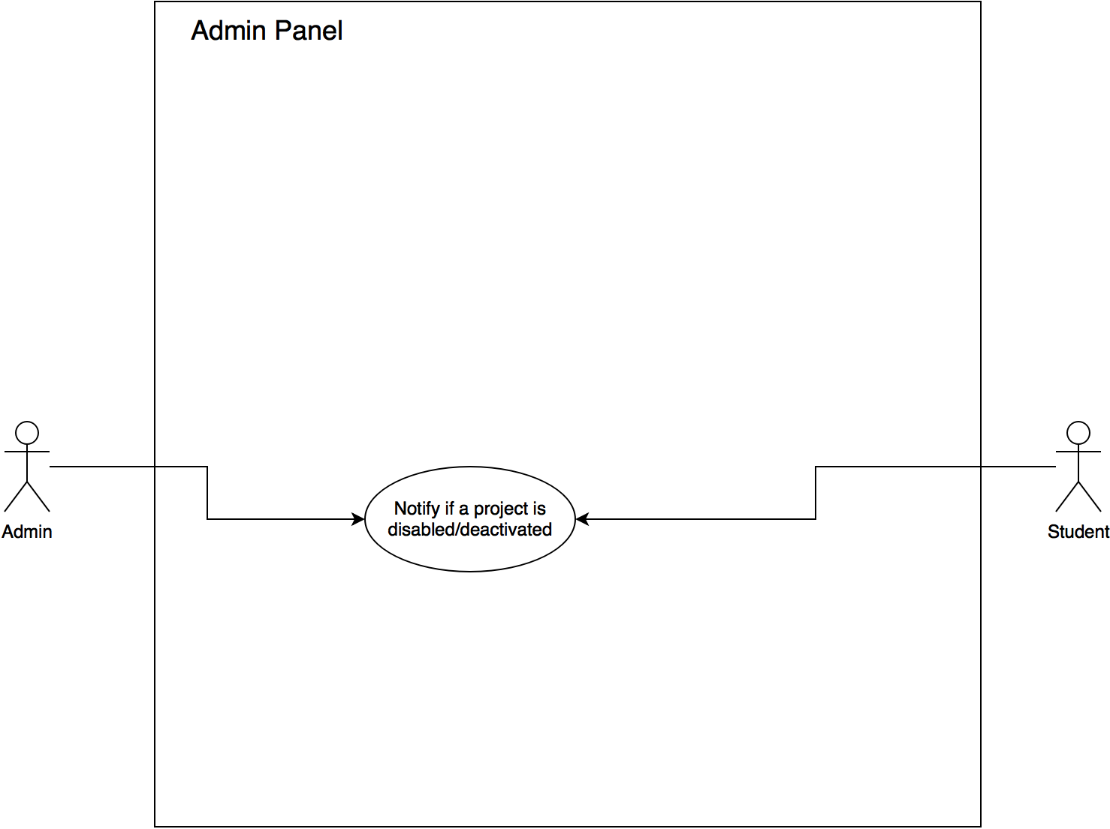](https://www.draw.io/?scale=2#G1XW6CQUYPVG1fKWa49iCtOle0EYpGCIDY)

Figure 1: User Story 1301 - Use Case Diagram

[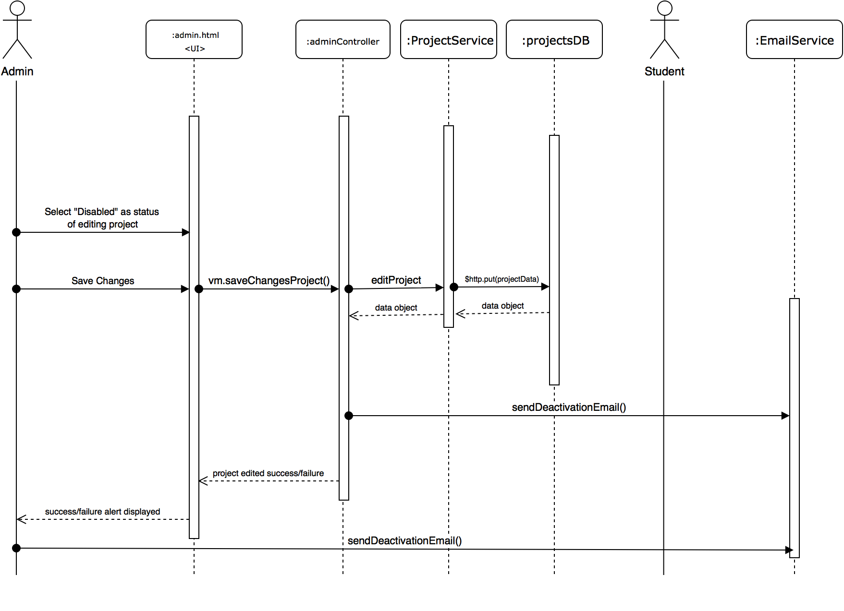](https://www.draw.io/?scale=2#G1DpPgmuxYrPHfxCRoi4Ec9Jl_84ob9O0v)

Figure 2: User Story 1301 - Sequence Diagram

[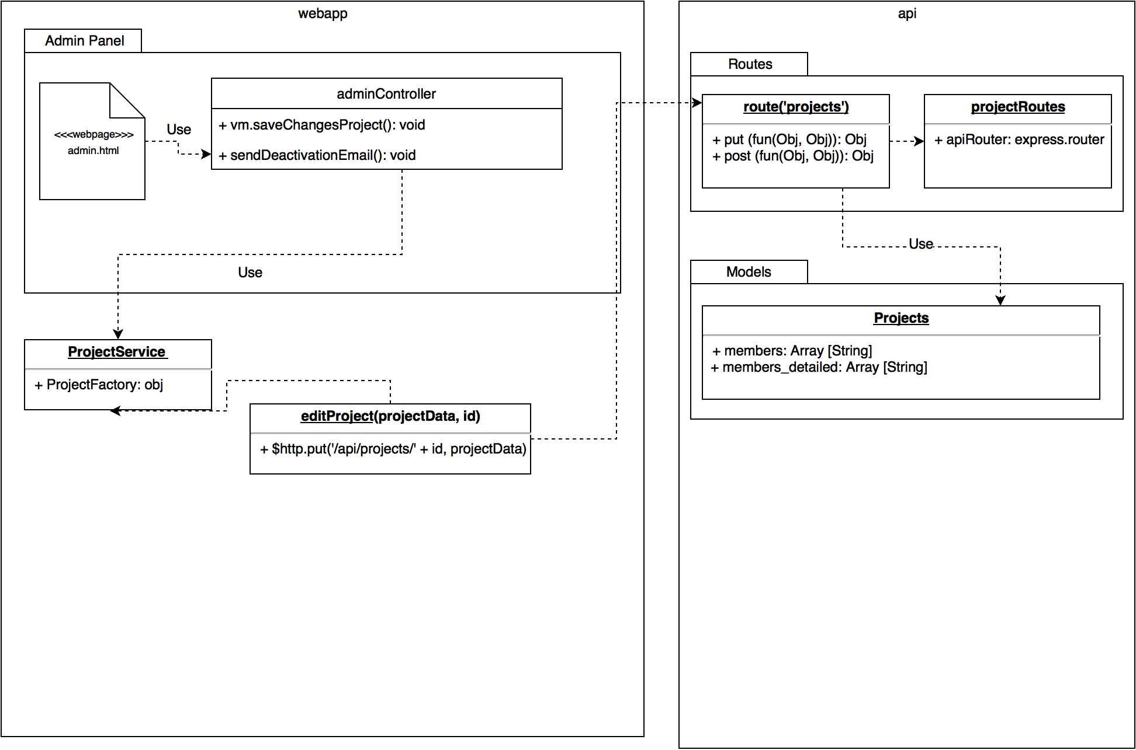](https://www.draw.io/?scale=2#G1KJtwOX2houibd2LSkdAN8am8G-gWowgp)

Figure 3: User Story 1301 - Class Diagram

[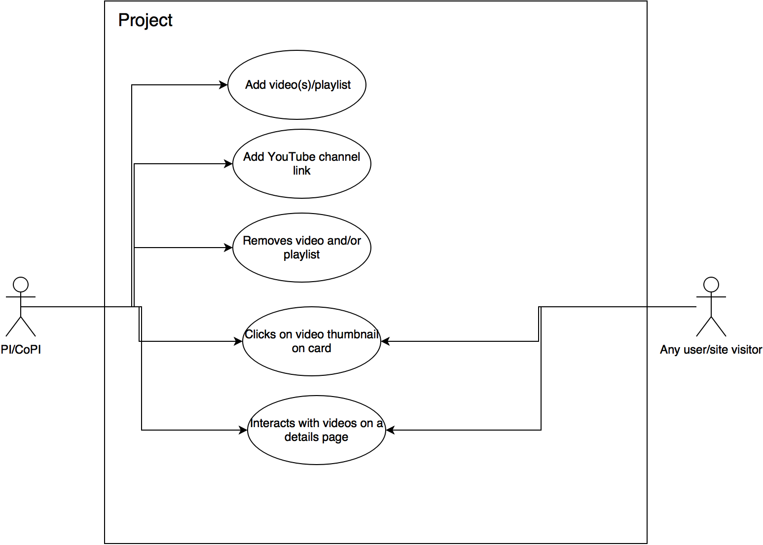](https://www.draw.io/?scale=2#G0B--foAwpDB6faE95WGpWMkt6VUk)

Figure 4: User Story 1329 - Use Case Diagram

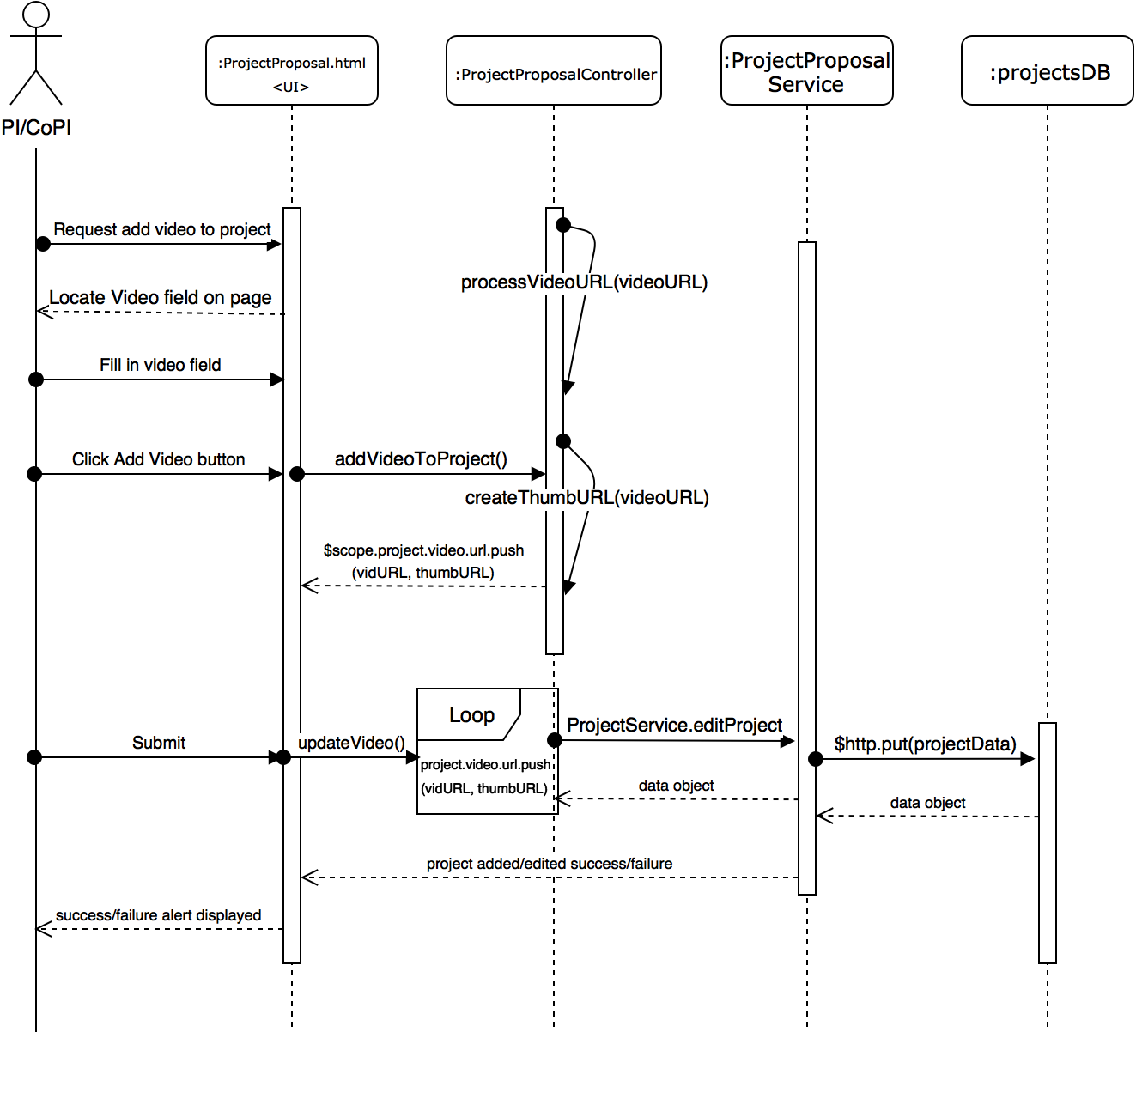Figure 5: User Story 1329 - Add Video Sequence Diagram

[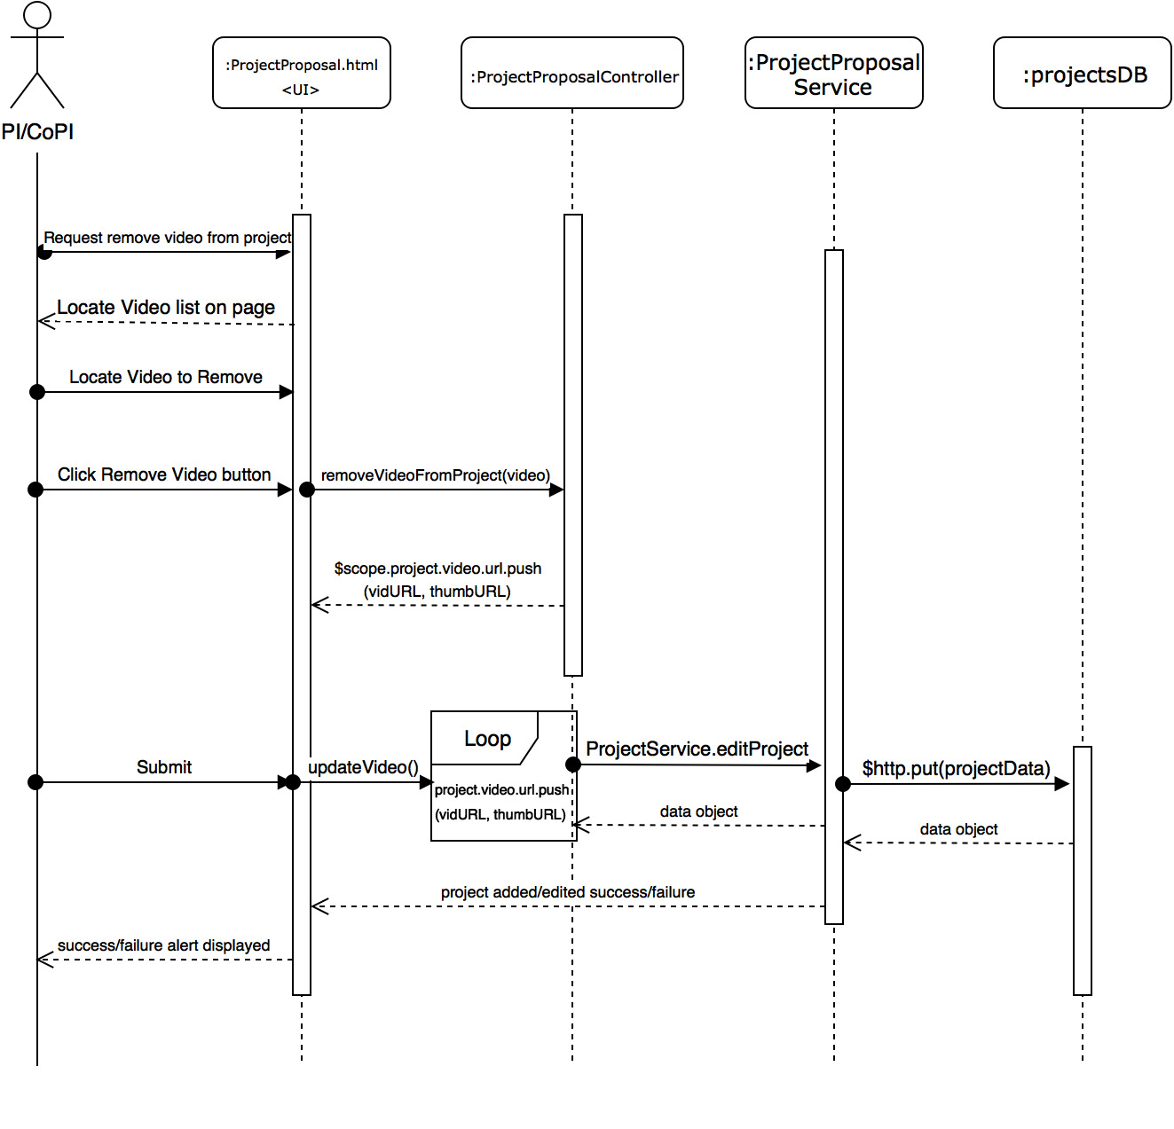](https://www.draw.io/?scale=2#G0B--foAwpDB6fWHlEdnZRckdTRzg)

Figure 6: User Story 1329 - Remove Video Sequence Diagram

[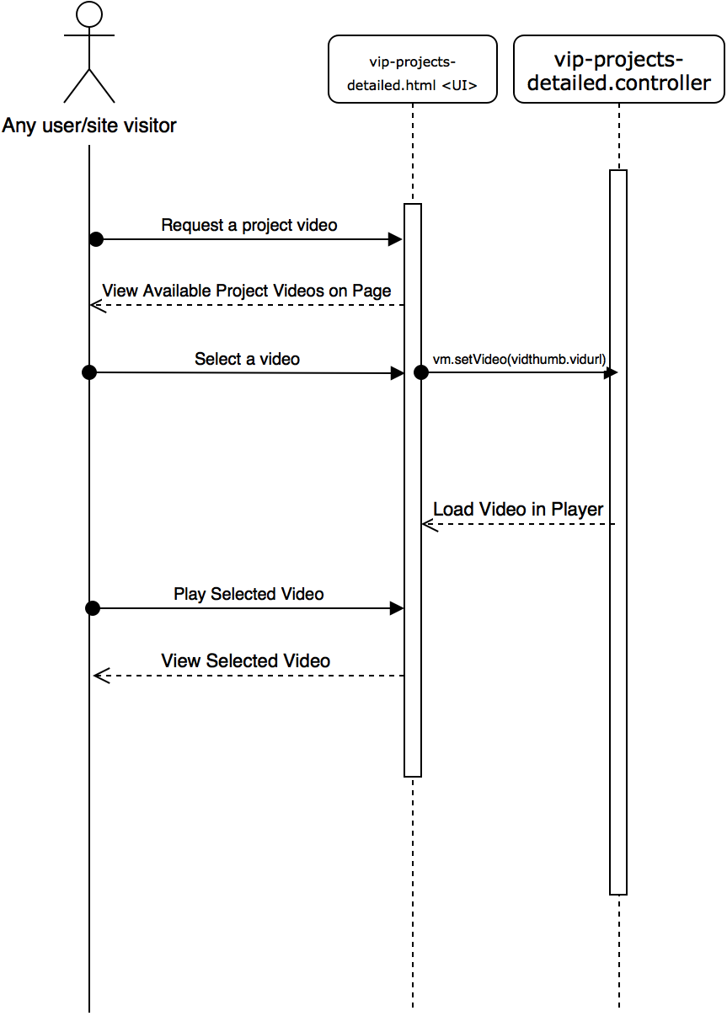](https://www.draw.io/?scale=2#G0B--foAwpDB6fNDJBRDJqU2RhdDQ)

Figure 7: User Story 1329 - Interact with Videos Sequence Diagram

[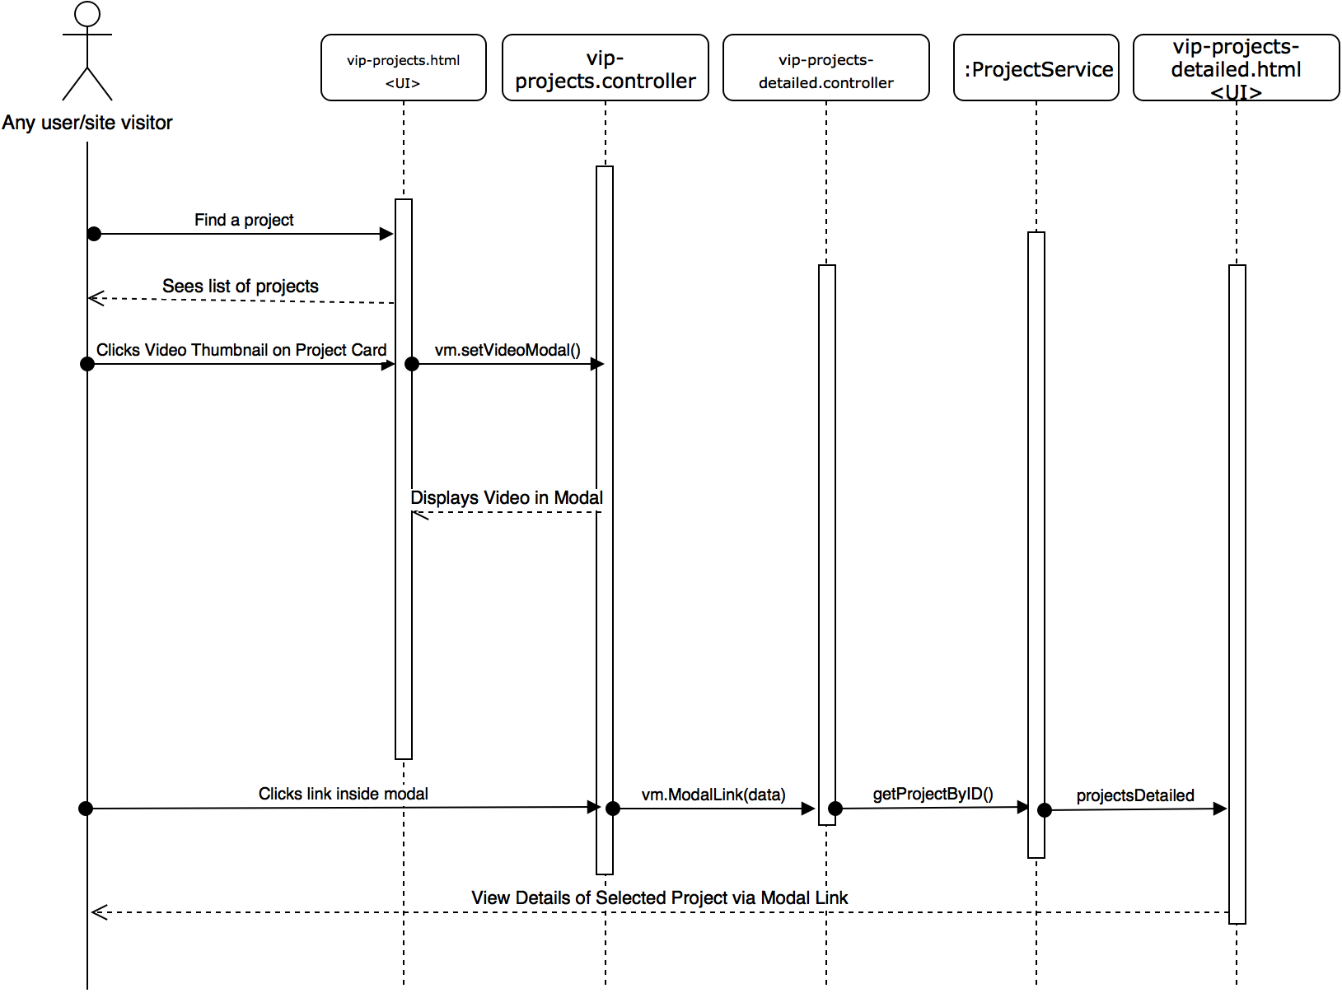](https://www.draw.io/?scale=2#G0B--foAwpDB6fQkplQkpMbjFJeGM)

Figure 8: User Story 1329 - Click Thumbnail on Card Sequence Diagram

[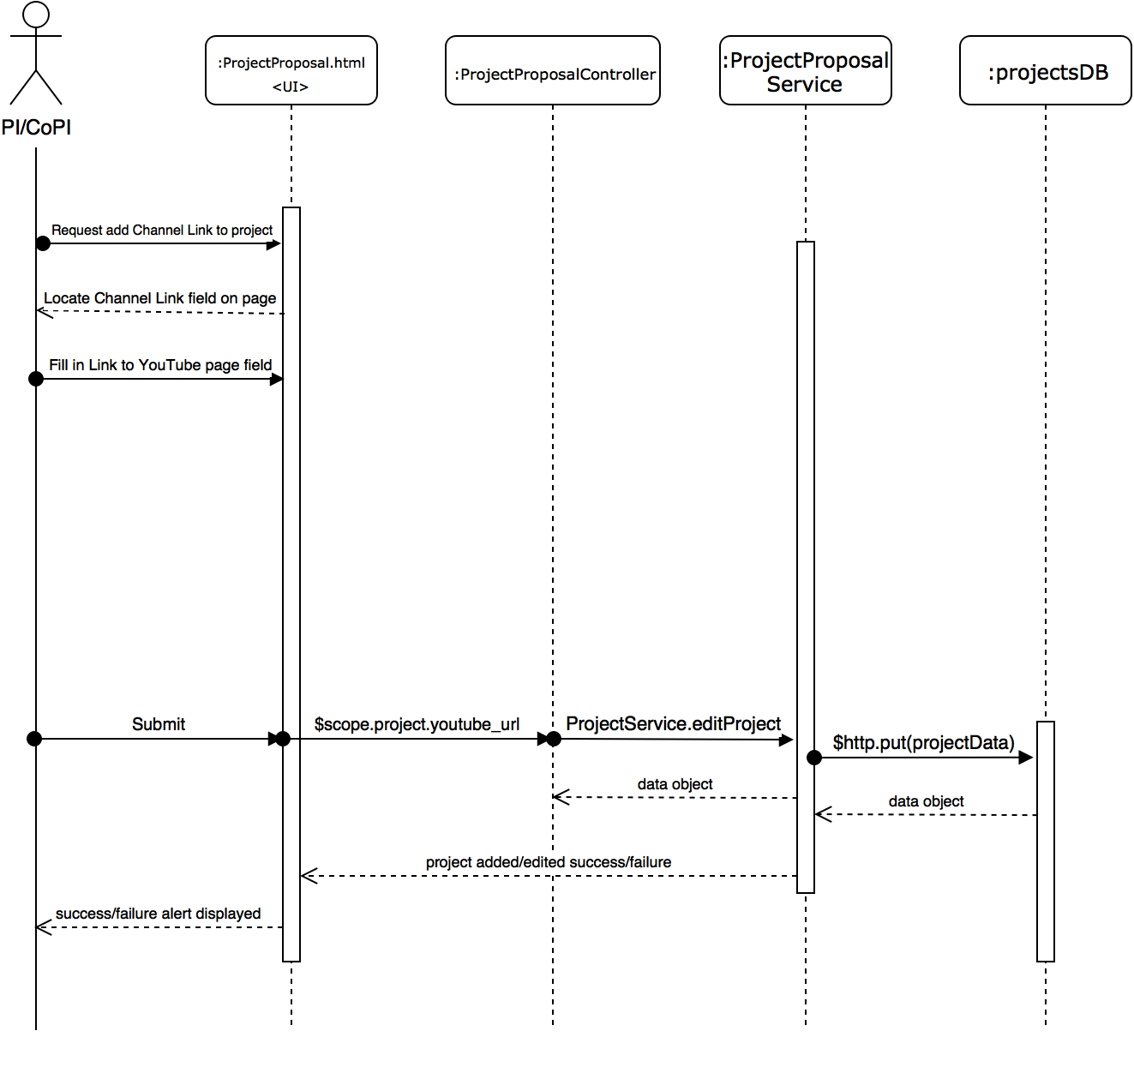](https://www.draw.io/?scale=2#G1ntVNG-kQfa7FJm023rSBRuL5tABrWQTr)

Figure 9: User Story 1329 - Add Channel Link Sequence Diagram

[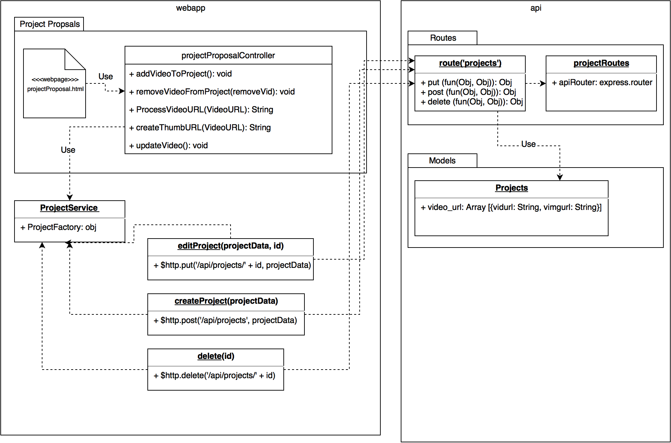](https://www.draw.io/?scale=2#G0B--foAwpDB6fRnNhNkRvNUlLX1U)

Figure 10: User Story 1329 - Class Diagram

[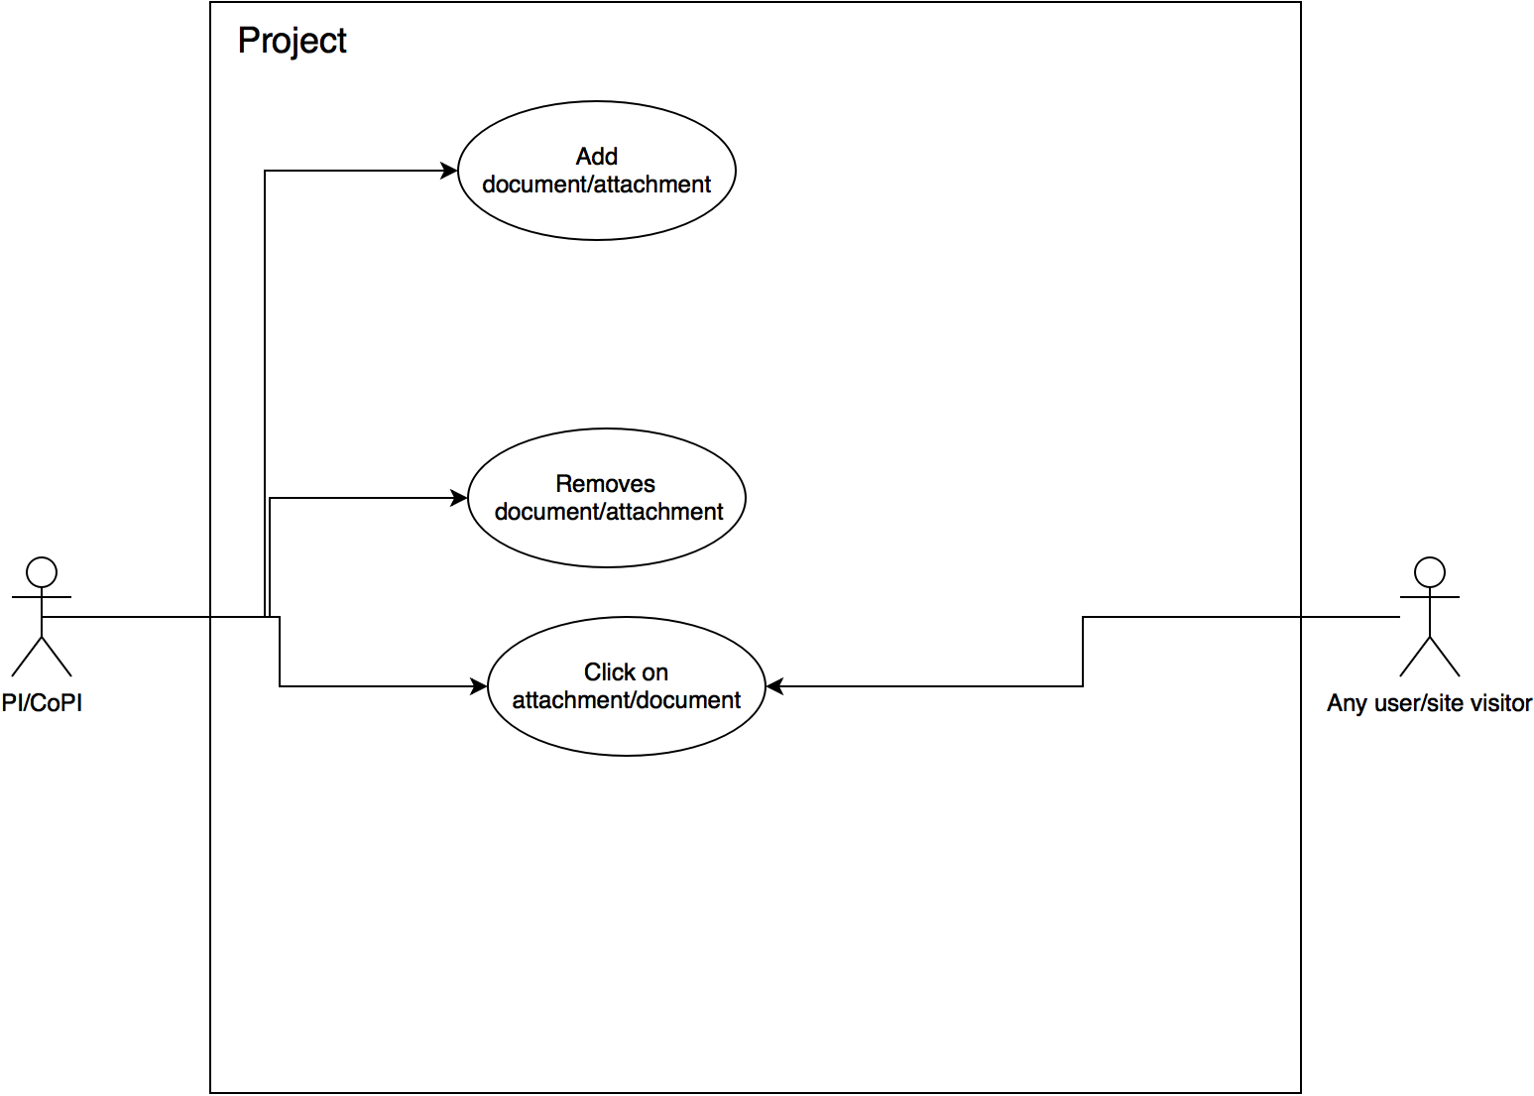](https://www.draw.io/?scale=2#G1VylOwFWDsihbC5Bw7rQ8zf0c6Svre3SW)

Figure 11: User Story 1331 - Use Case Diagram

[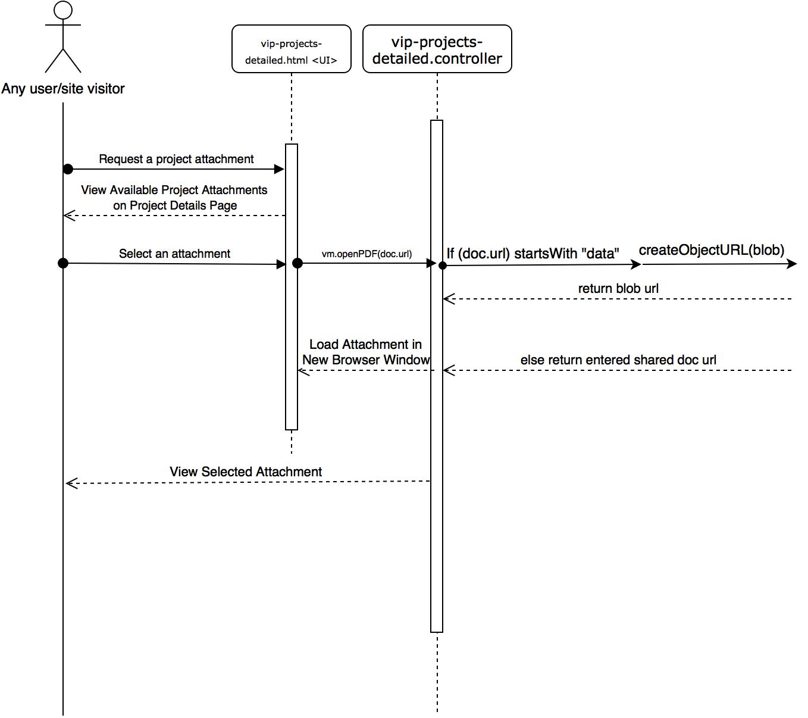](https://www.draw.io/?scale=2#G1uCV24_0CaVQJM10N0xxPebbVjCKBTbfd)

Figure 12: User Story 1331 - Interact with Documents Sequence Diagram

[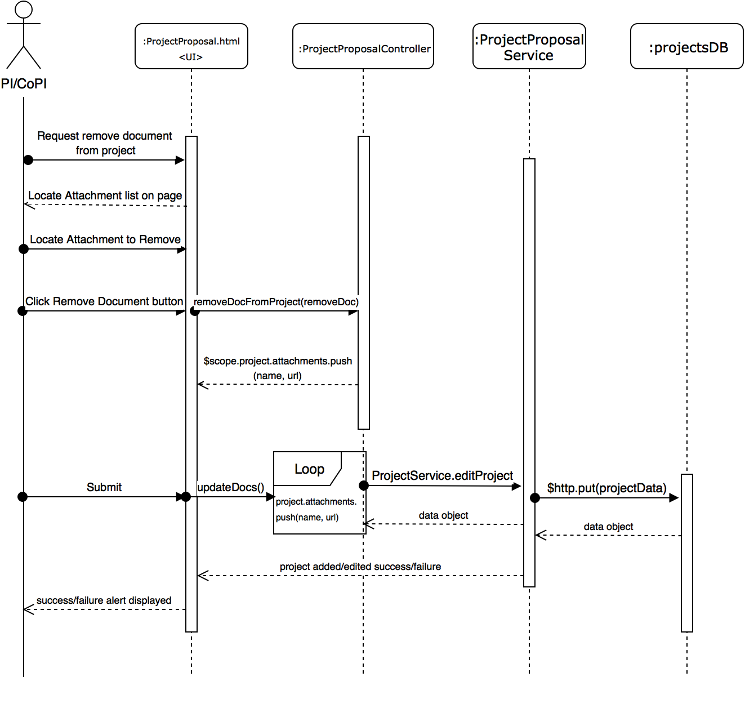](https://www.draw.io/?scale=2#G1Atc_moP_vKeDbe_gl3sjKbXlt9PtVU0N)

Figure 13: User Story 1331 - Remove Document Sequence Diagram

[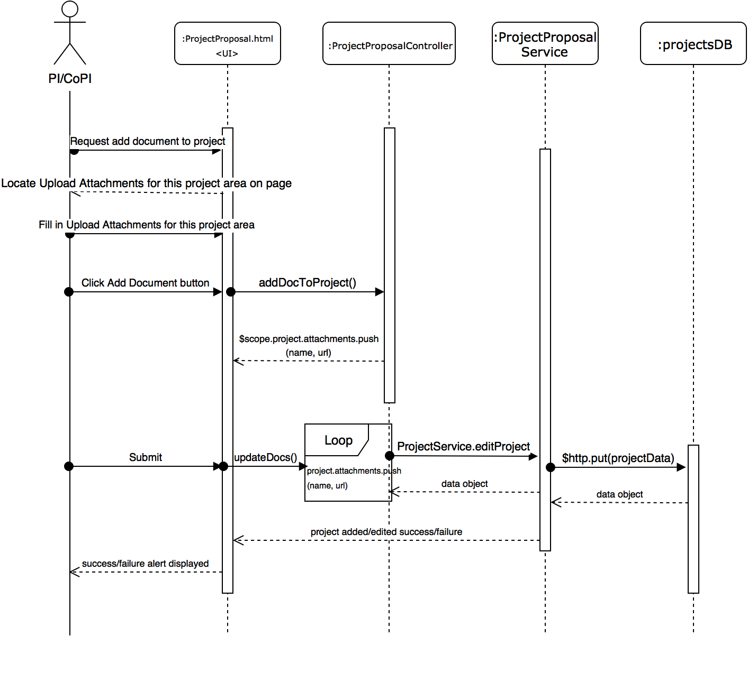](https://www.draw.io/?scale=2#G1IUcXdHYd2rRiMXRkaEAvR2ypqIESReWD)

Figure 13: User Story 1331 - Add Document Sequence Diagram

[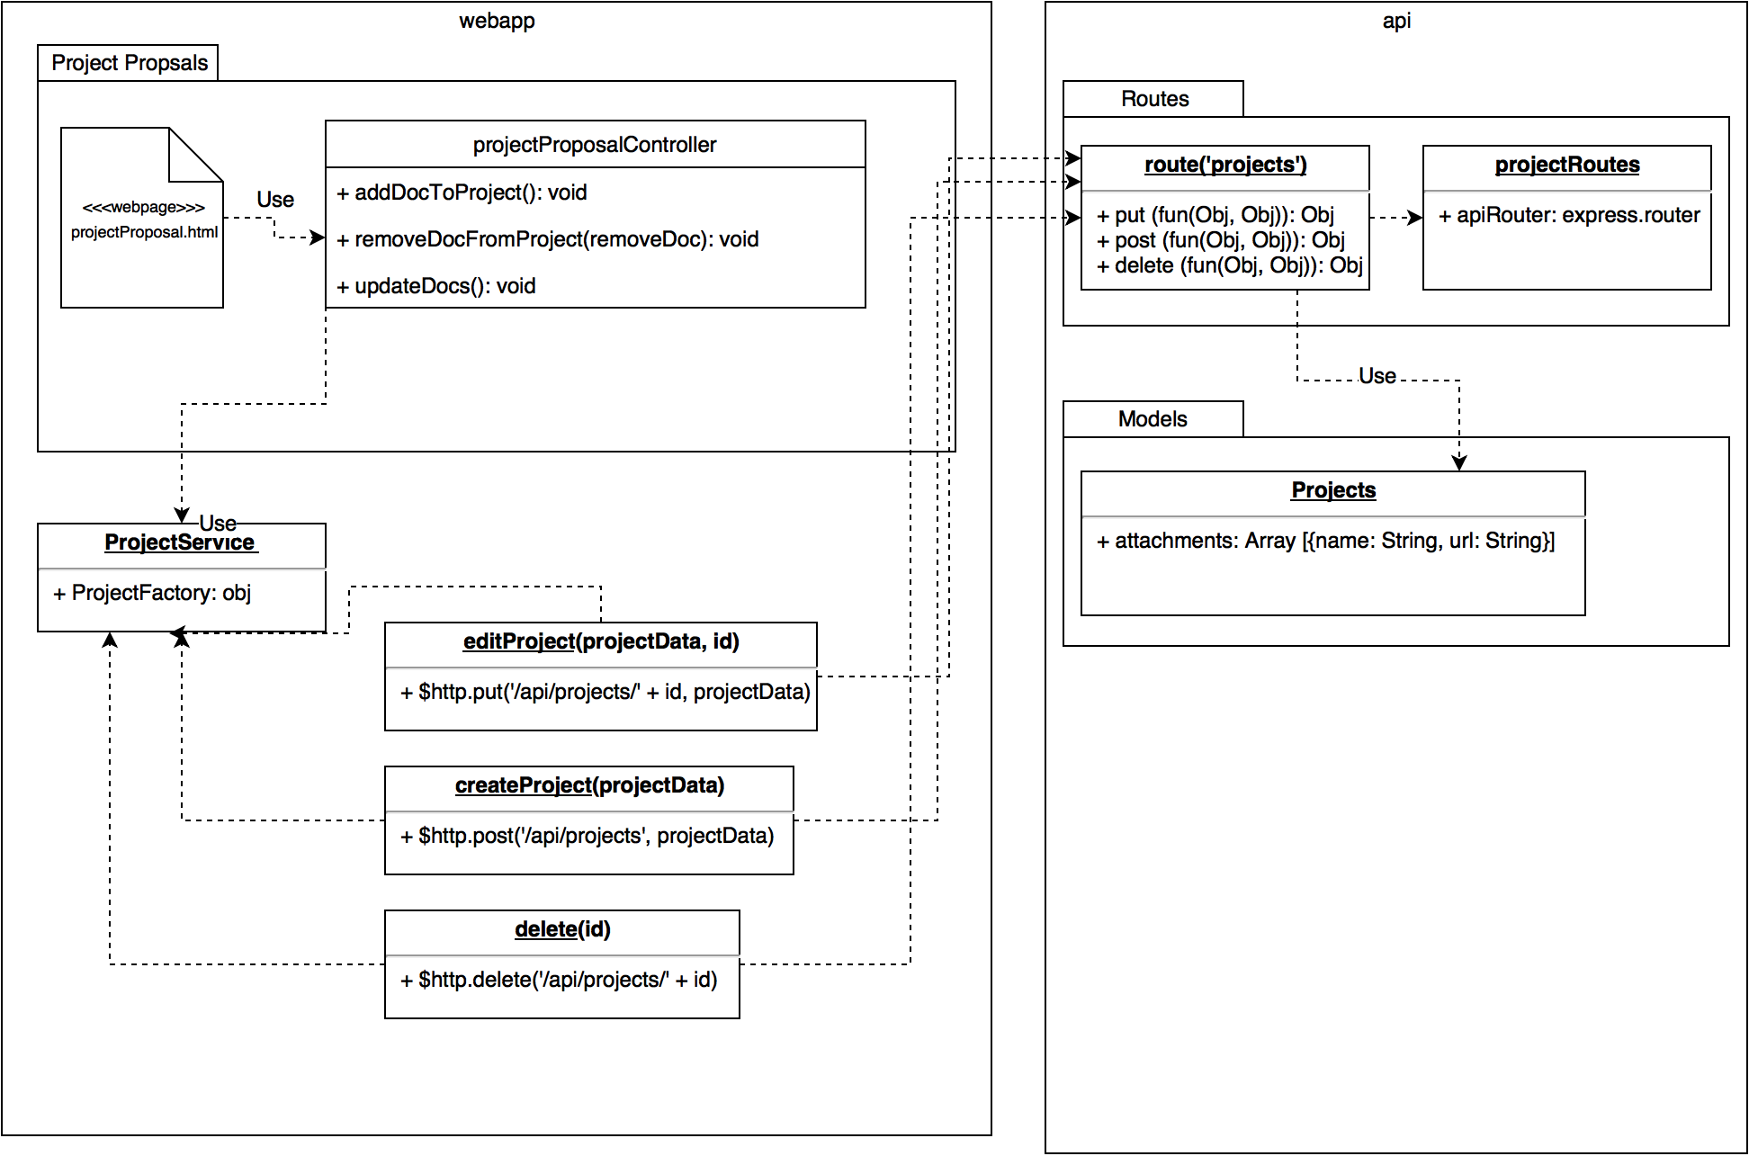](https://www.draw.io/?scale=2#G15ScmcPw8nQotFT-h4ecpIO6B4KeKX6Bs)

Figure 14: User Story 1331 - Class Diagram

[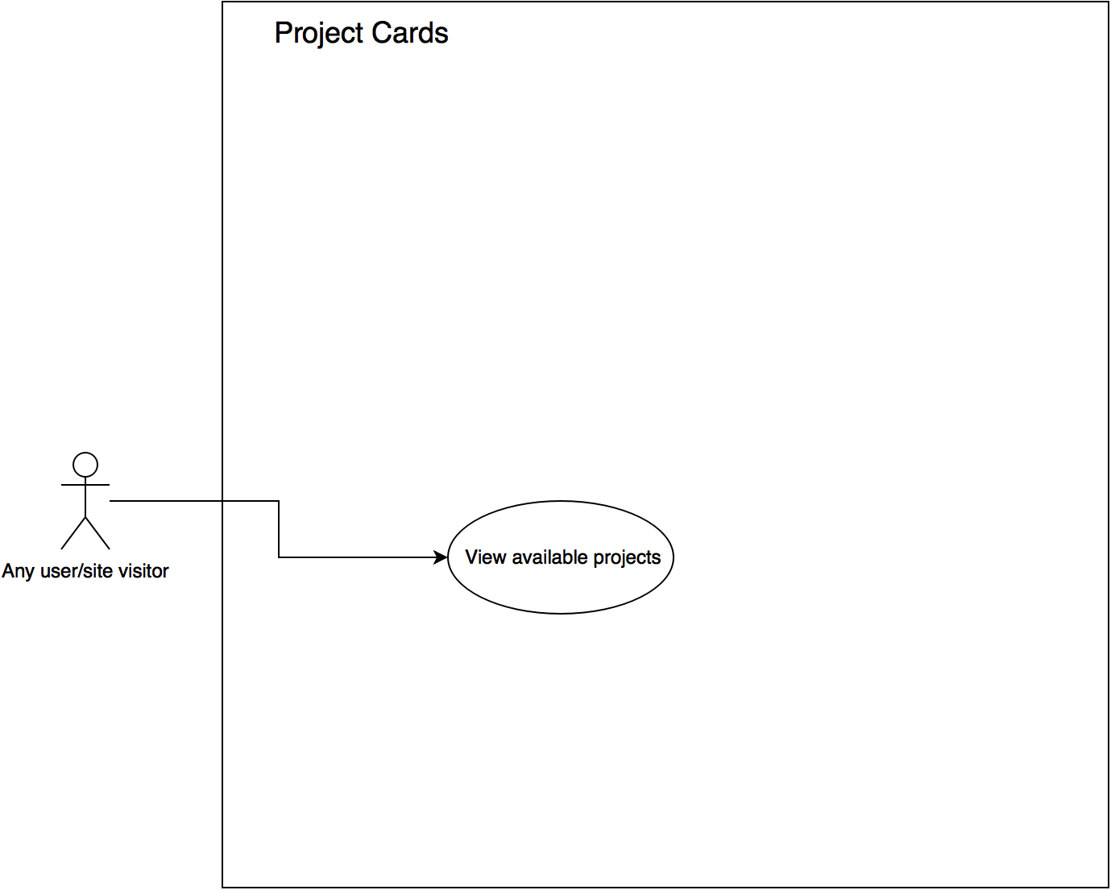](https://www.draw.io/?scale=2#G1UPc1xdfBbq6yjvNIoXVSN9PrhKOnrdwB)

Figure 15: User Story 1351 - Use Case Diagram

[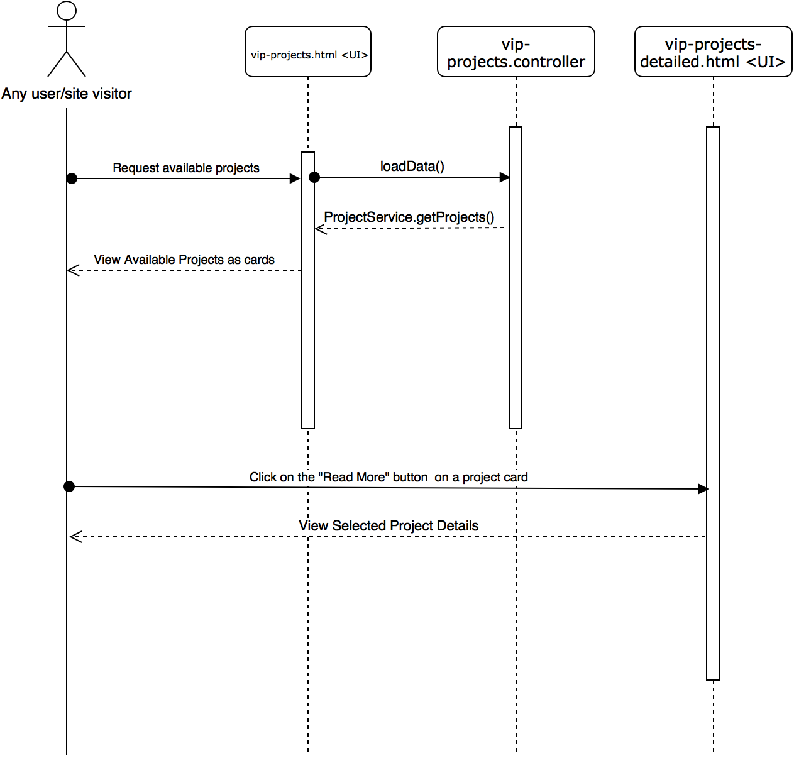](https://www.draw.io/?scale=2#G1OJN5tY0DKWatdM-Fsord2XepUzZxYRSV)

Figure 16: User Story 1351 - View available projects Sequence Diagram

[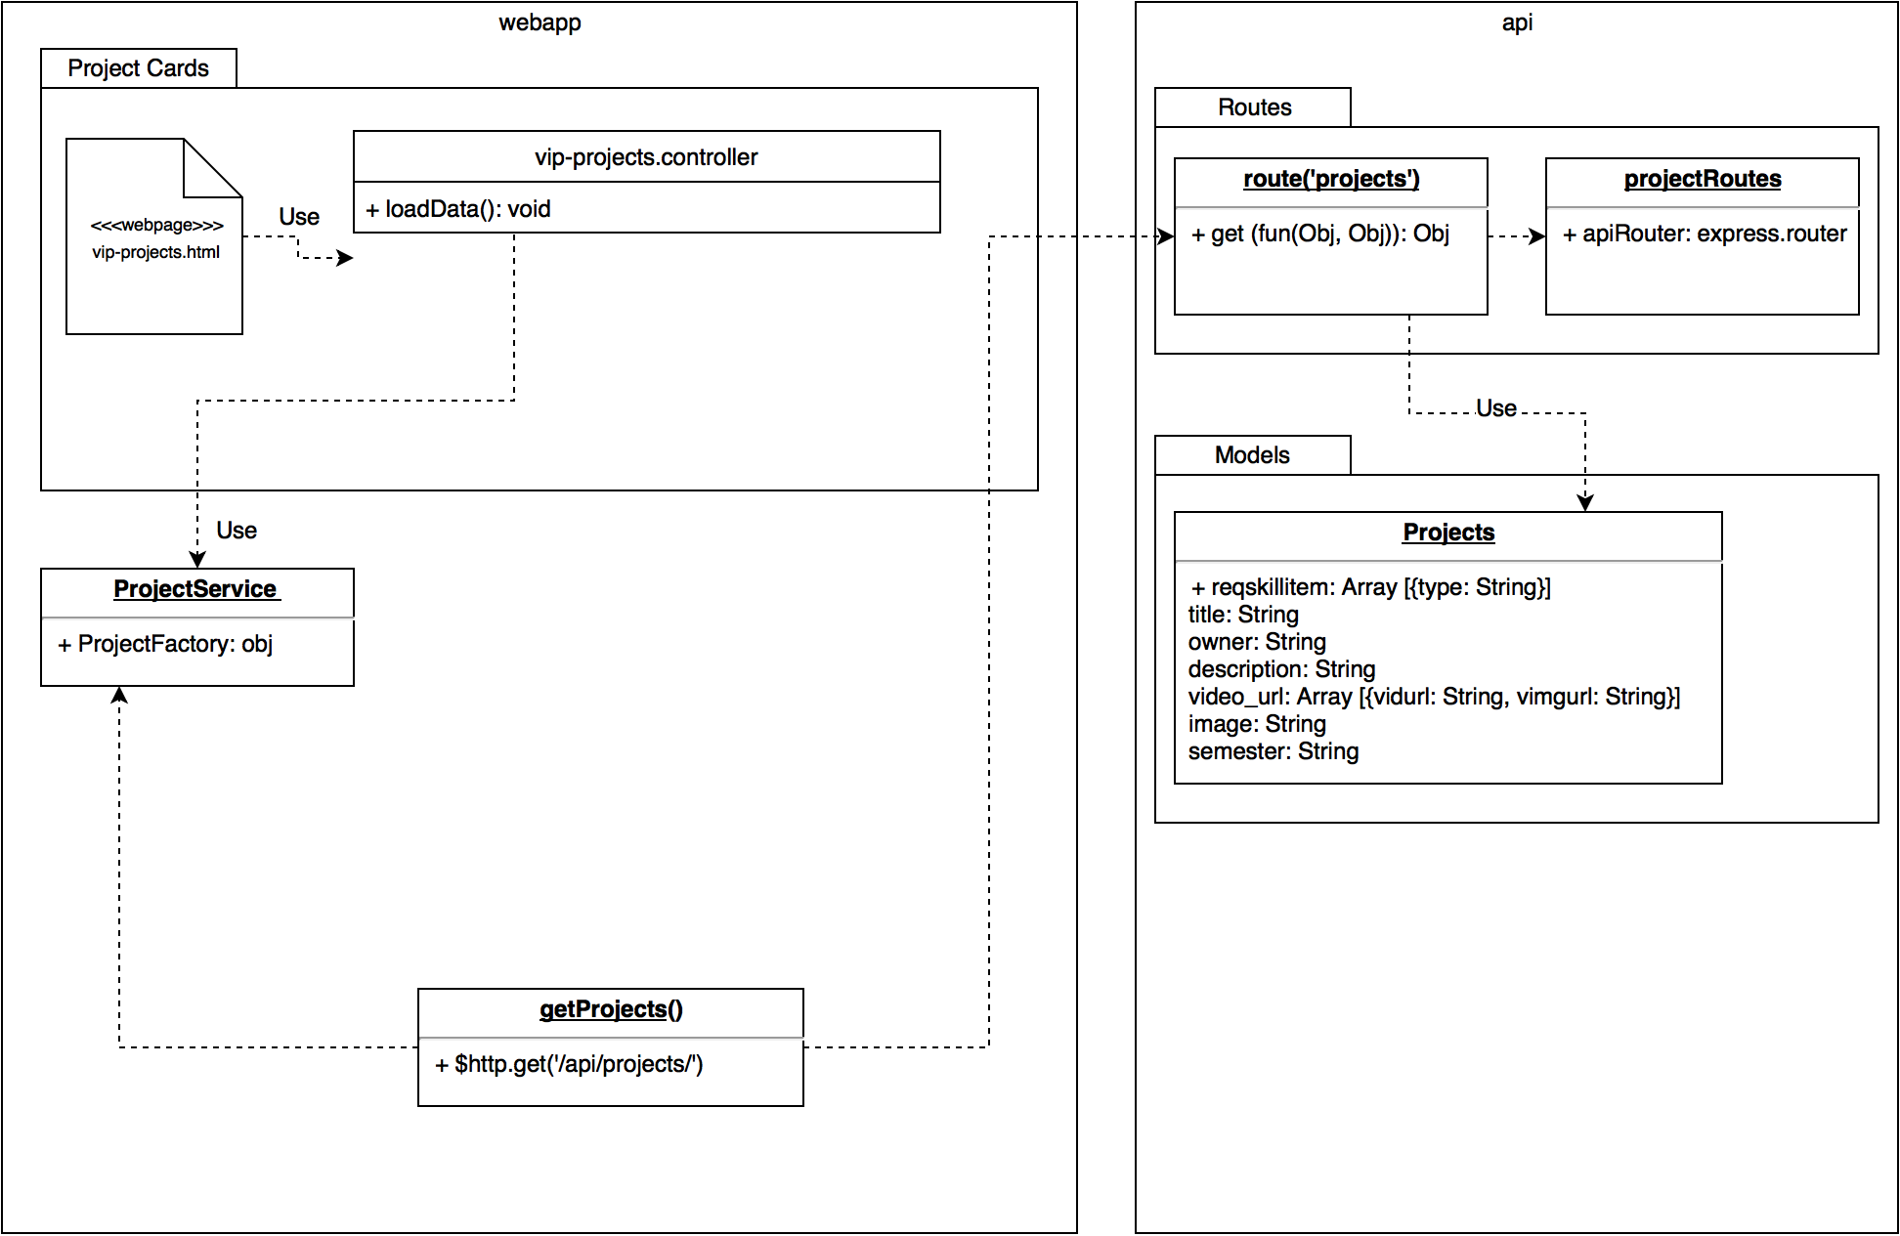](https://www.draw.io/?scale=2#G1V3VNB8lWim1-NidM2rvFfYCbua9I0ofW)

Figure 17: User Story 1351 - Class Diagram

[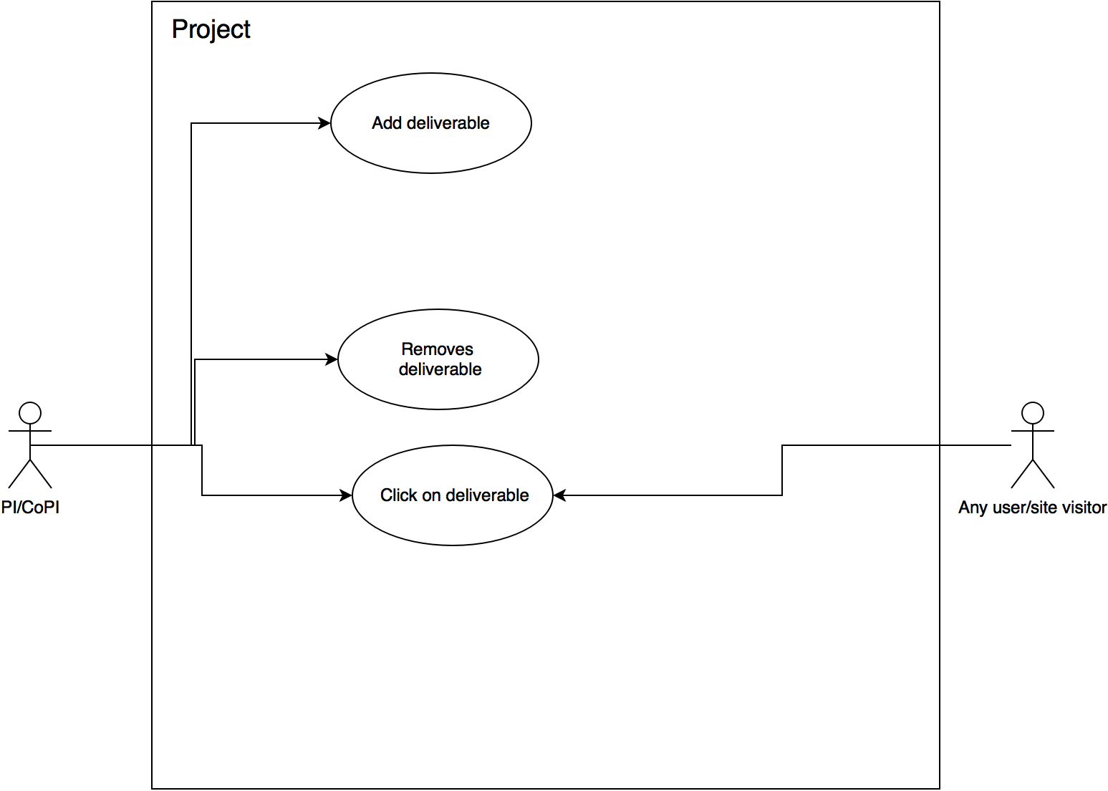](https://www.draw.io/?scale=2#G17PbC5MaPslDS72PIZRKz0qI-N2e7WhKH)

Figure 18: User Story 1364 - Use Case Diagram

[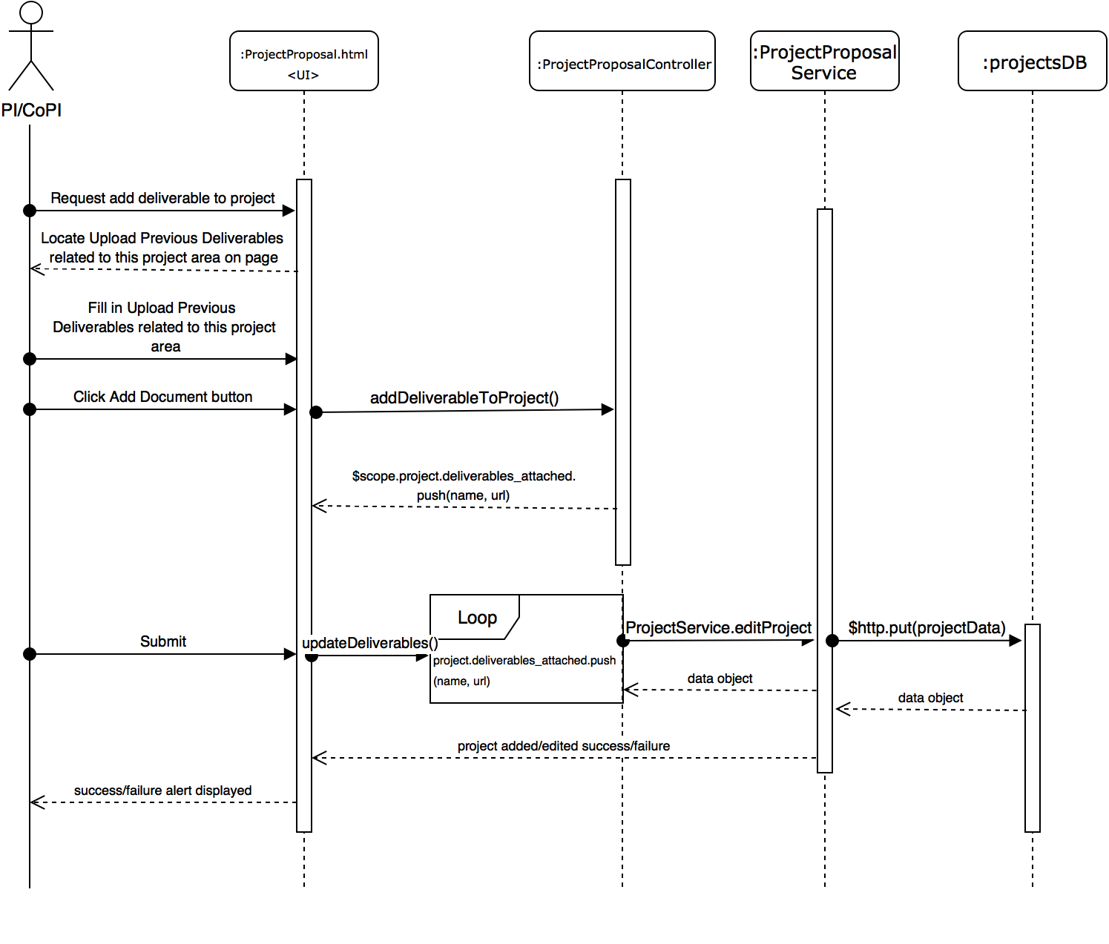](https://www.draw.io/?scale=2#G1tZiwTRg0ogsHCGjcVnS5pL1S6Ik2289e)

Figure 19: User Story 1364 - Add Deliverable Sequence Diagram

[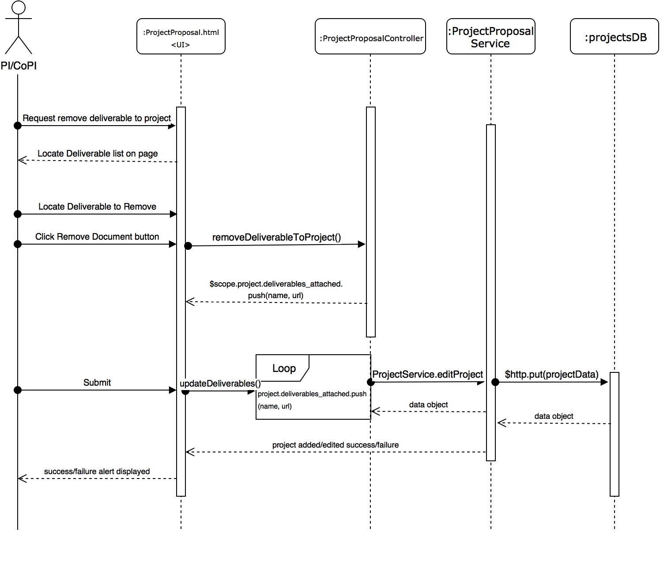](https://www.draw.io/?scale=2#G1y28BaS7sm2NJWABYgke3SZMQDa4J9tFw)

Figure 20: User Story 1364 - Remove Deliverable Sequence Diagram

[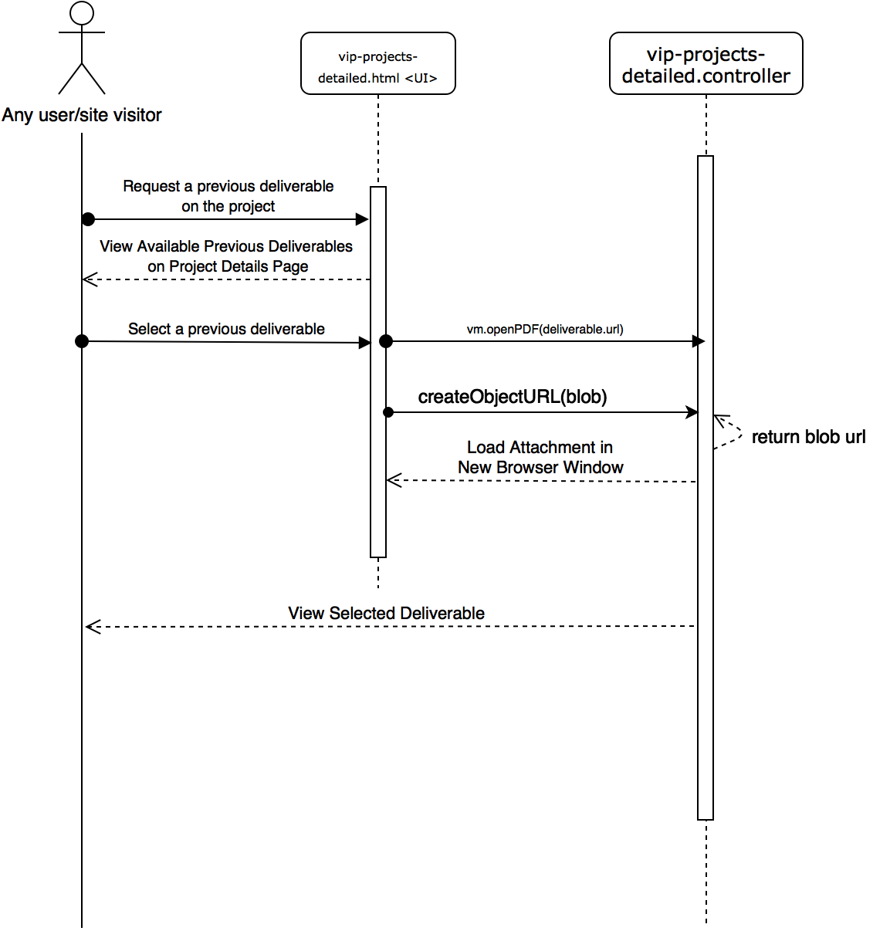](https://www.draw.io/?scale=2#G1_iB9DMccGgnMv4rDWl4jWjgsOx8gLe26)

Figure 21: User Story 1364 - View Previous Deliverable Sequence Diagram

[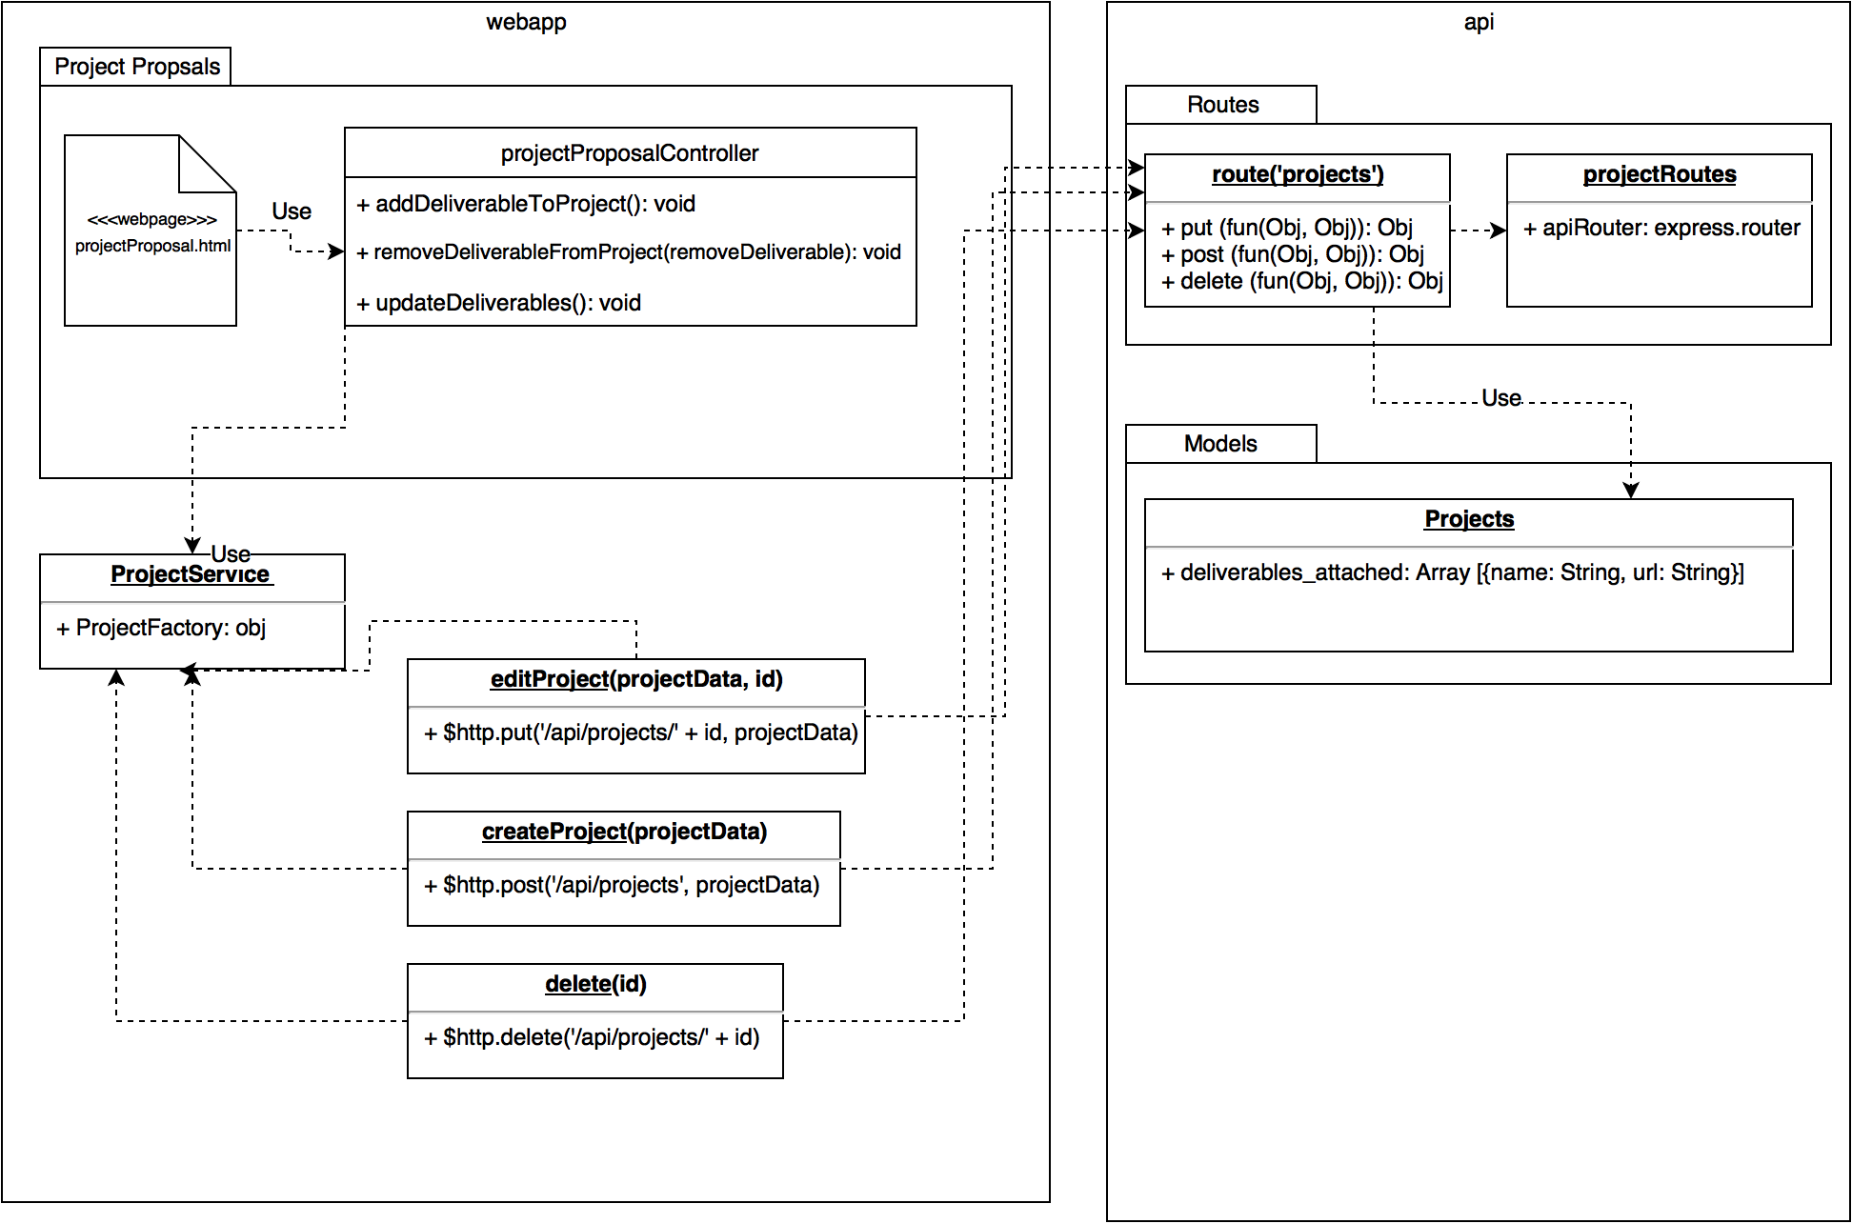](https://www.draw.io/?scale=2#G1D4hYJhx1UIL8dm9kWip_3jFL9vAXo7L0)

Figure 22: User Story 1364 - Class Diagram

[](https://www.draw.io/?scale=2#G0B--foAwpDB6fWm9EQlBMQmZQems)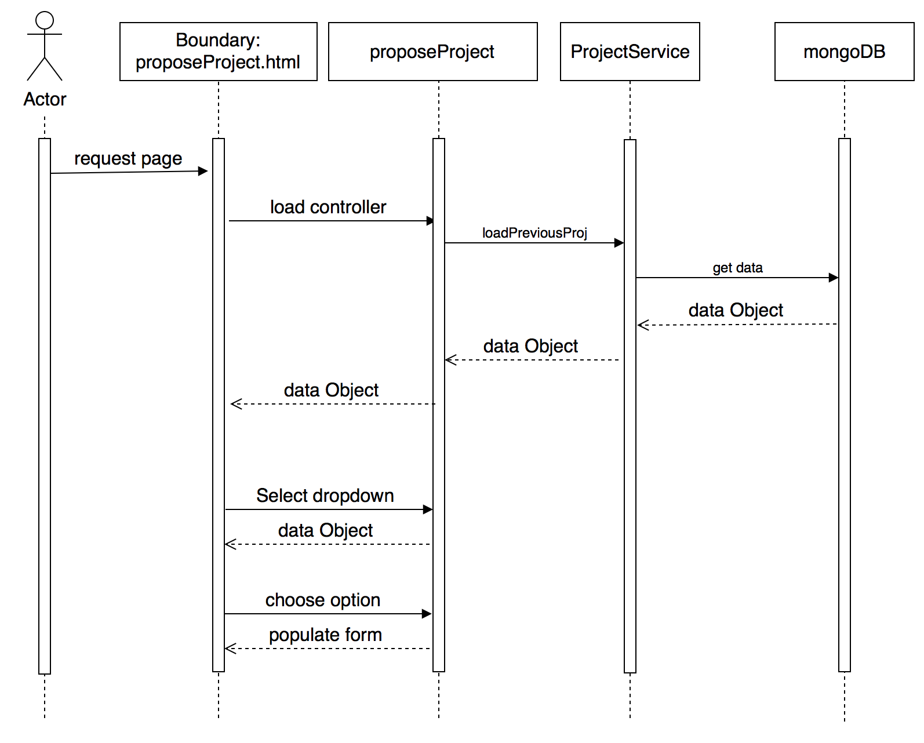

Figure 23: 1305 - Re-propose projects from previous semester

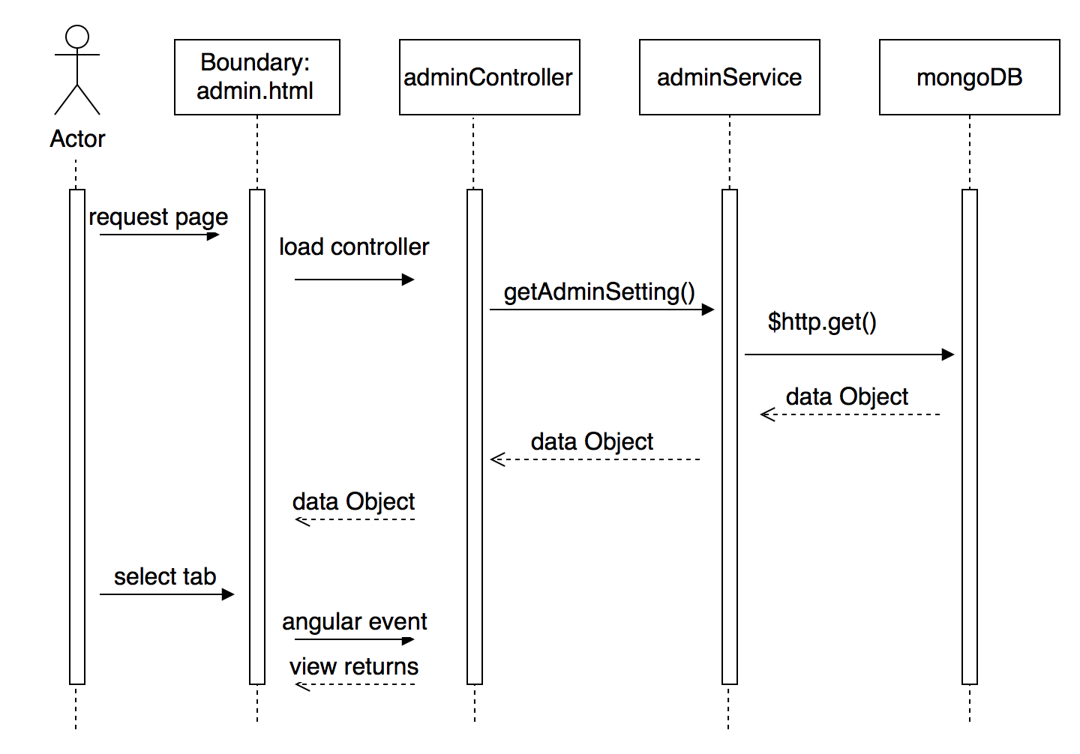

Figure 24: 1314 Create Admin Panel Tabs

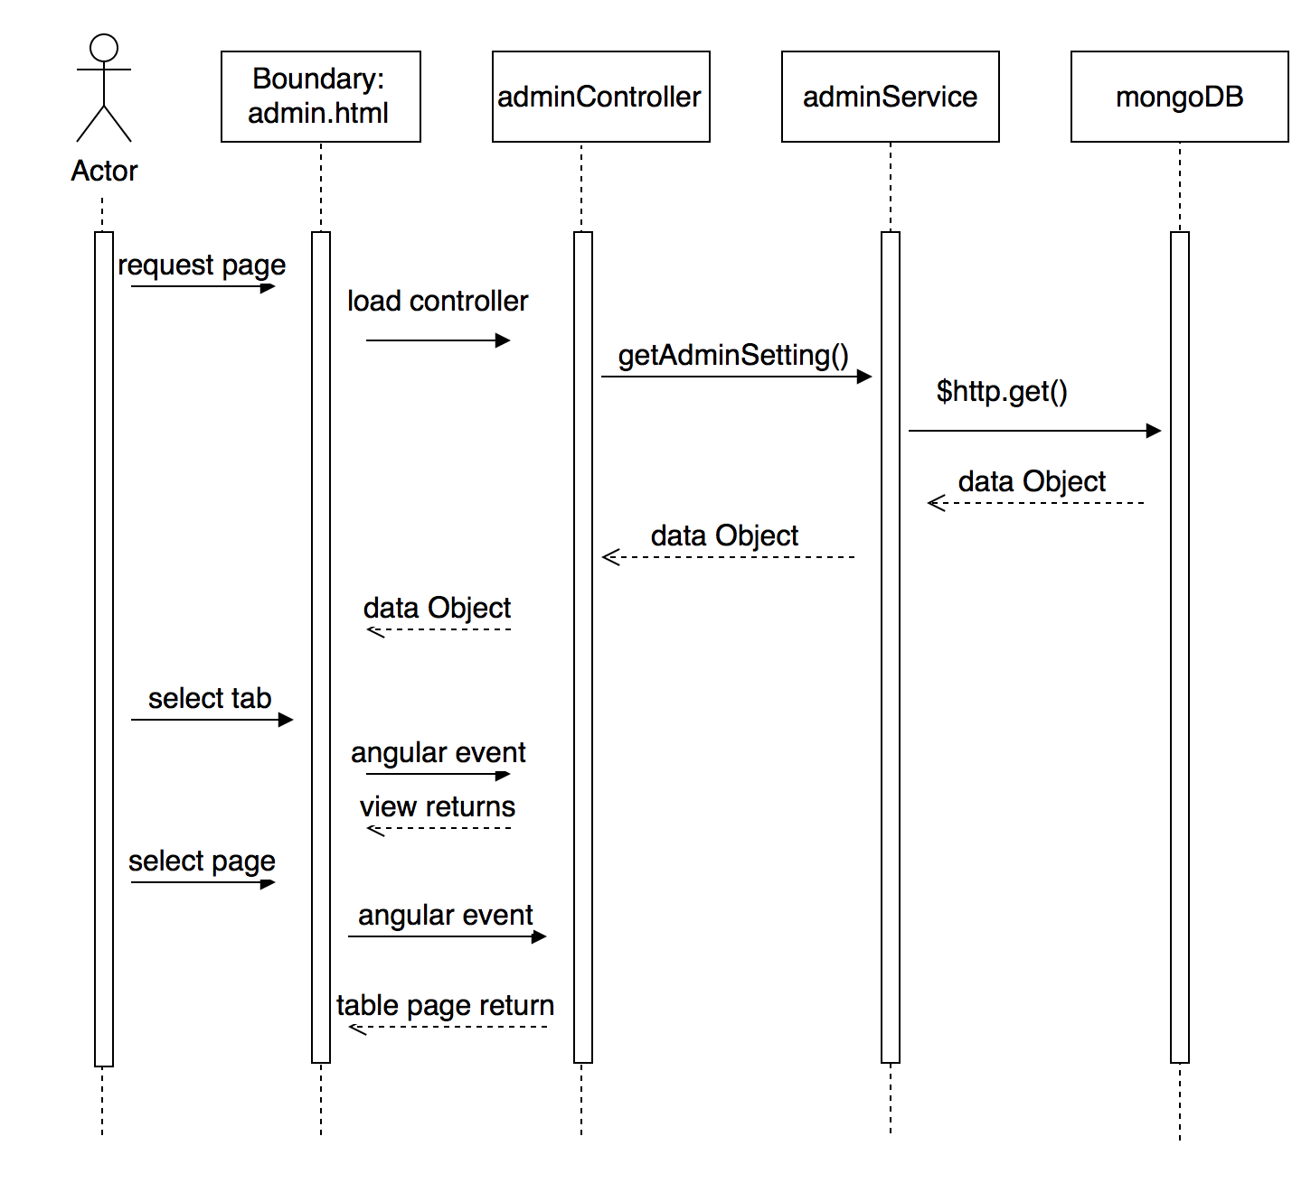

Figure 25: 1322 - Pagination in User Maintenance and Project Maintenance Table

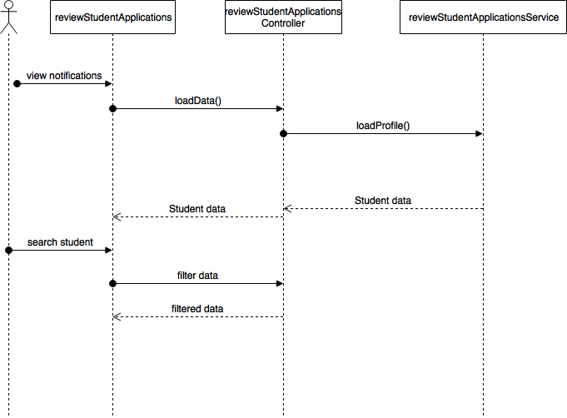

Figure 26: 1332 - Search Functionality For Inbox and Student Review

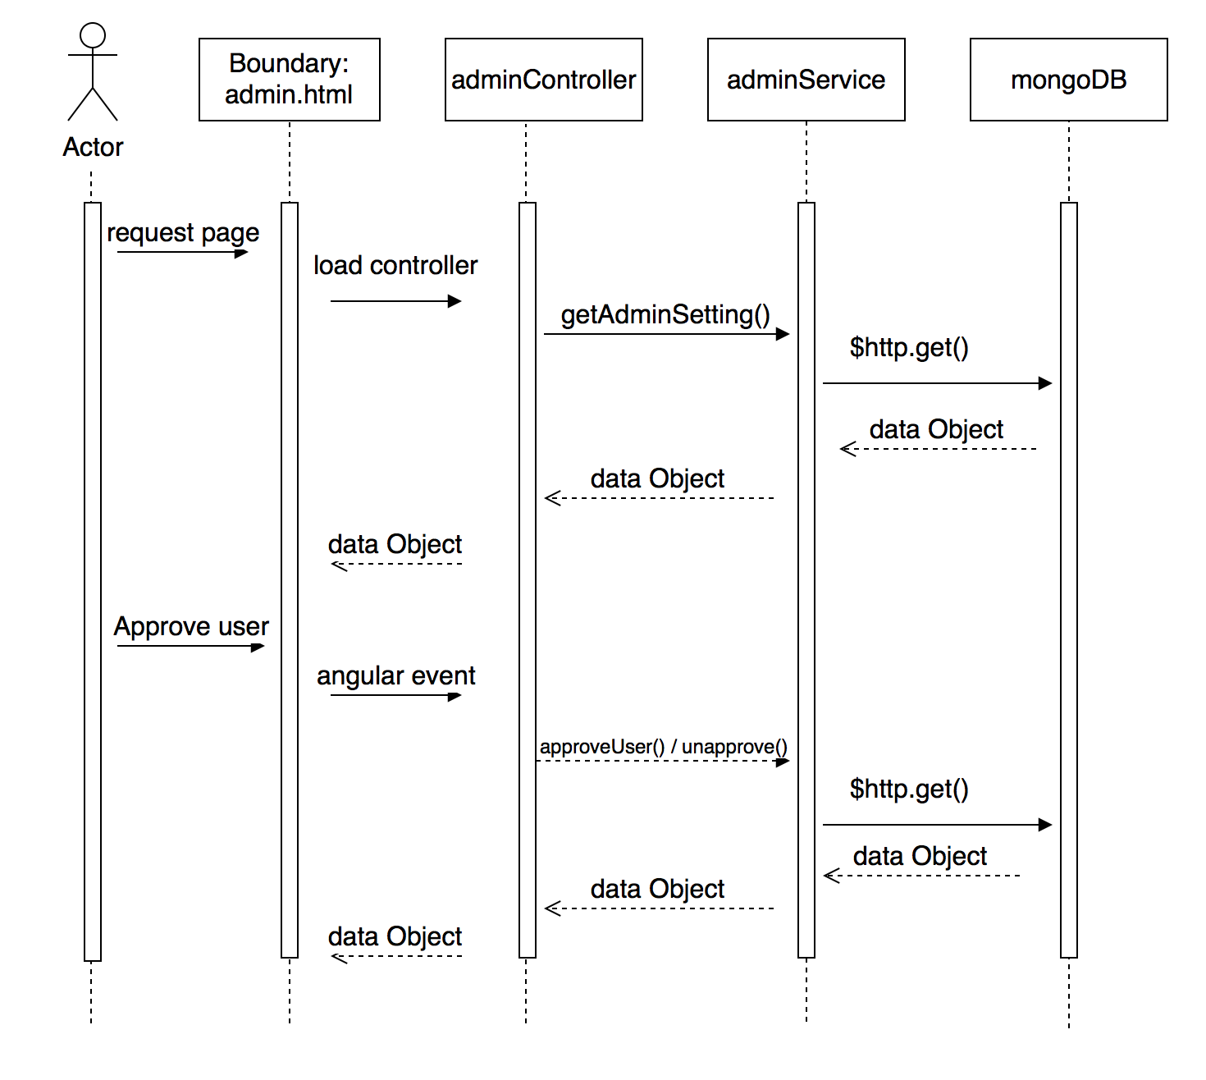

Figure 27: 1356 - Approve student registrations via admin panel

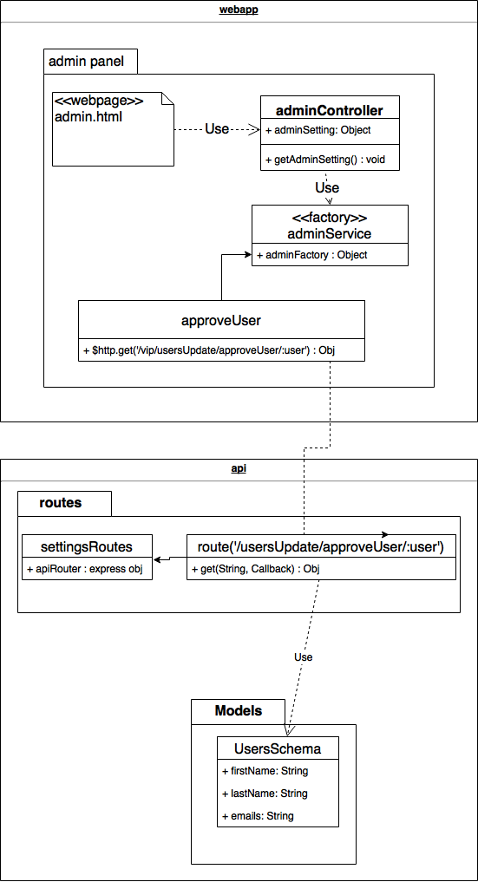

Figure 28: 1356 class diagram

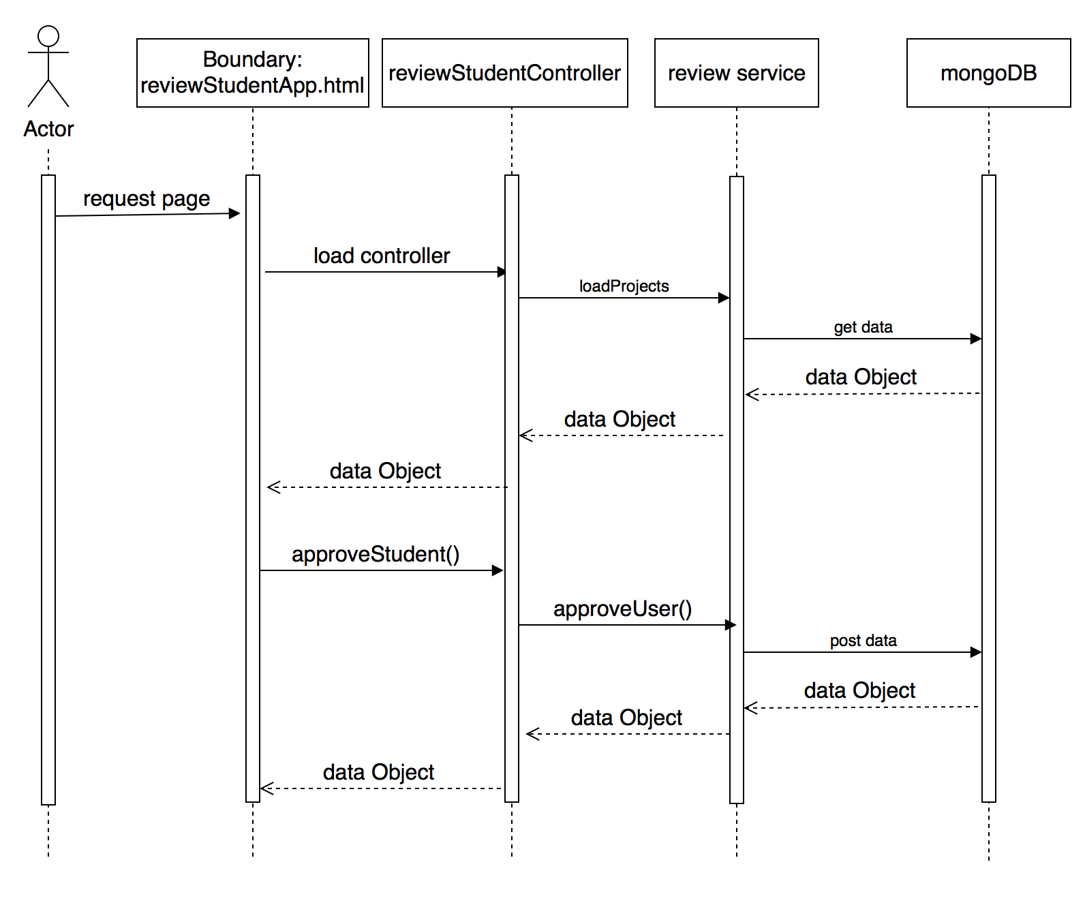

Figure 29: 1361 - Redesign student review page

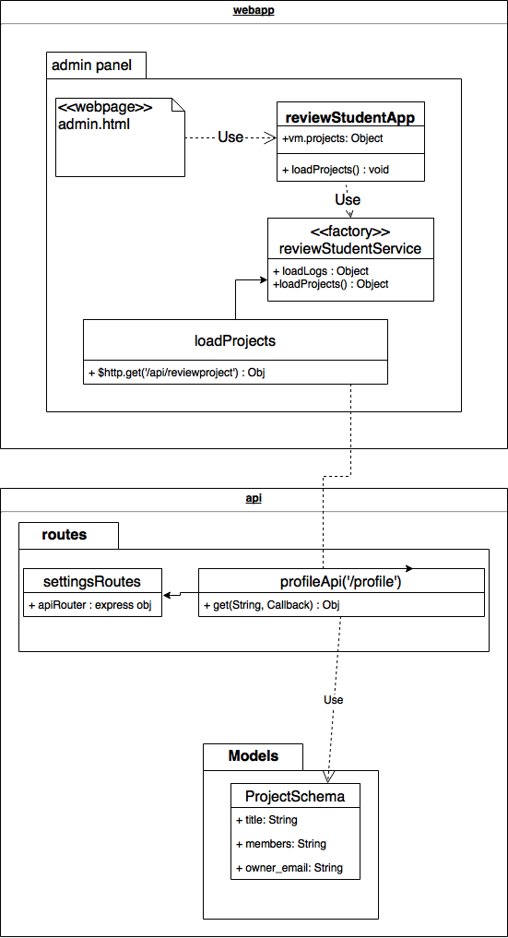

Figure 30: 1361 Class diagram

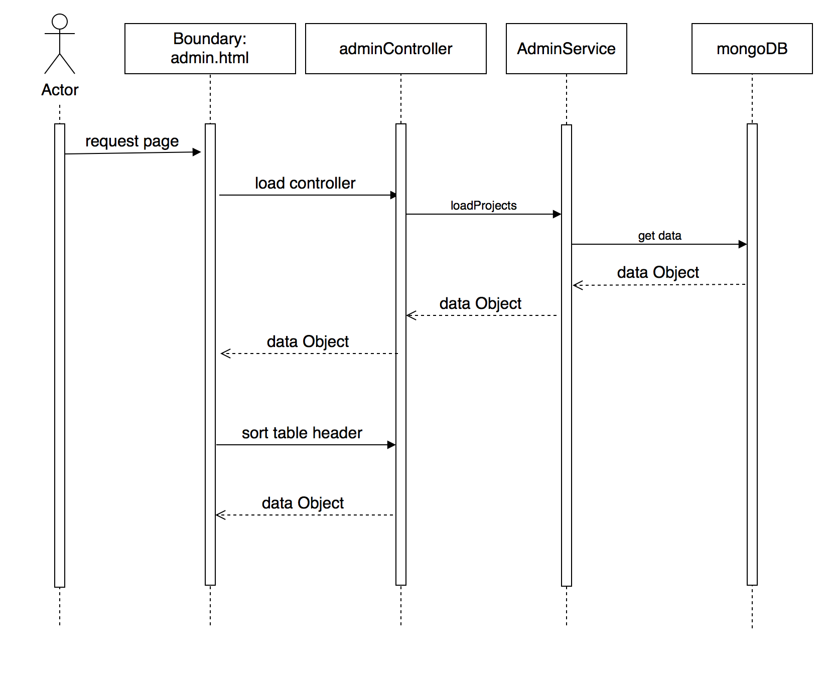

Figure 31: 1363 - Sort column header for tables

[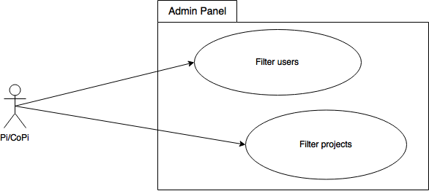](https://www.draw.io/#G1jRV-pNfx8VNRzkqHarVLM7P4vkHDCqkv)

Figure 32: 1176 - Use Case Diagram

[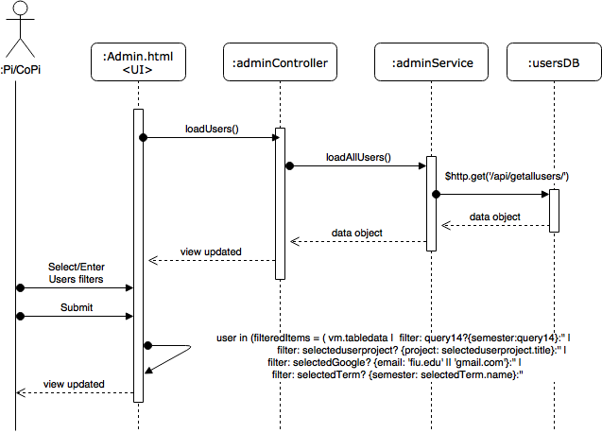](https://www.draw.io/#G1vygeAp5w2BFCX9ceoa3bKcXrzXQa0Z8r)

Figure 33: 1176 - Filtering Users

[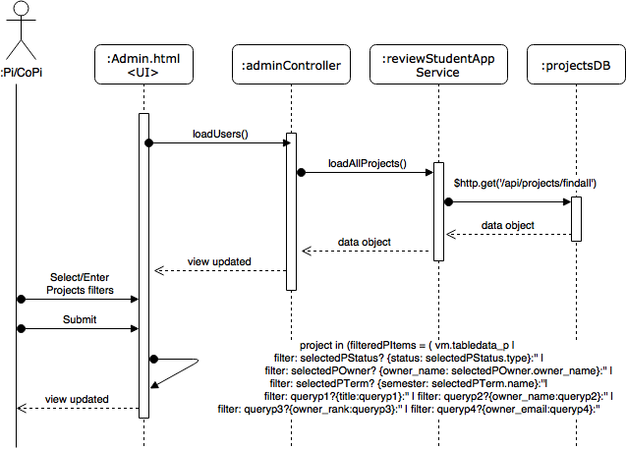](https://www.draw.io/#G1Vzj0lN-Z5MN8lrXeHFS7UX9tnuijTj9B)

Figure 34: 1176 - Filtering Projects

[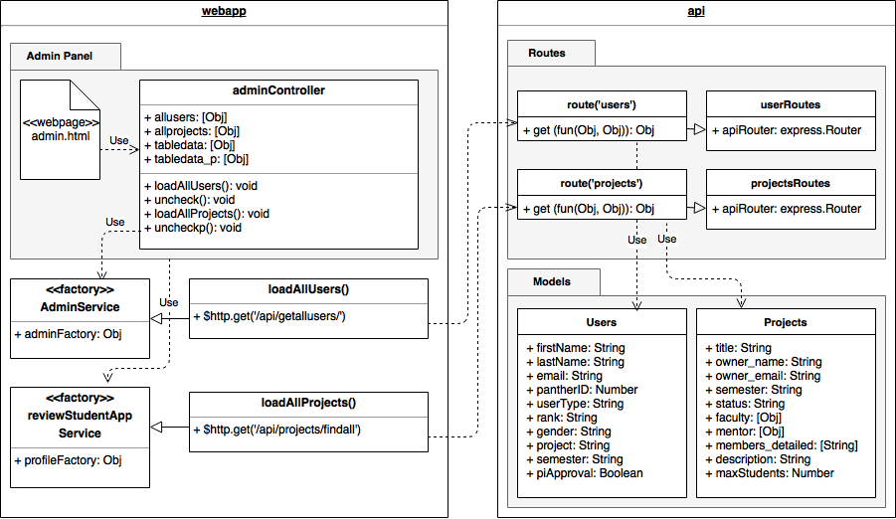](https://www.draw.io/#G1MF3Nzt9VoVCd4coUzzbeCj7daQWpLBxW)

Figure 35: 1176 - Class Diagram

[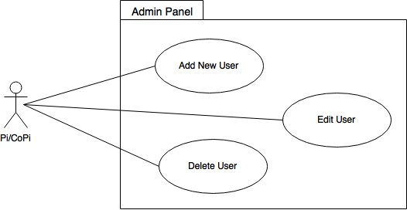](https://www.draw.io/#G0B_dj3TRYcWPad2xzY3ZEMFlIOXc)

Figure 36: 1300 - Use Case Diagram

[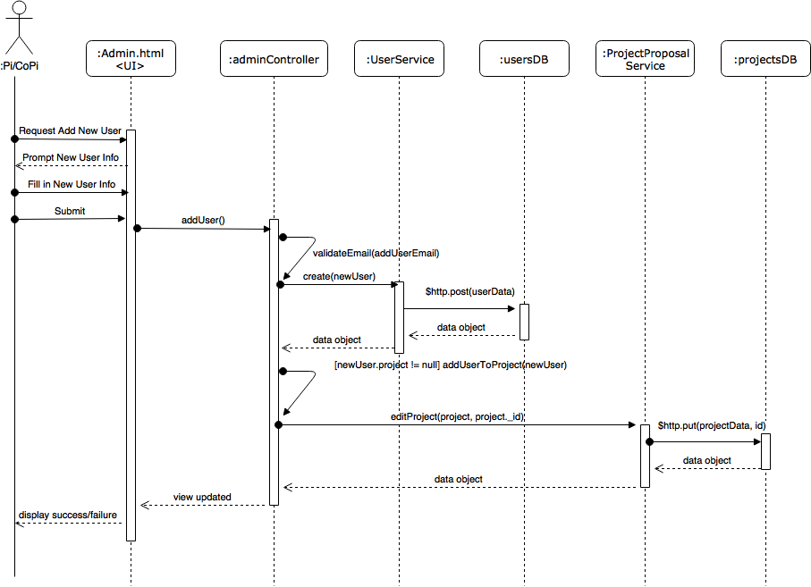](https://www.draw.io/#G0B_dj3TRYcWPadTFrbEMwWGJBT28)

Figure 37: 1300 - Add New User

[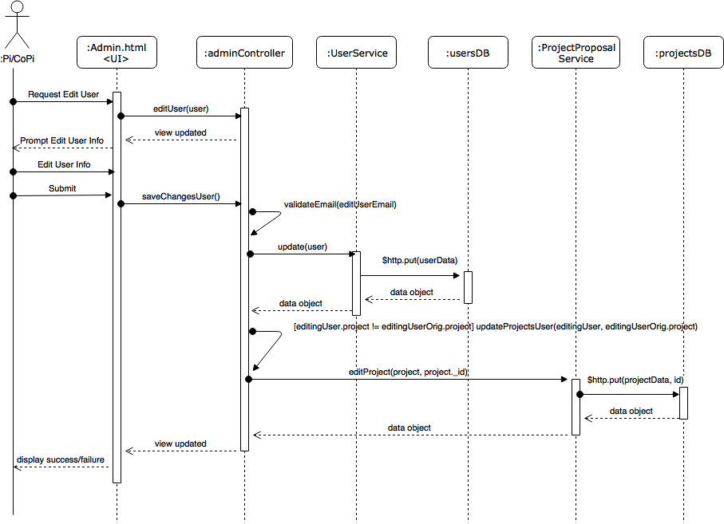](https://www.draw.io/#G0B_dj3TRYcWPaYzRzM0h2eUlQTE0)

Figure 38: 1300 - Edit User

[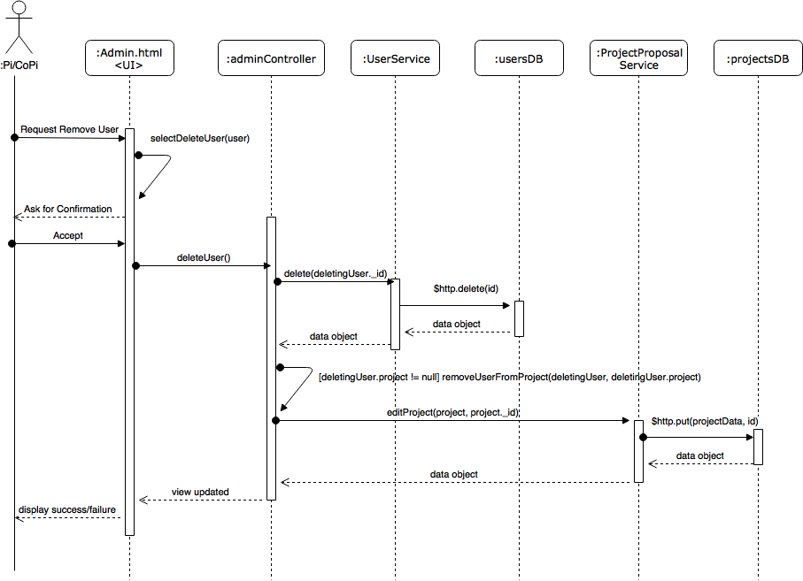](https://www.draw.io/#G0B_dj3TRYcWPacEpoTl9WcjA5dkk)

Figure 39: 1300 - Remove User

[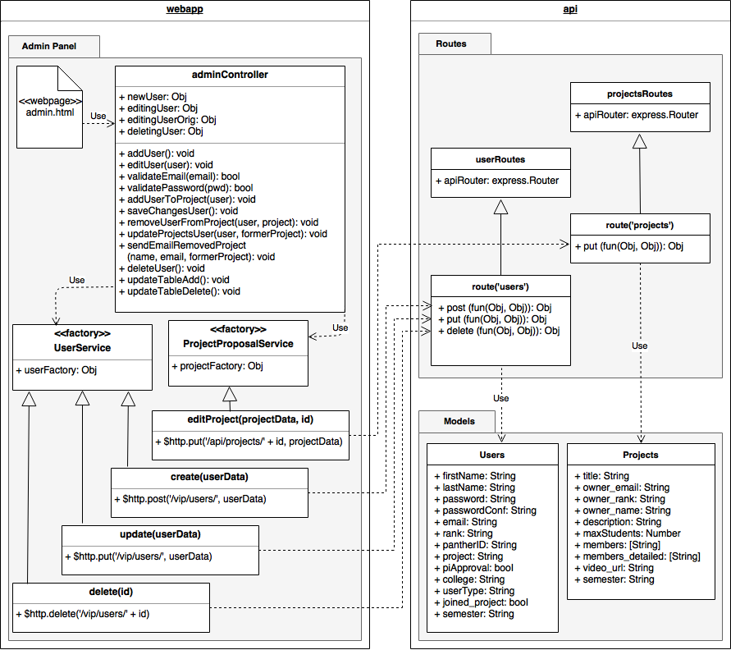](https://www.draw.io/#G0B_dj3TRYcWPac3RQQWx1NHFtejg)

Figure 40: 1300 - Class Diagram

[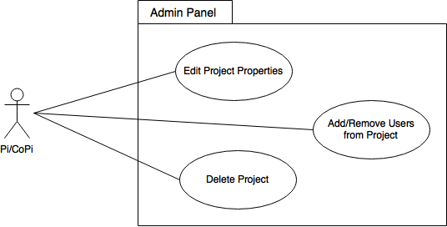](https://www.draw.io/#G0B_dj3TRYcWPaNm9yNmpsRVRvZjQ)

Figure 41: 1313 - Use Case Diagram

[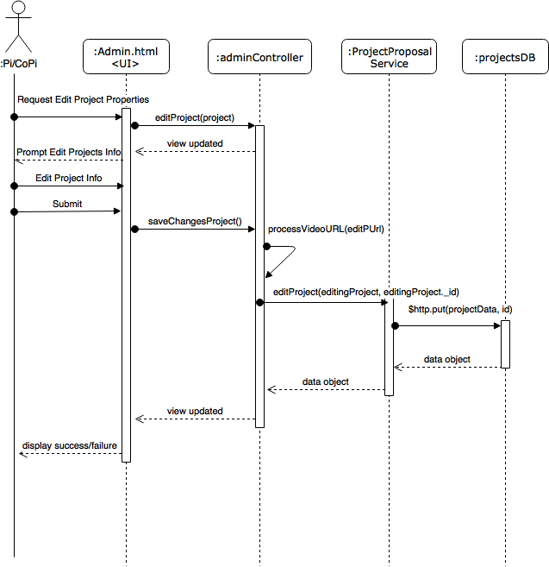](https://www.draw.io/#G0B_dj3TRYcWPaTEt4dWQzeDR3cDg)

Figure 42: 1313 - Edit Project Properties

[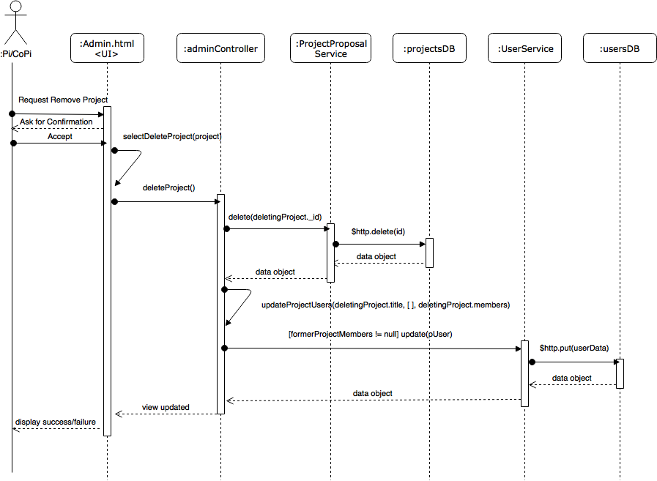](https://www.draw.io/#G0B_dj3TRYcWPaXzR3UFBxQU9FQkk)Figure 43: 1313 - Remove Project[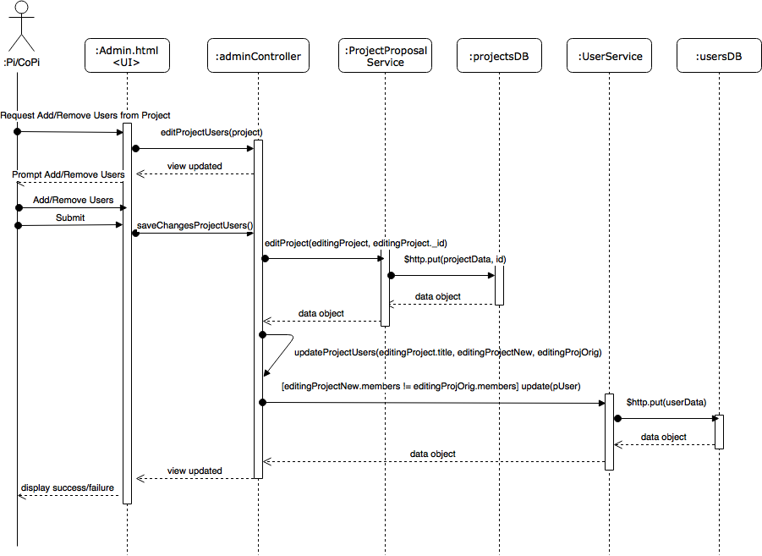](https://www.draw.io/#G0B_dj3TRYcWPaYlBaTy1DSU9Sa1U)

Figure 44: 1313 - Add/Remove Users from Project

[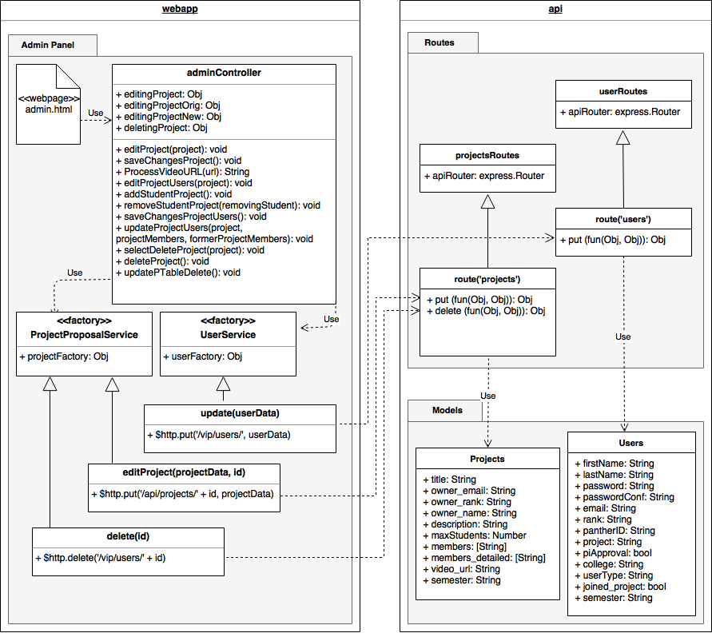](https://www.draw.io/#G0B_dj3TRYcWPaVXNGTUQzZzdwb3M)

Figure 45: 1313 - Class Diagram

[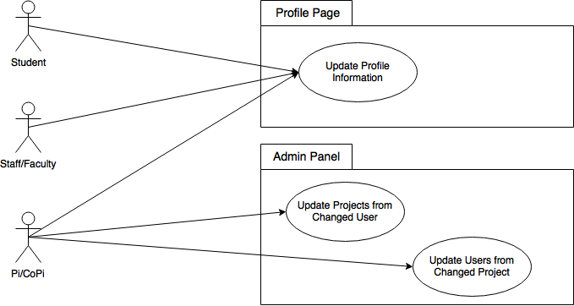](https://www.draw.io/#G0B_dj3TRYcWPaaUdZQldjZm1NcFk)

Figure 46: 1328 - Use Case Diagram

[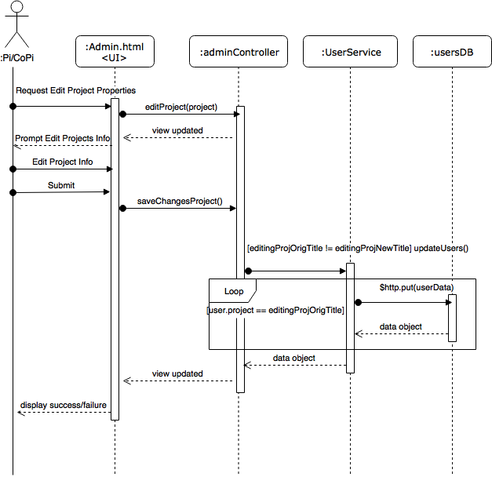](https://www.draw.io/#G0B_dj3TRYcWPaZUlMUjFBQjB2dkE)Figure 47: 1328 - Update Users from Changed Project[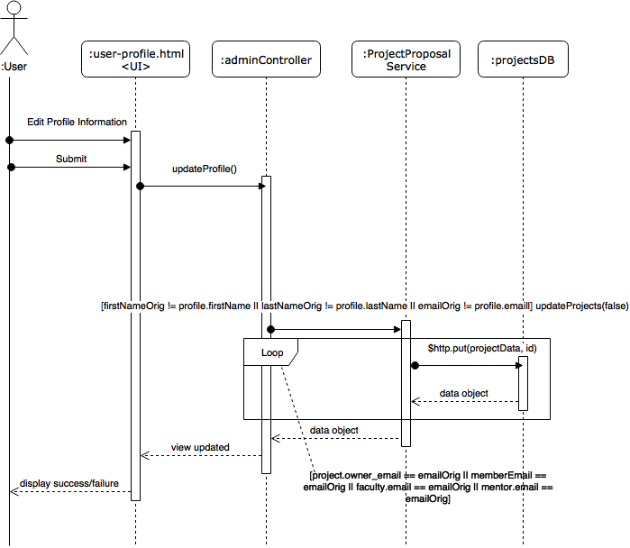](https://www.draw.io/#G0B_dj3TRYcWPacVdTVkllTjdoRGM)

Figure 47: 1328 - Update Profile Information

[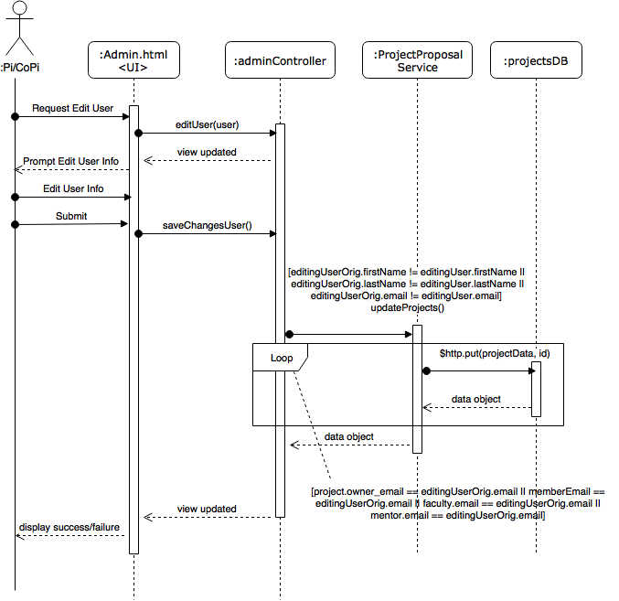](https://www.draw.io/#G0B_dj3TRYcWPab1BjVG5BdkVLTlE)

Figure 47: 1328 - Update Projects from Changed User

[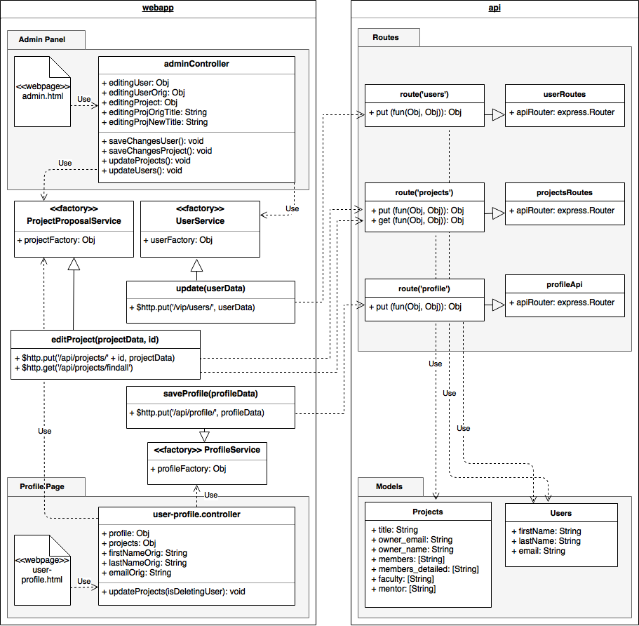](https://www.draw.io/#G0B_dj3TRYcWPabkQyLWFkek11RXc)

Figure 47: 1328 - Class Diagram

[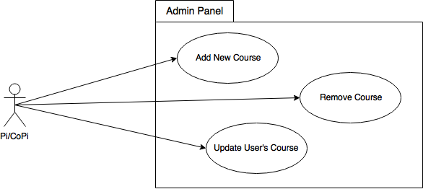](https://www.draw.io/#G0B_dj3TRYcWPaTjlvWjNWZ1RPZzQ)

Figure 48: 1345 - Use Case Diagram

[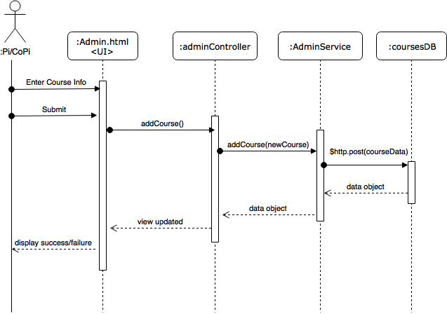](https://www.draw.io/#G0B_dj3TRYcWPaU19uU3lwMjFqY2c)

Figure 49: 1345 - Admin Adds a Course

[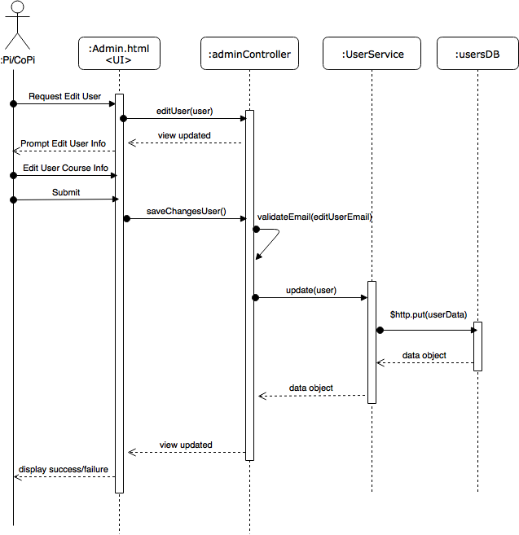](https://www.draw.io/#G0B_dj3TRYcWPaSHhDa1dFdDIzZ3M)

Figure 50: 1345 - Admin updates a User’s course

[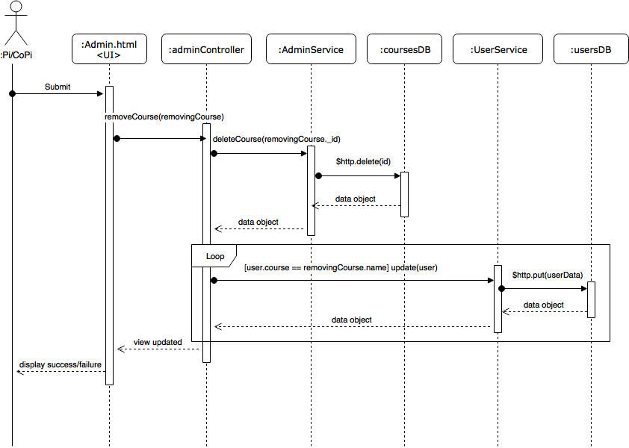](https://www.draw.io/#G0B_dj3TRYcWPaMDJTYzBLTjZHVEk)

Figure 51: 1345 - Admin Removes a course

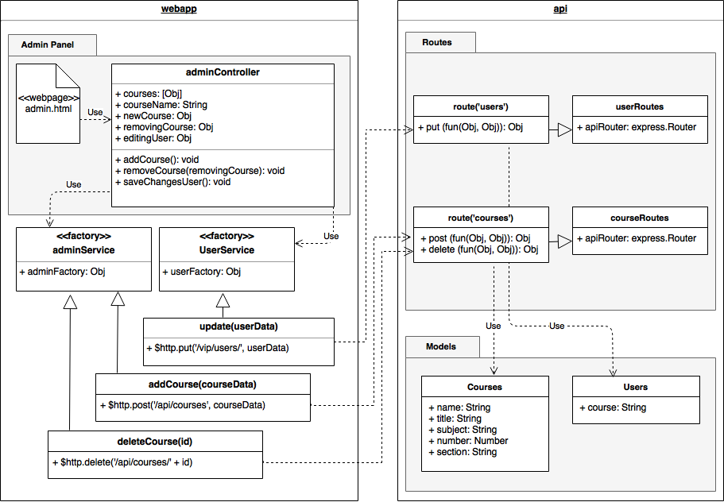

Figure 52: 1345 - Class Diagram

[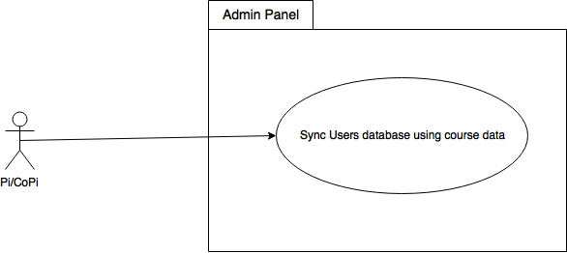](https://www.draw.io/#G10vE1lOvgPZrUlPJaTtL1ool5xidzkgo3)

Figure 53: 1346 - Use Case Diagram

[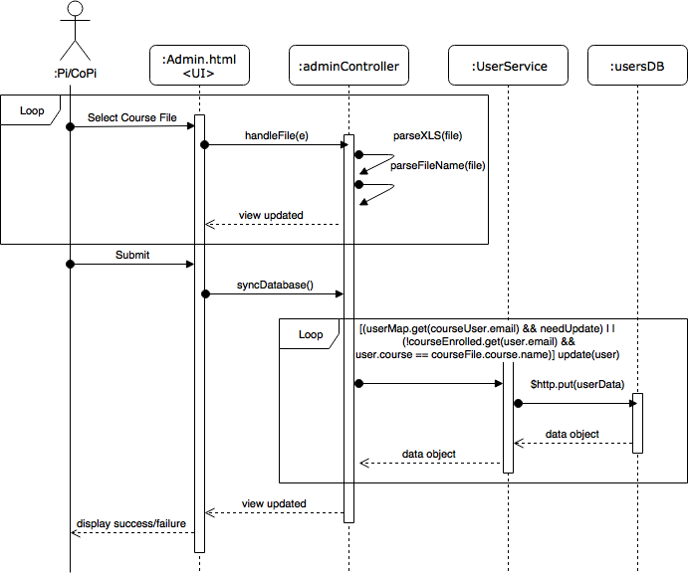](https://www.draw.io/#G1LGqA45Tw3OtN-hUNVMWO6Eou3HZYzQcD)

Figure 54: 1346 - Admin syncs Users database using course data

[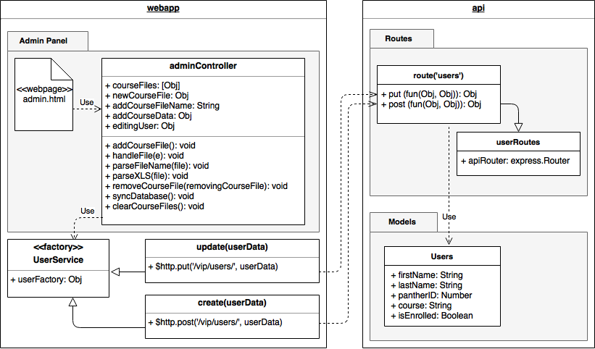](https://www.draw.io/#G184Kc86YfgjuN0onBF6FfxusfqQ3YeoyN)

Figure 55: 1346 - Class Diagram

[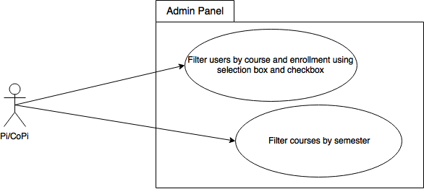](https://www.draw.io/#G1A3T_GzGbpzyGI7twLten1HVCT4vOWIRO)

Figure 56: 1352 - Use Case Diagram

[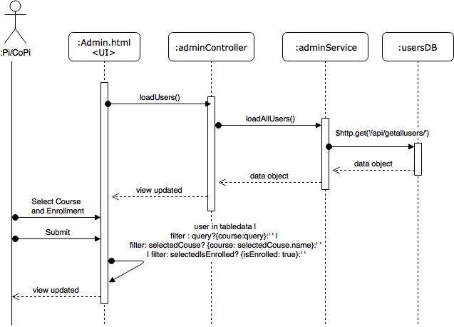](https://www.draw.io/#G1w6RZ2wMejkcs62p1-rgAMII7WncNGXNS)

Figure 57: 1352 - Filtering Users by Courses

[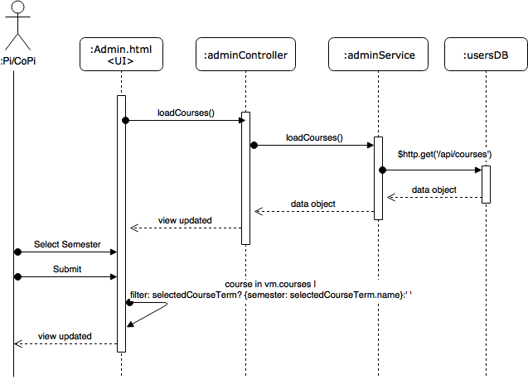](https://www.draw.io/#G1n1vxvzIidMxgi7uBtfFj4kgGYo2cQBZR)

Figure 58: 1352 - Filter Courses by Semester

[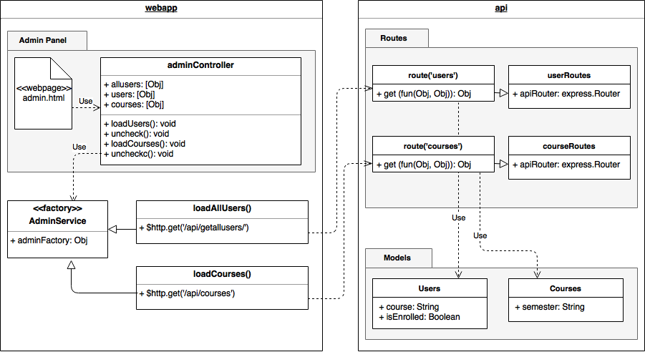](https://www.draw.io/#G1dj_mSQo-ttUkoAJk8YE7Ea3MDW5FwWfZ)

Figure 59: 1352 - Class Diagram

[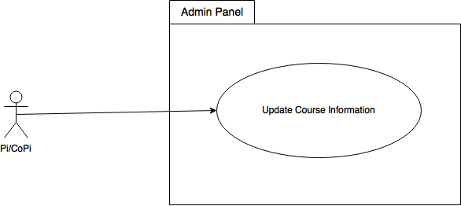](https://www.draw.io/#G1Iu6d9ftXc7acomGzLiwPKhNogy9ATYMY)

Figure 60: 1362 - Use Case Diagram

[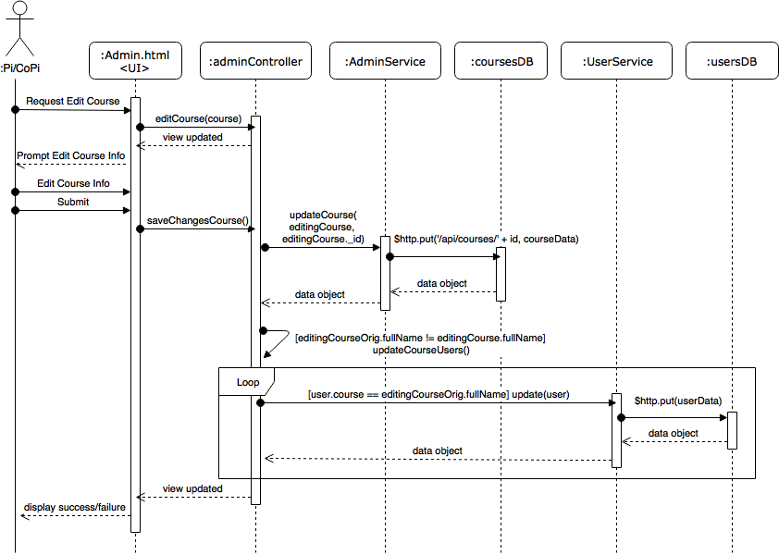](https://www.draw.io/#G1M52kgFYBJ2wPQnzCwo_LhOp_V7IsrHok)

Figure 61: 1362 - Admin updates a course’s information

[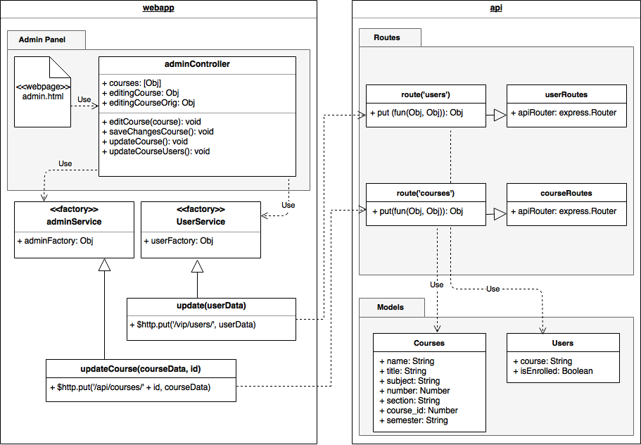](https://www.draw.io/#G1yjocvByRjHBQo_xukgJhoHqdQTFKqqNS)

Figure 62: 1362 - Class Diagram

[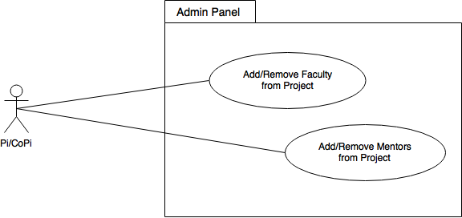](https://www.draw.io/#G1ySqAkKIsAxDyn6i2wqKnn1MyyCvD6KUF)

Figure 63: 1365 - Use Case Diagram

[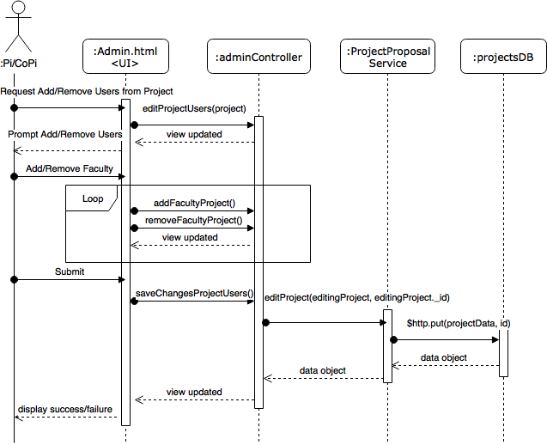](https://www.draw.io/#G1UbtBDDrsLnPOKa4V-Mofj0utKFcJLZNB)

Figure 64: 1365 - Add/Remove Faculty from Project

[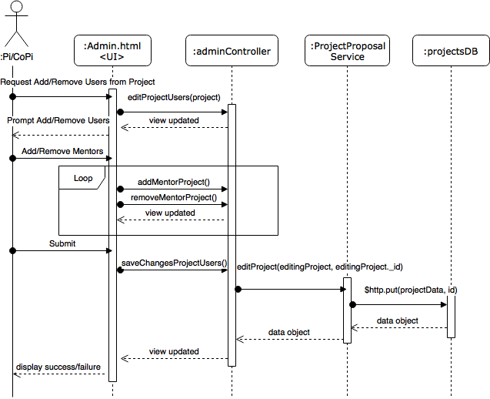](https://www.draw.io/#G1ITcumGCKpKhLAGMZMFK6Gq7X7TXVlLhC)

Figure 65: 1365 - Add/Remove Mentors from Project

[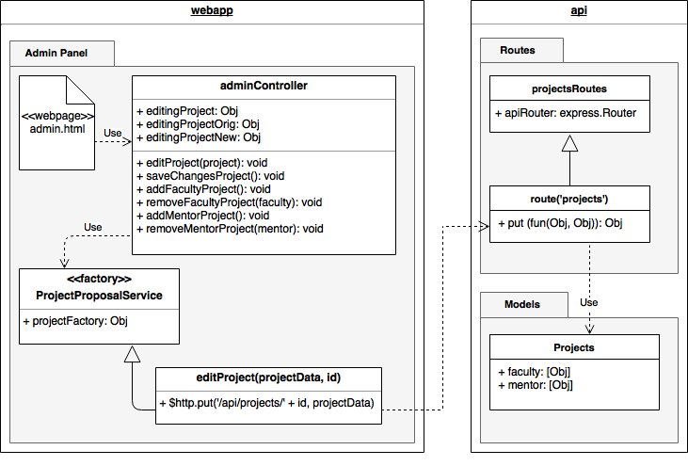](https://www.draw.io/#G1OdYIuLLIZS9eUpfMa3_cbT0AjUVB0urS)

Figure 66: 1365 - Class Diagram

[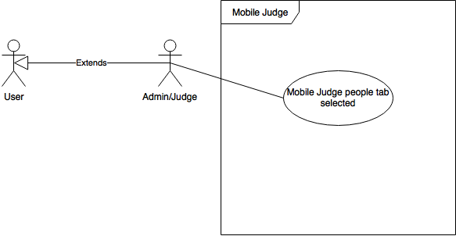](https://www.draw.io/#G1z1NQAAhYUt6VESEl6e1FmJGBjGG6HDjs)

Figure 67: 1355 Use Case Diagram

[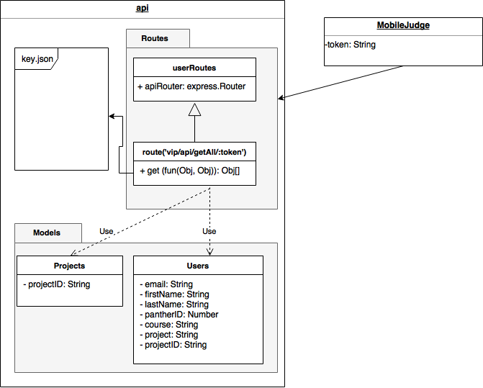](https://www.draw.io/#G1JbqwTUH9i5q655juKQsF8S_BdY34ArpQ)

Figure 68: 1355 Class Diagram

[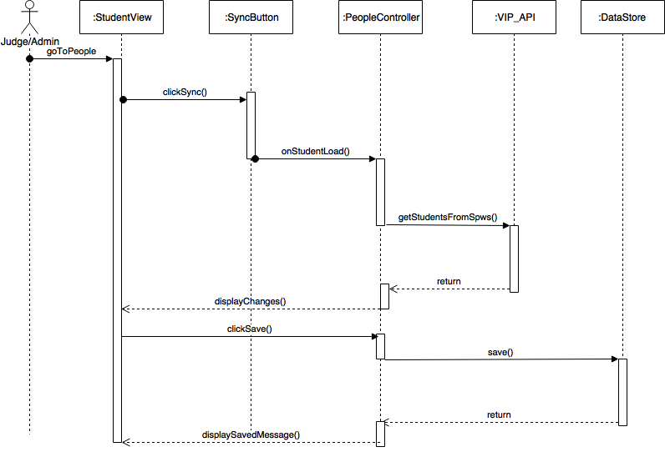](https://www.draw.io/#G1WCVzoGJPwwk0NW07o6qdO13RUaOLE5RW)

Figure 69: 1355 Sequence Diagram

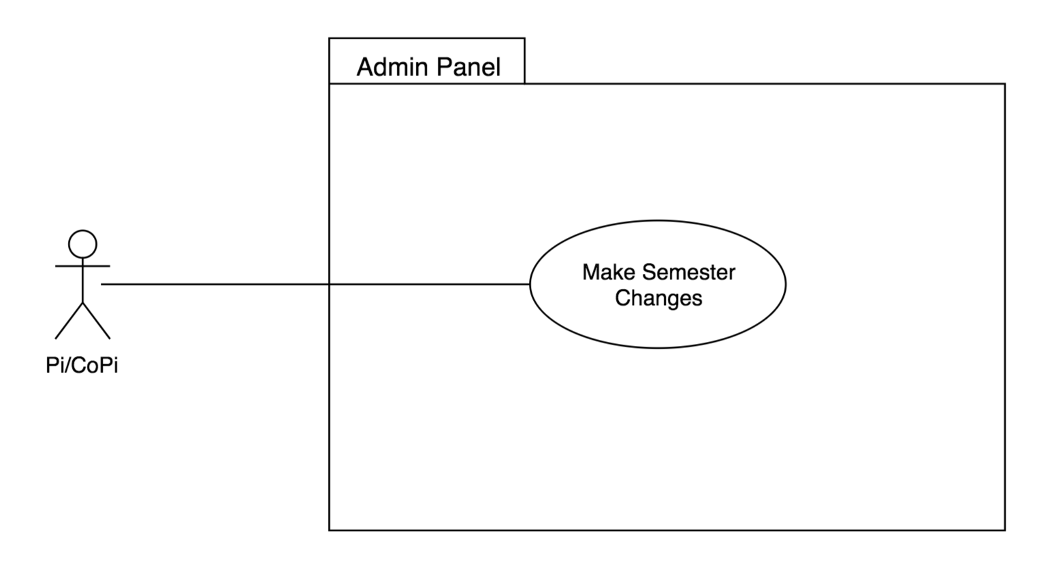

Figure 70: 1298 Use Case Diagram

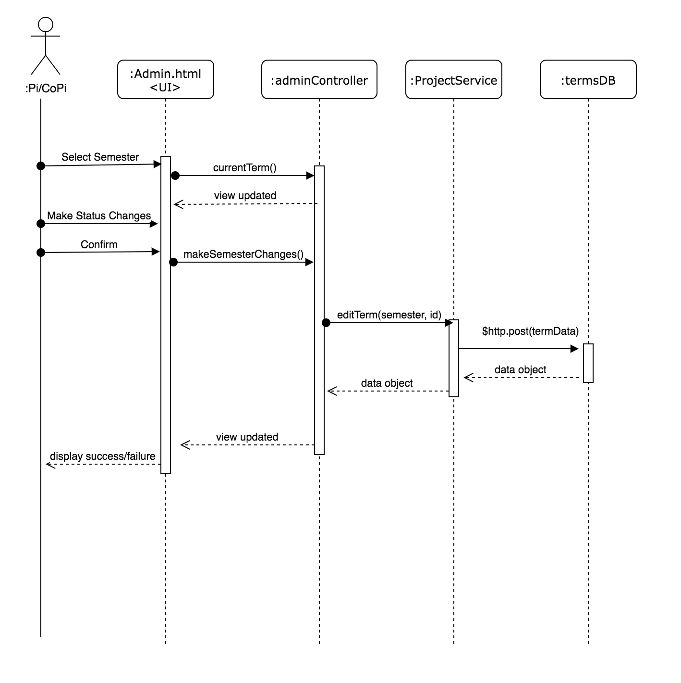

Figure 71: 1298 Sequence Diagram

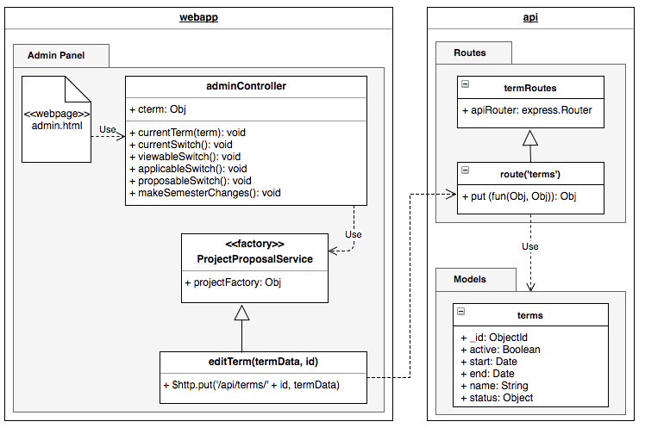

FIgure 72: 1298 Class Diagram

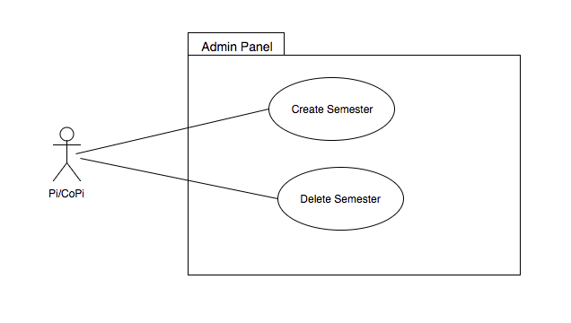

FIgure 73: 1302 Use Case Diagram

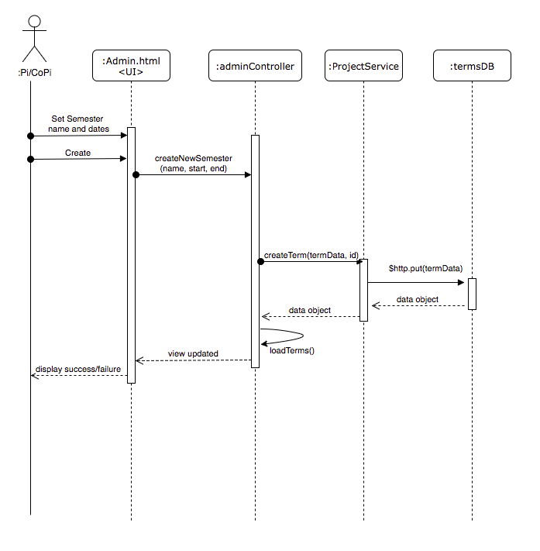

Figure 74: 1302 Sequence Diagram (Add Semester)

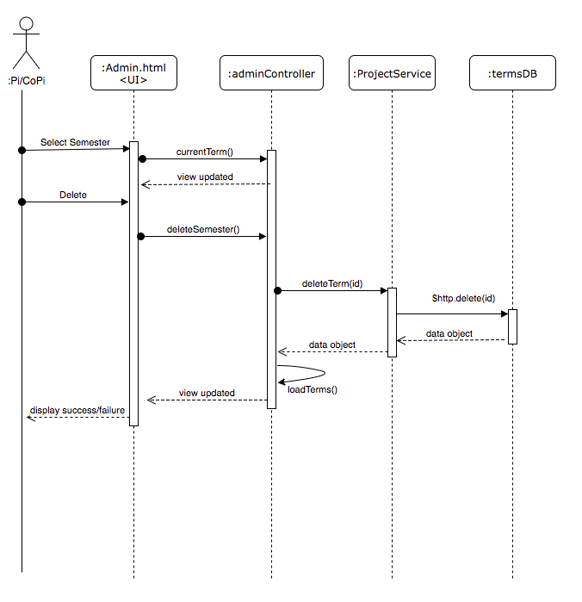

Figure 75: 1302 Sequence Diagram(Delete Semester)

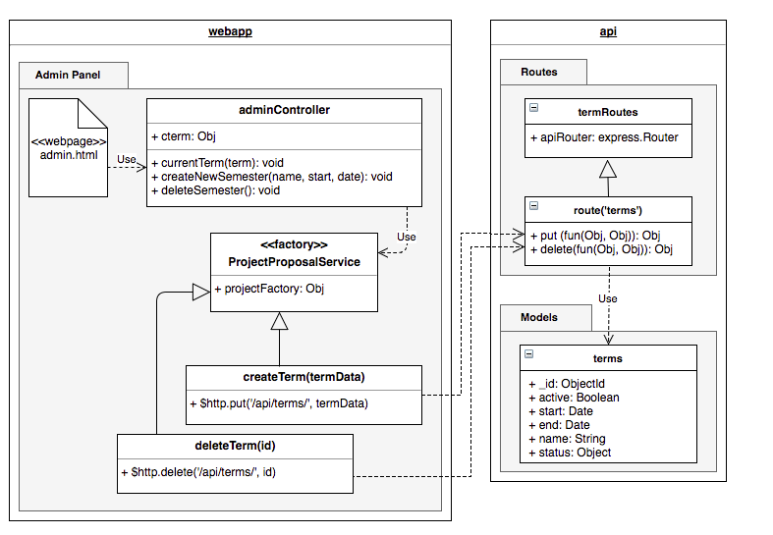

Figure 76: 1302 Class Diagram

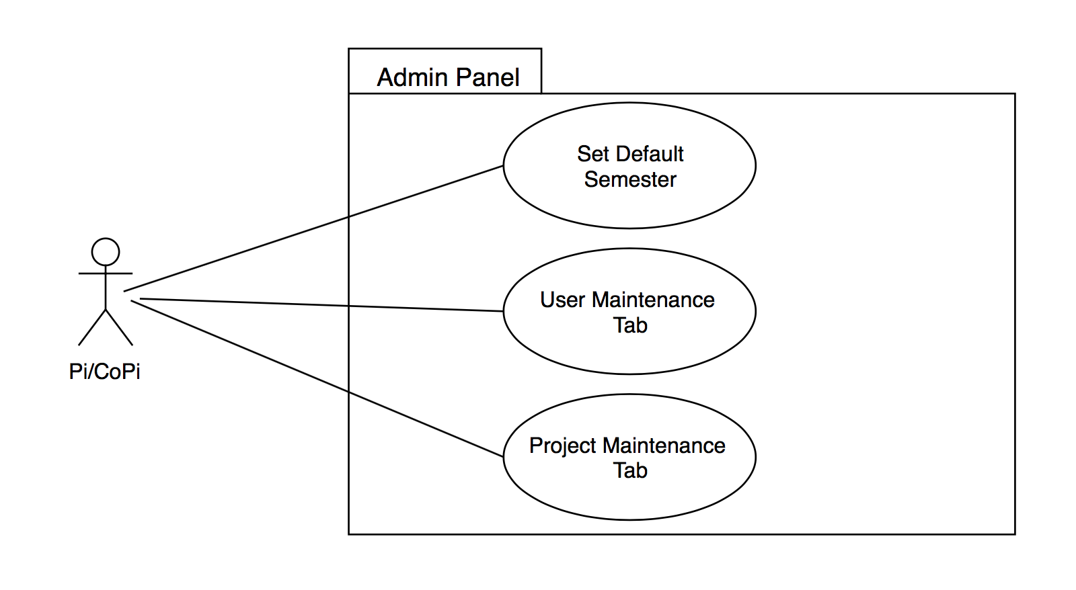

Figure 77: 1360 Use Case Diagram

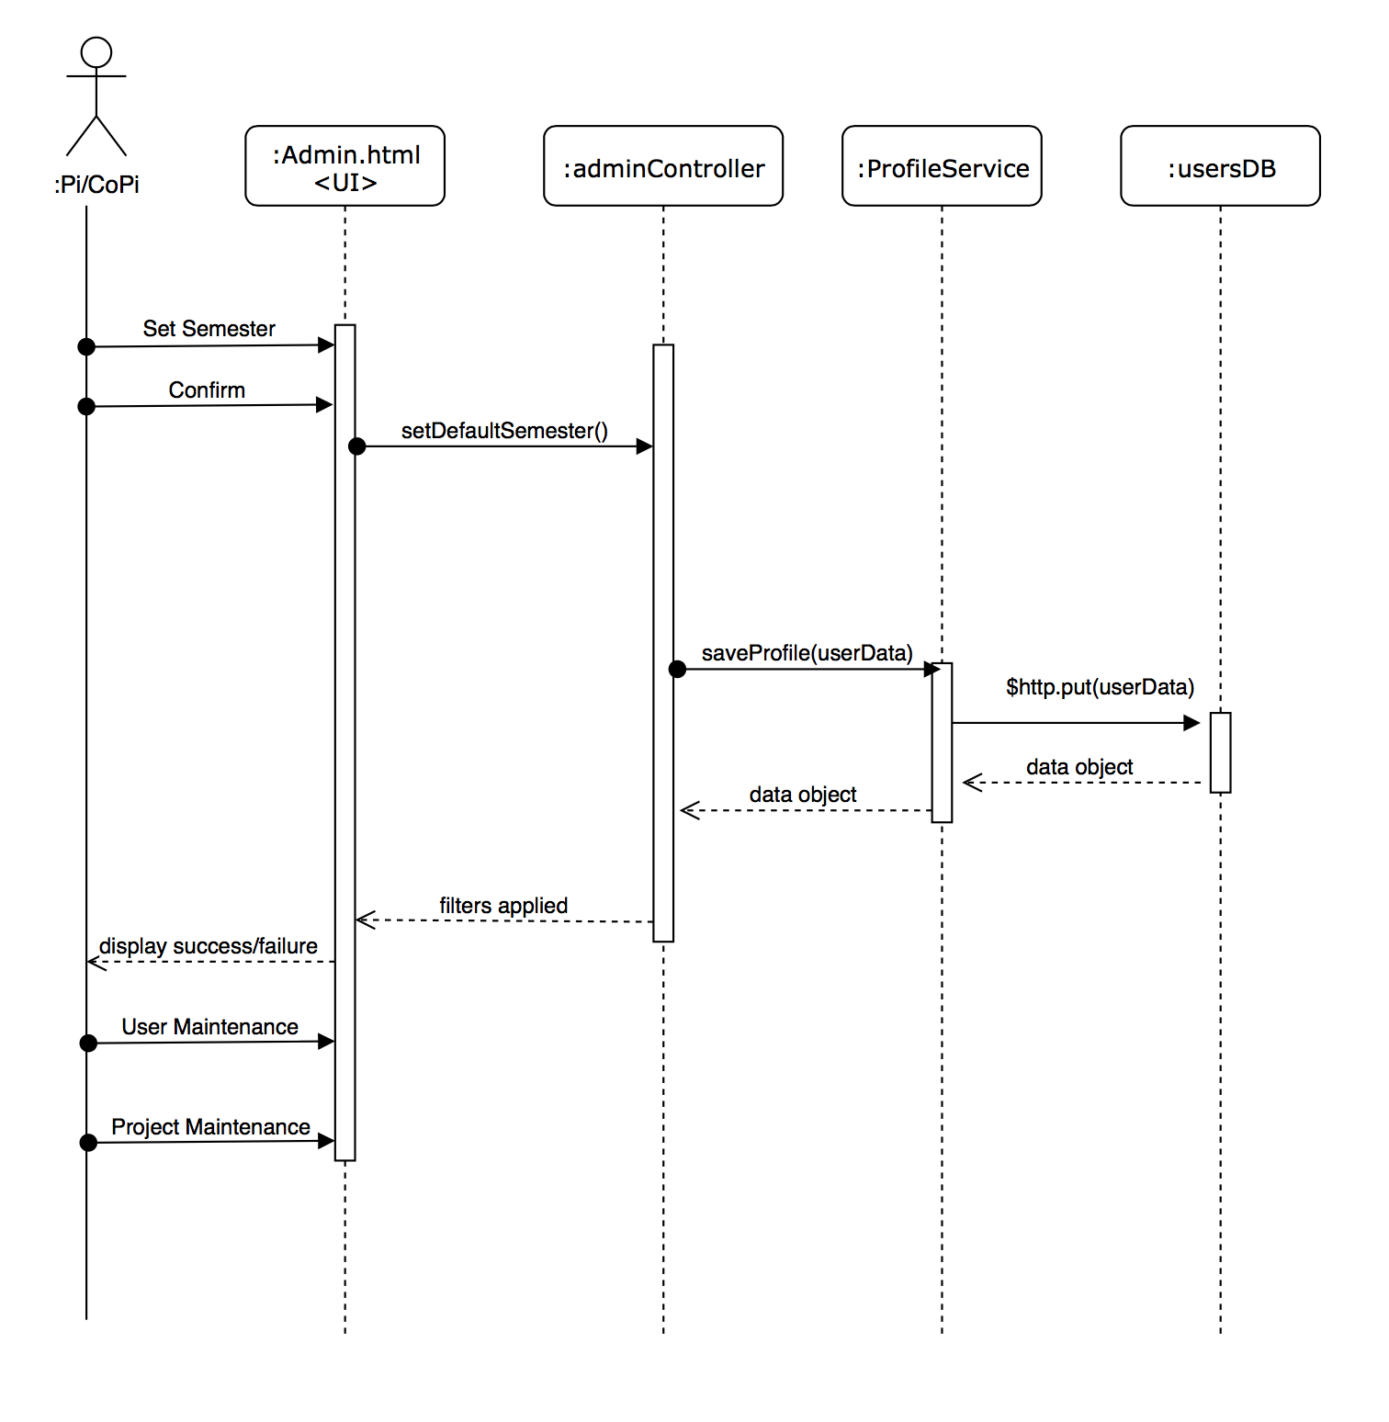

Figure 78: 1360 Sequence Diagram

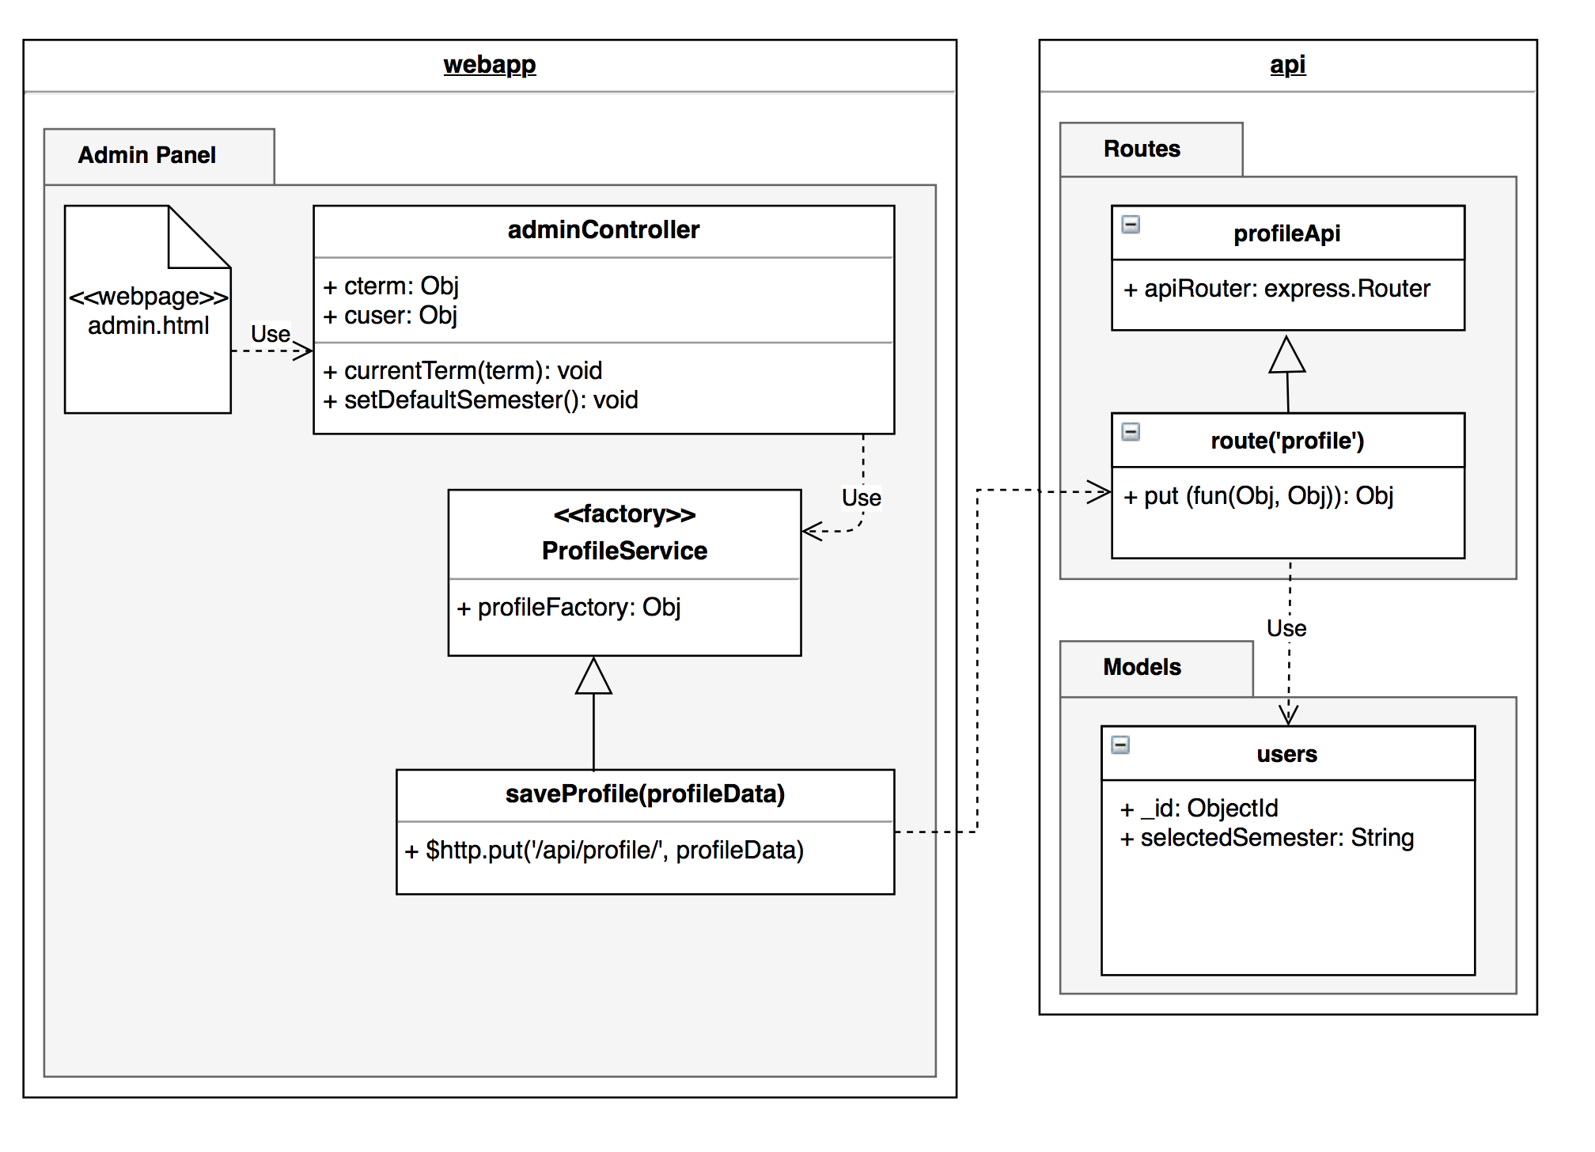

Figure 79: 1360 Class Diagram

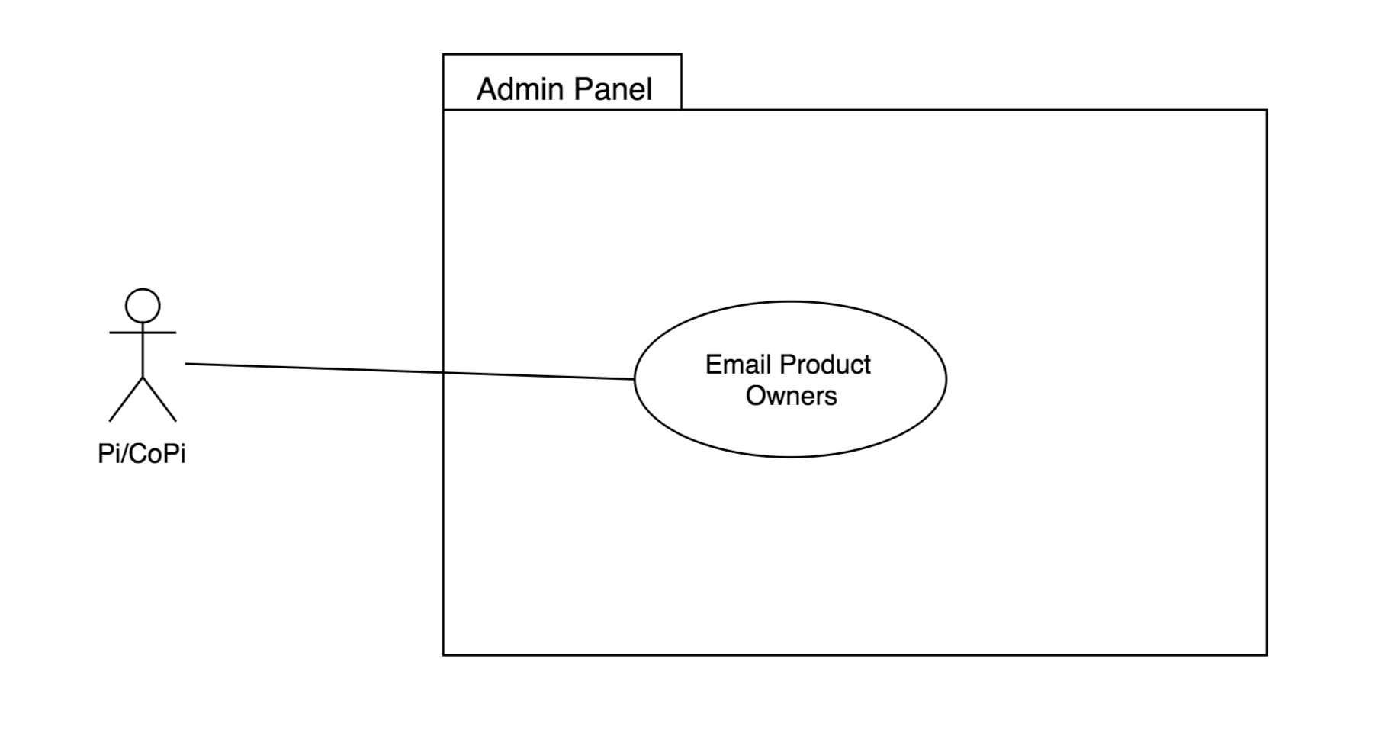

Figure 80: 1371 Use Case Diagram

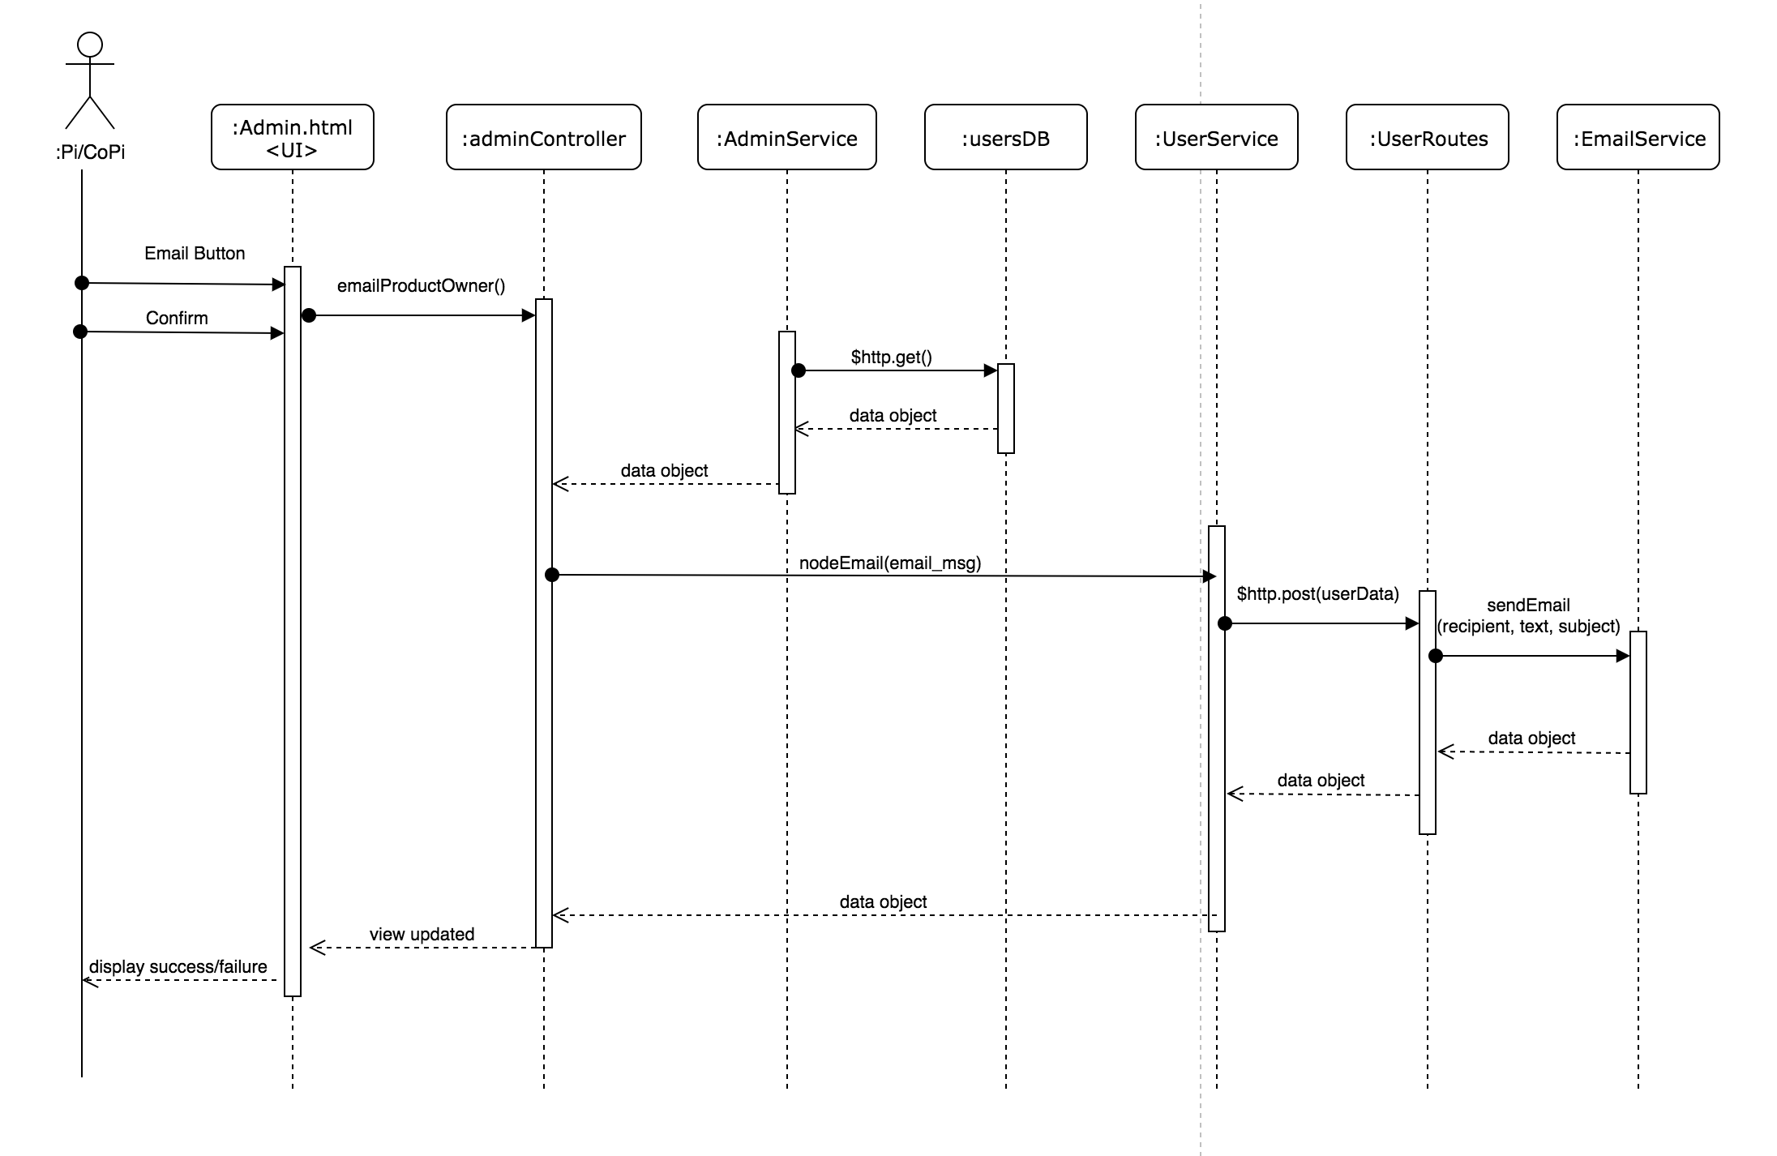

Figure 81: Sequence Diagram

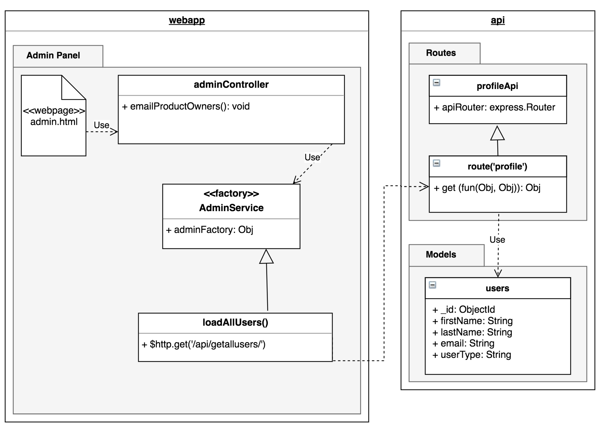

Figure 82: Class Diagram

# Appendix B - User Interface Design

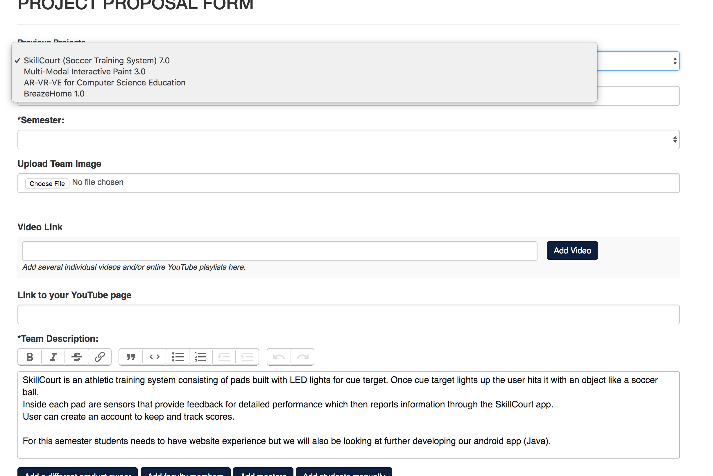

User story #1305

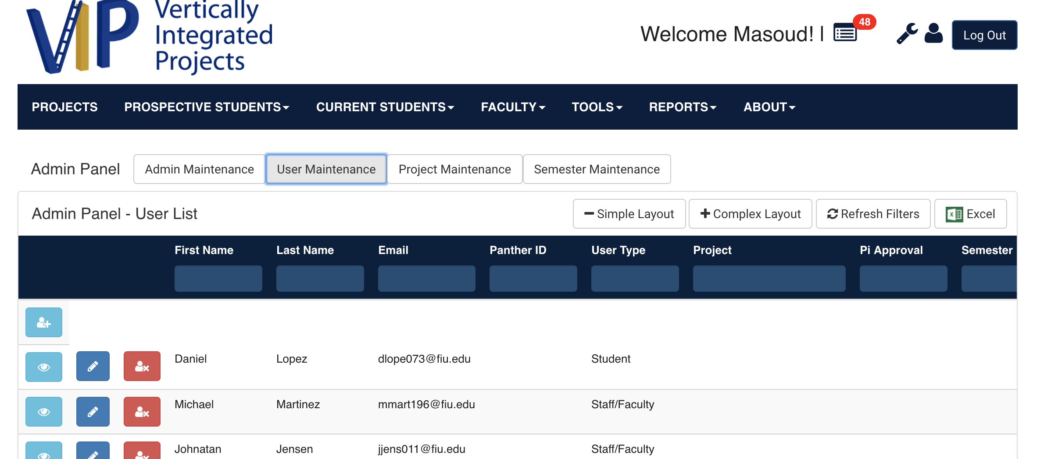

User story #1314

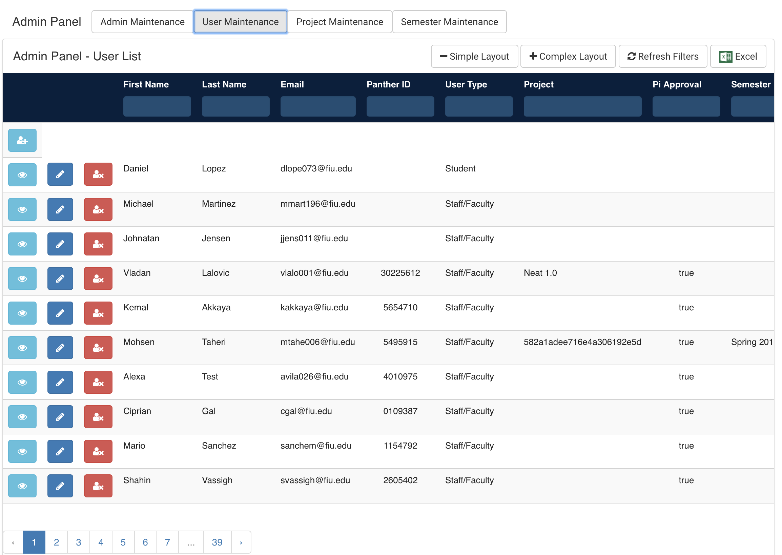

1322

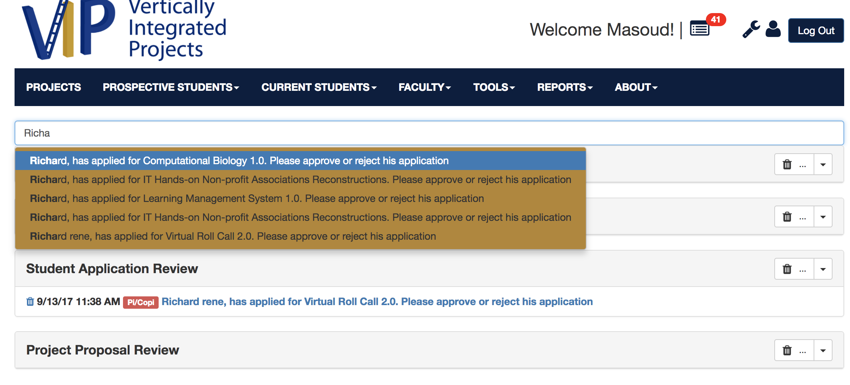

1332

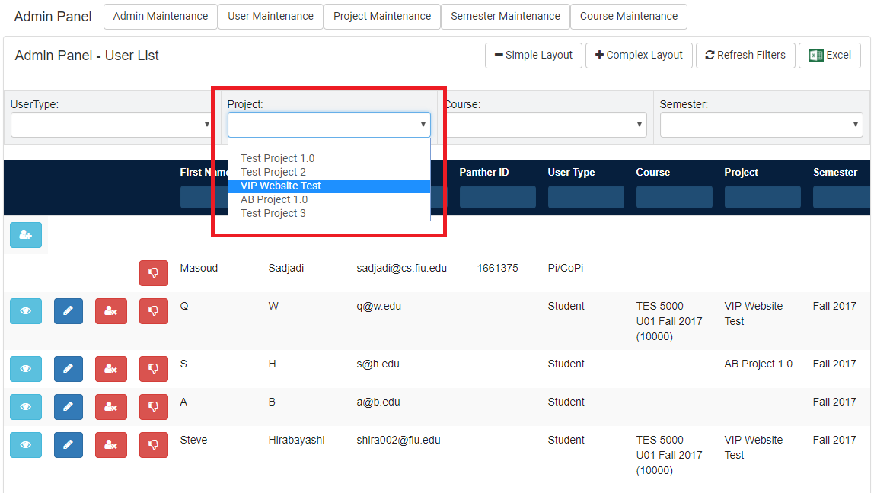

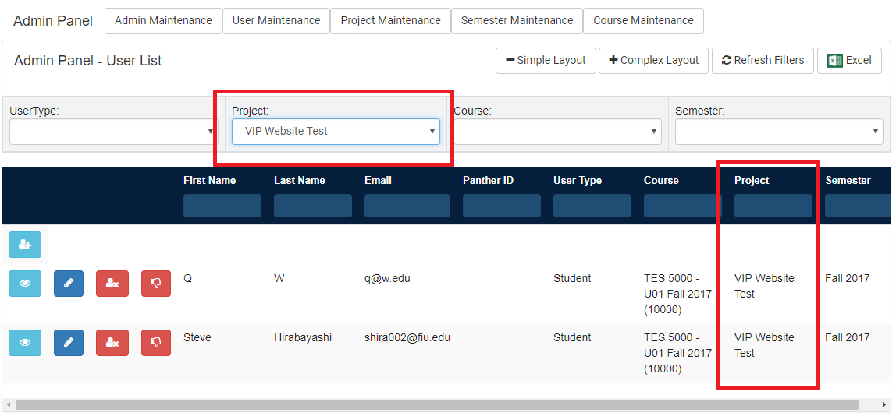

User Story #1176 - Filtering Users

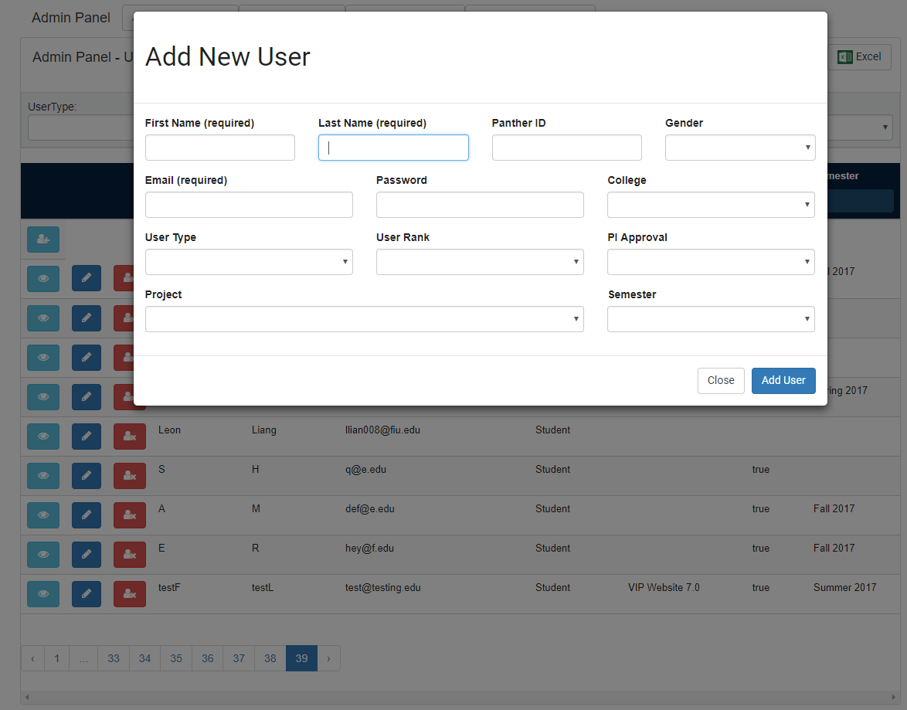

User Story #1300 - Add New Users

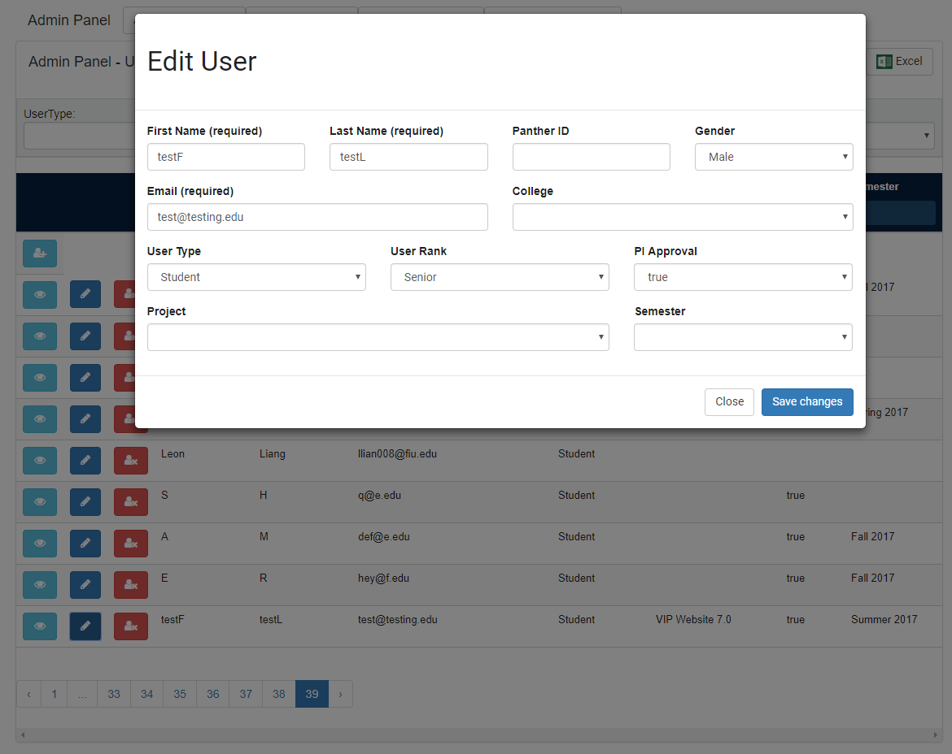

User Story #1300 - Edit Users

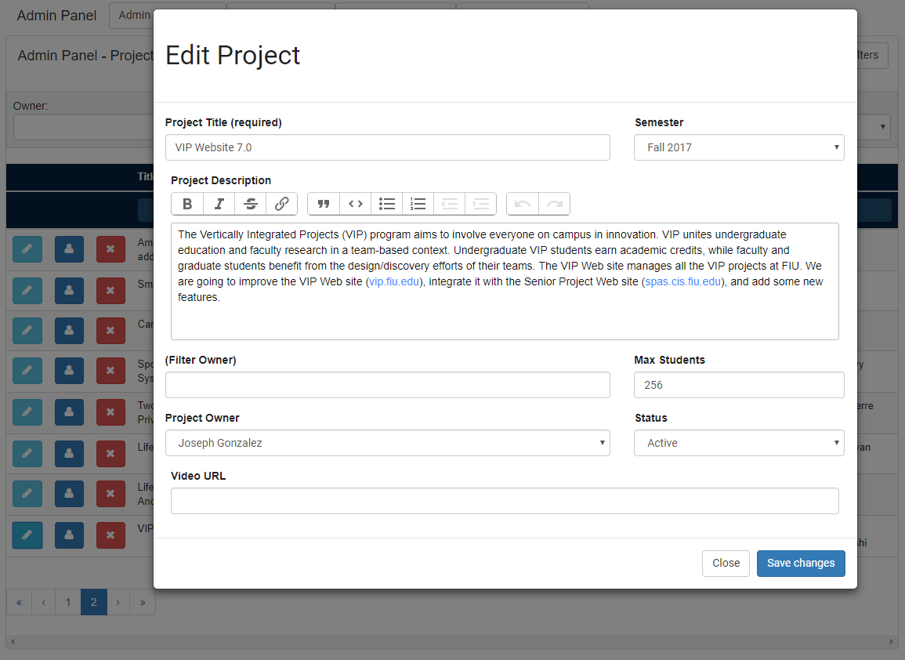

User Story #1313 - Edit Project Properties

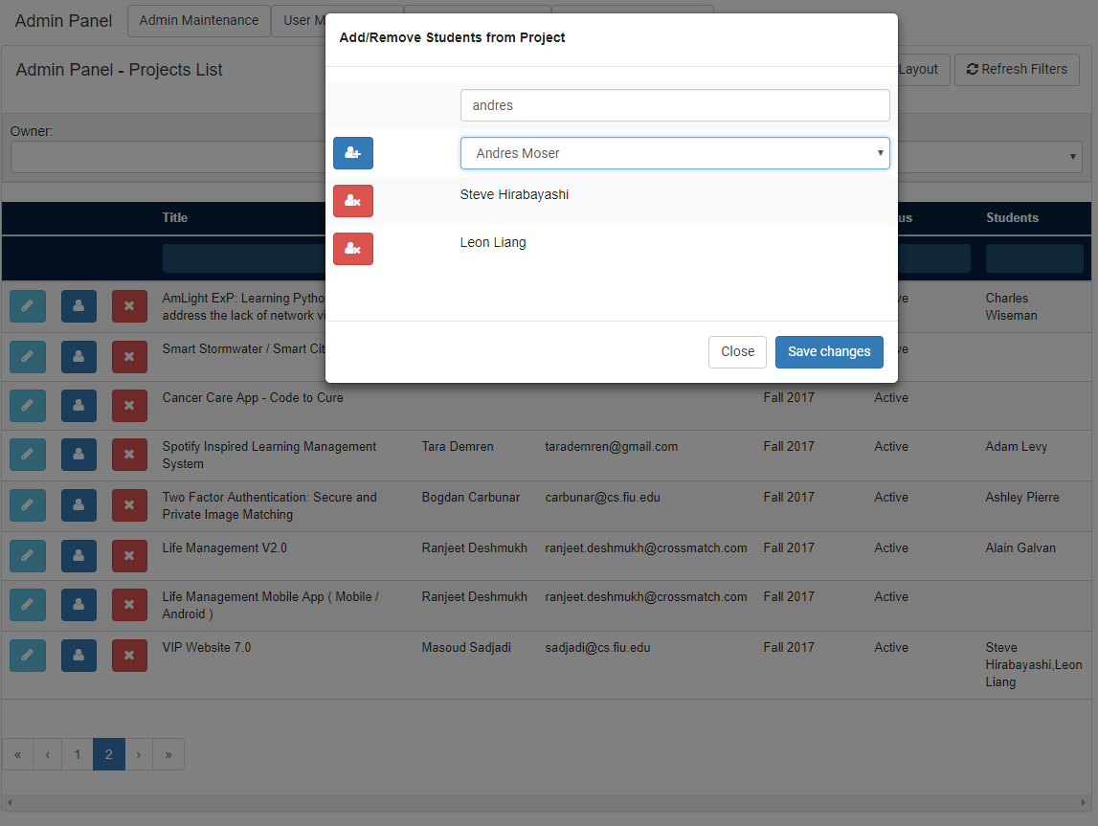

User Story #1313 - Edit Project Users

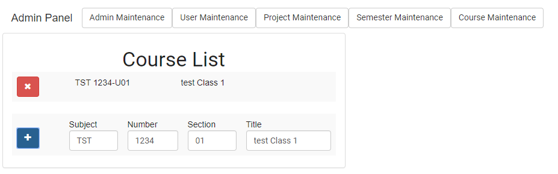

User Story #1345 - Add/Remove Courses

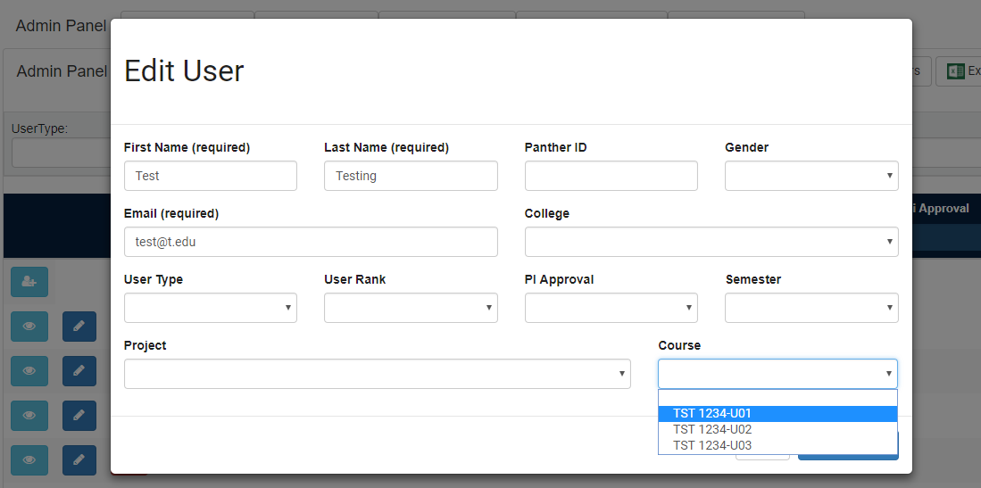

User Story #1345 - Edit User’s Course

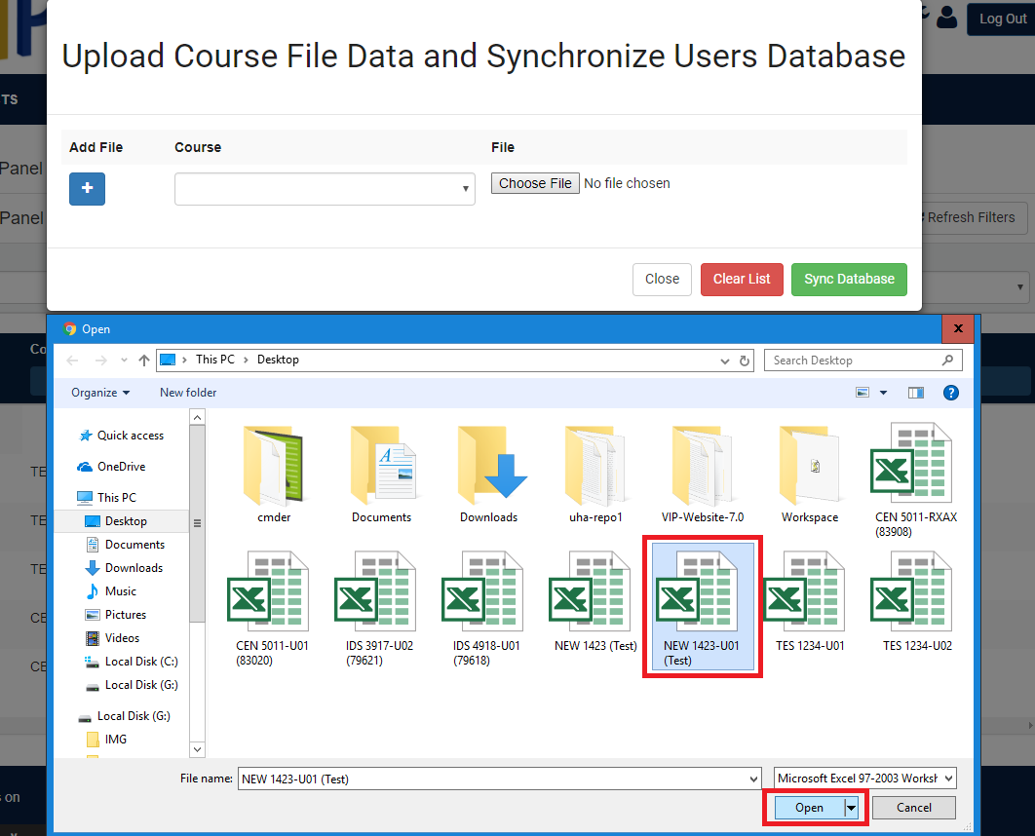

User Story #1346 - Synchronize Users Database with Panthersoft Data

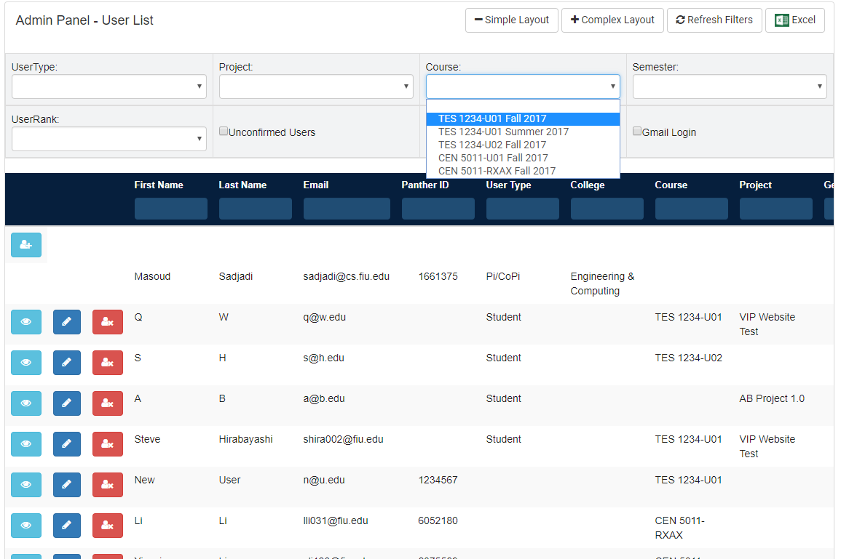

User Story #1352 - Filtering Users by Course

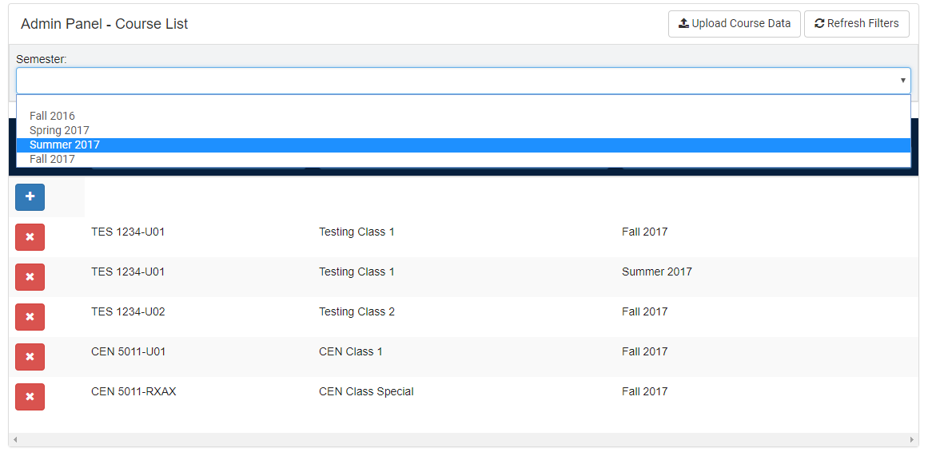

User Story #1352 - Filtering Courses by Semester

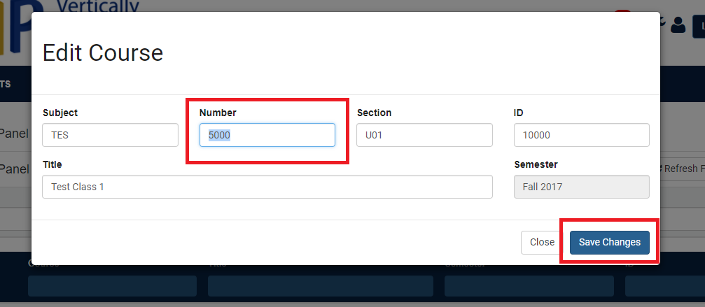

User Story #1362 - Editing Course

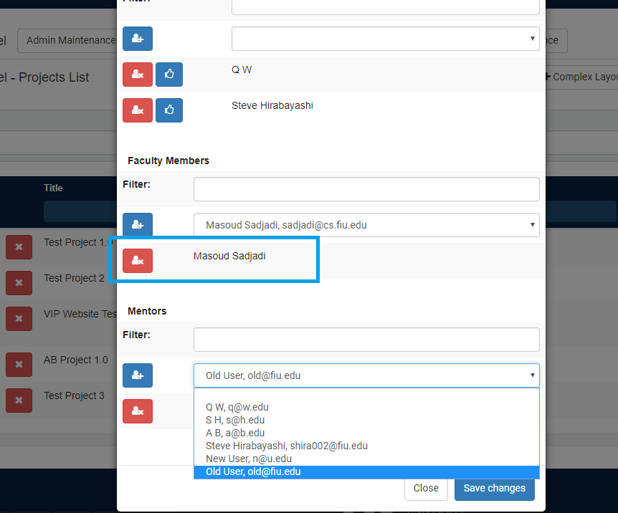

User Story #1365 - Add/Remove Faculty and Mentors from Project

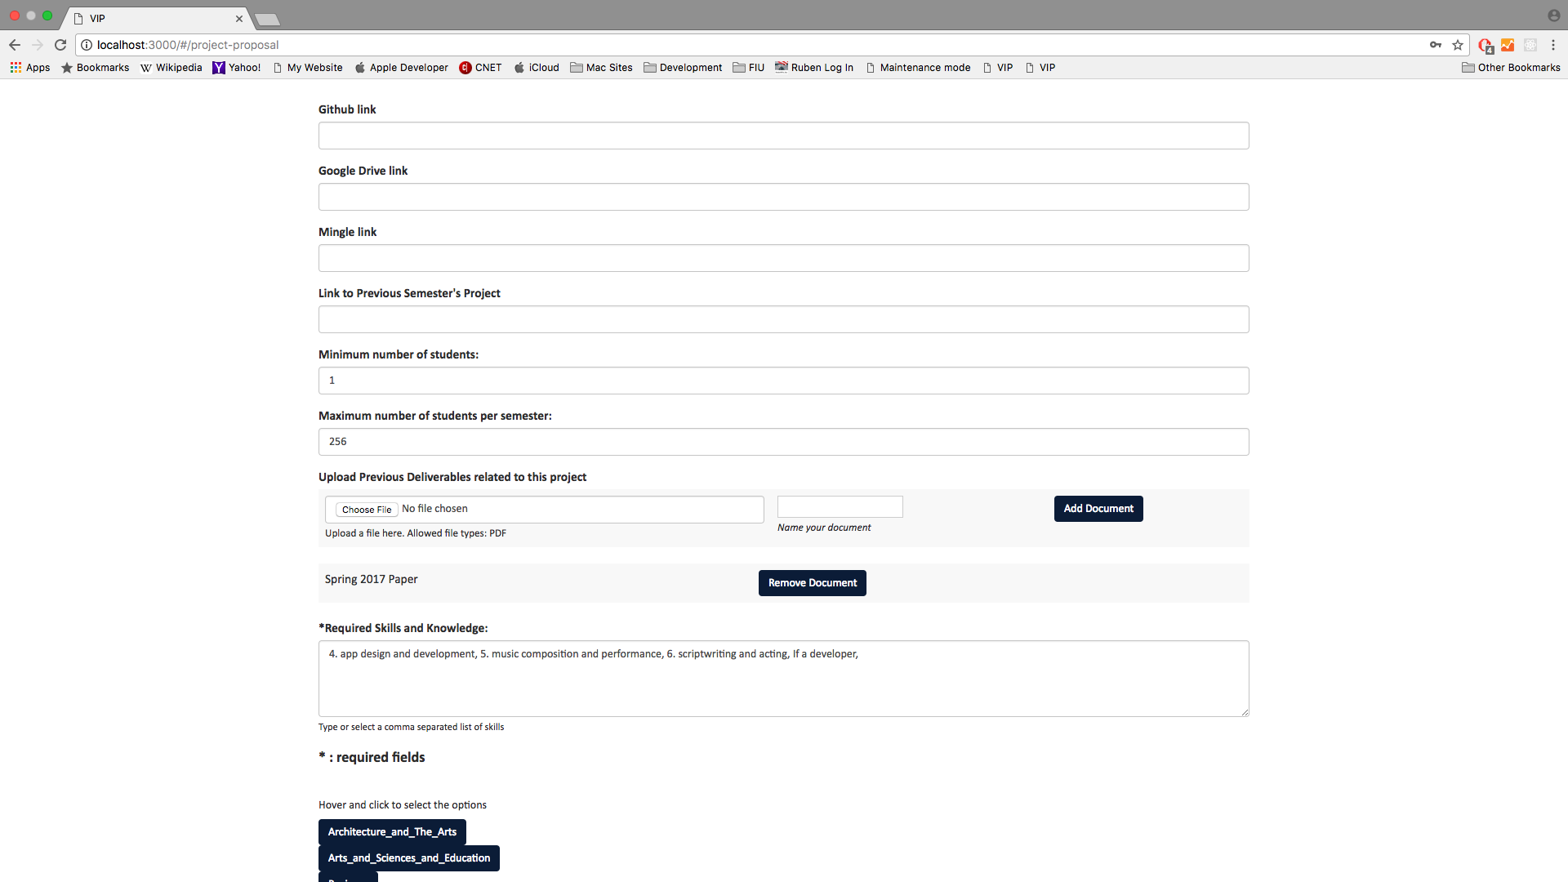

User Story #1364 - Add/Remove Previous Deliverables from Project

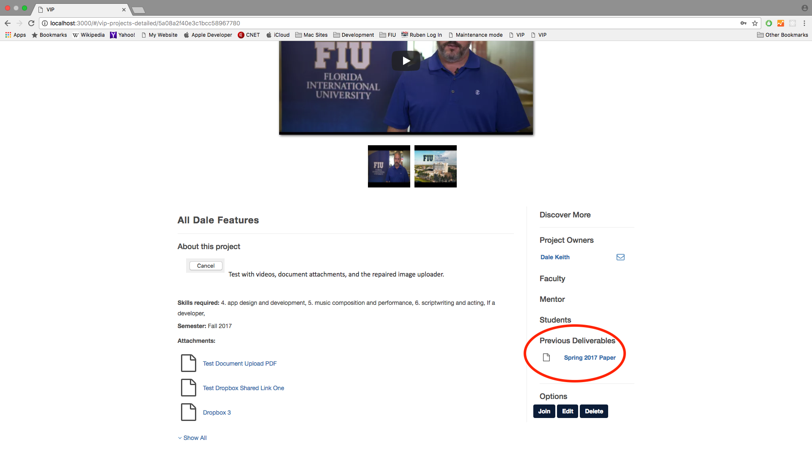

User Story #1364 - Previous Deliverables on the Project Details Page

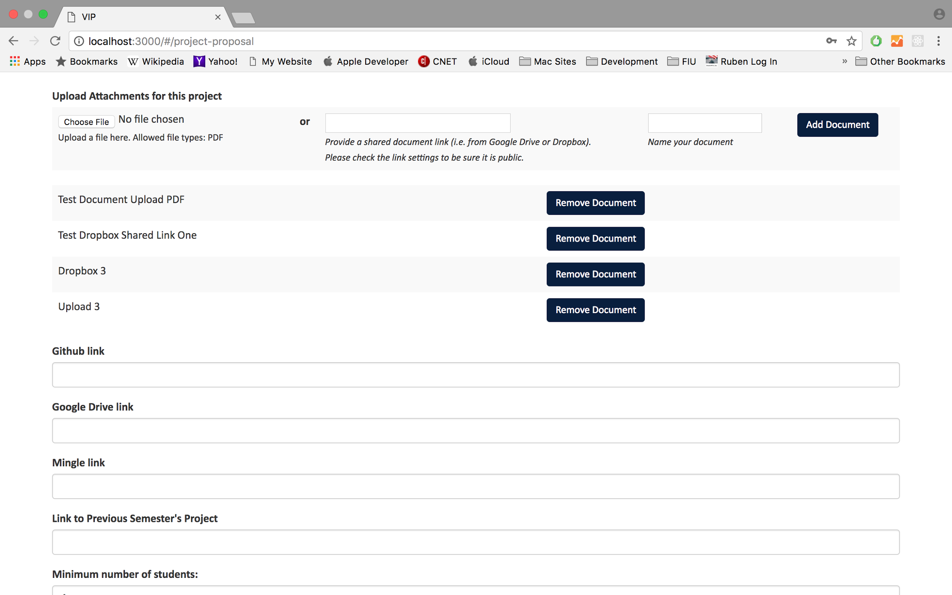

User Story #1331 - Add/Remove Attachments from Project

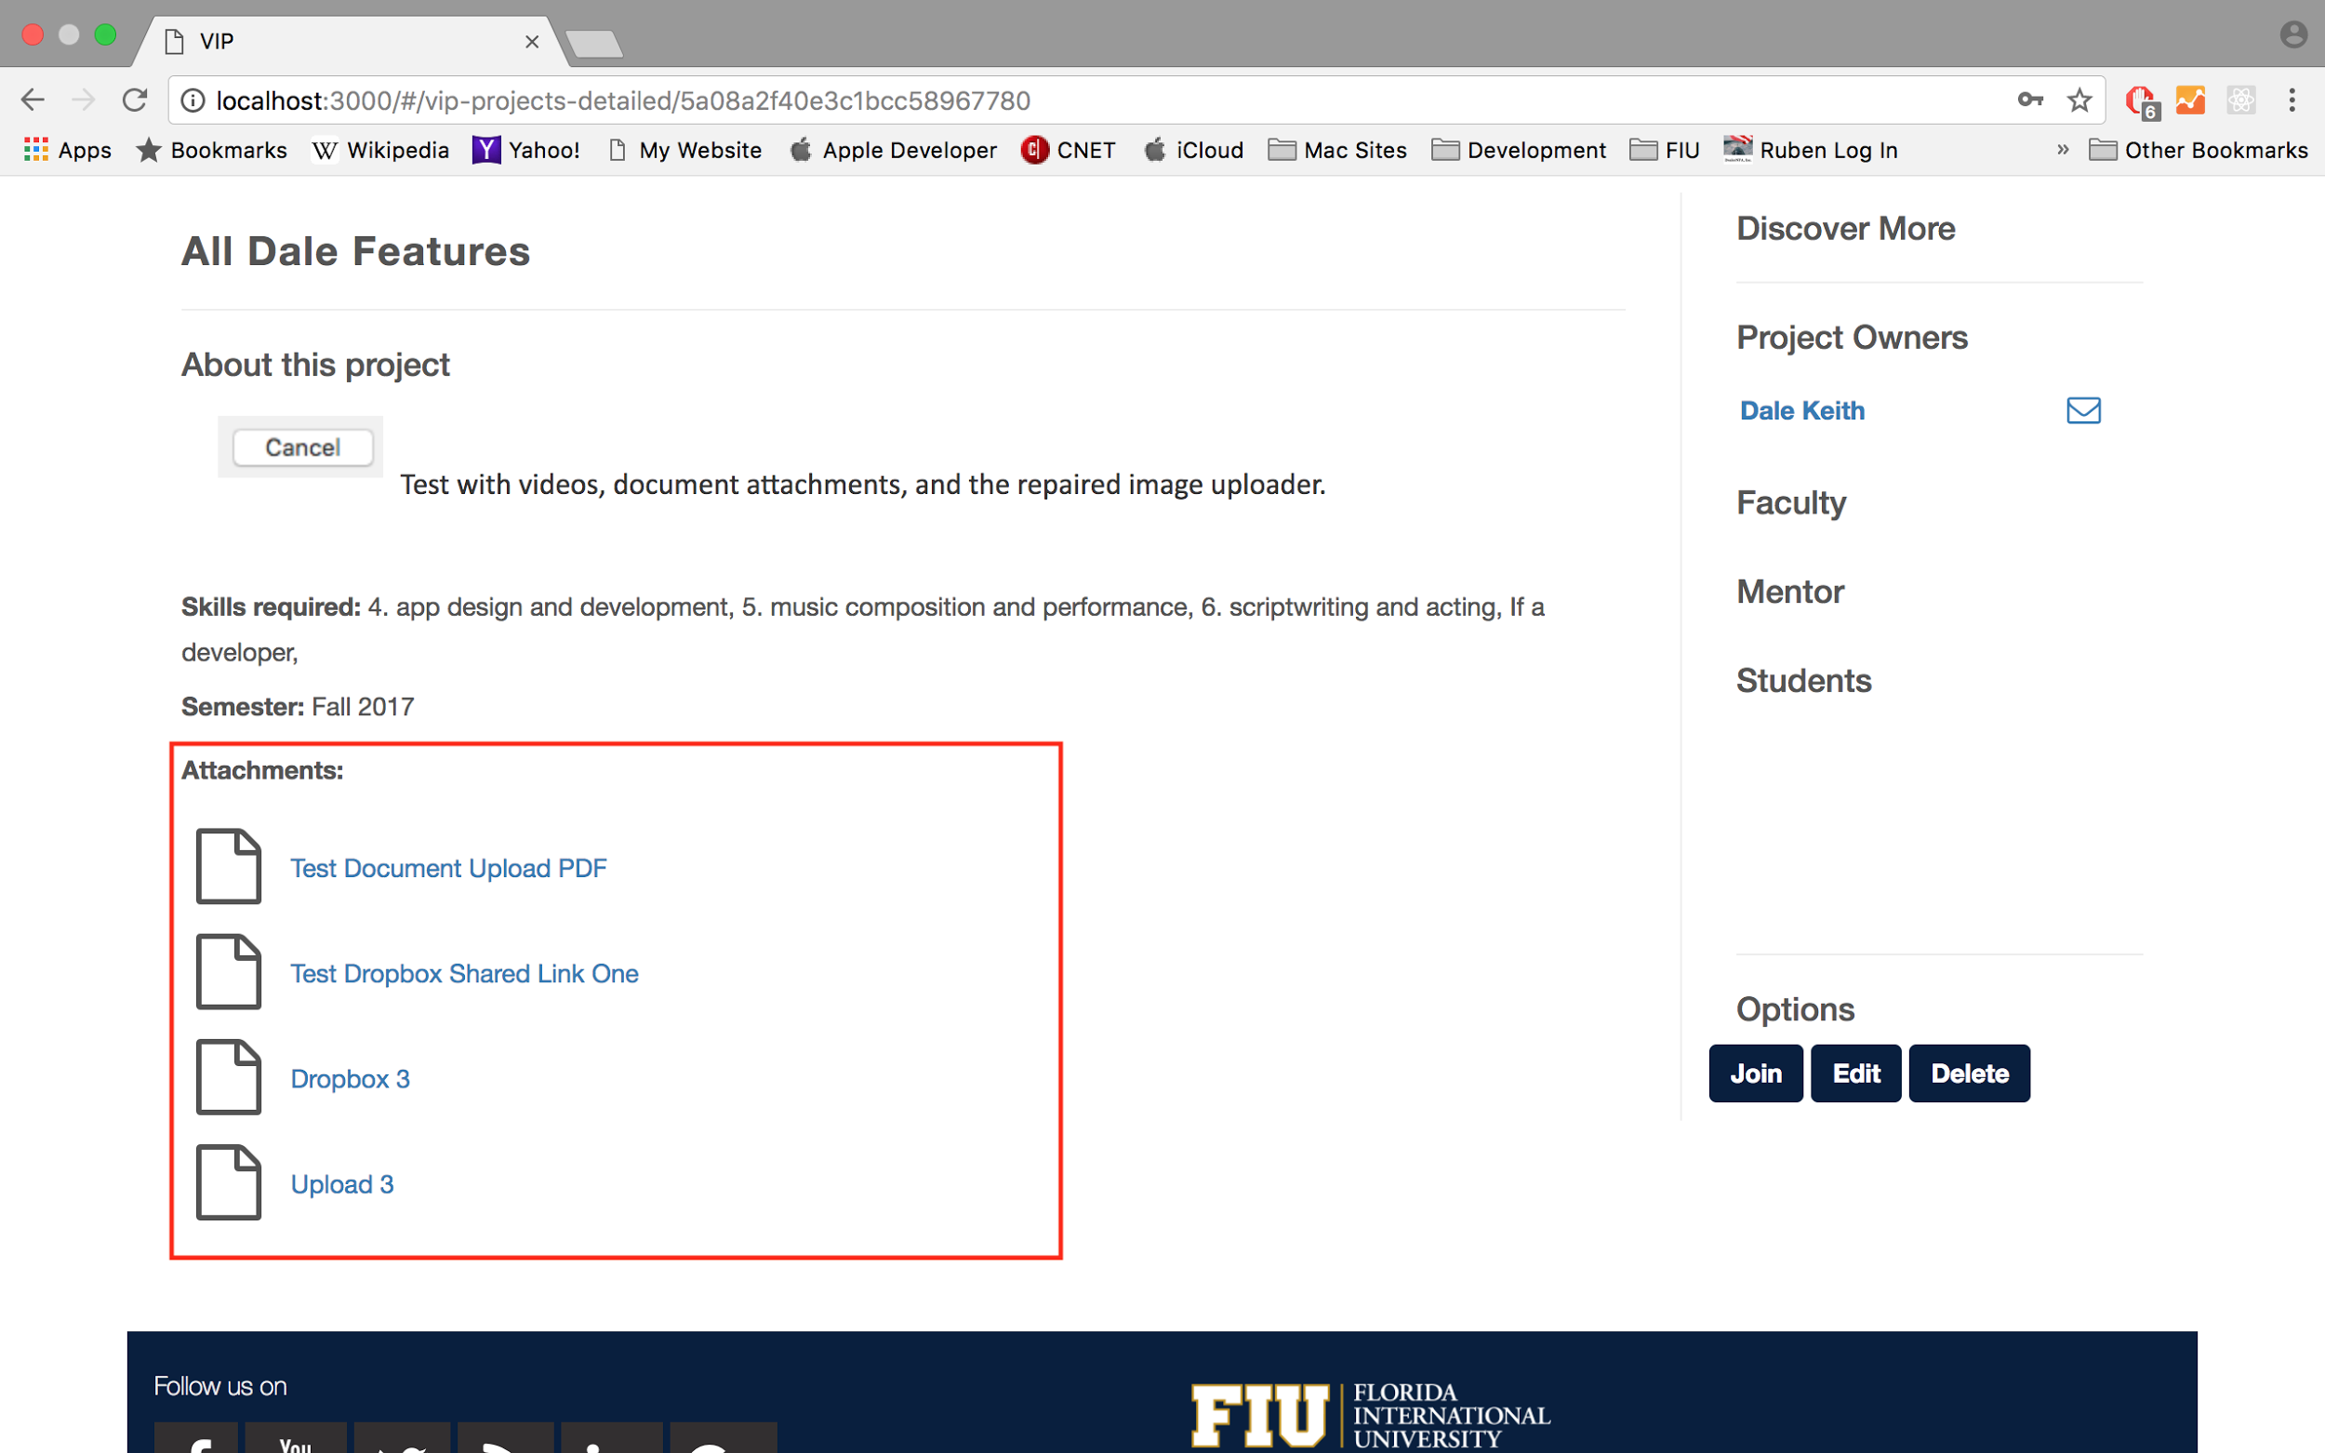

User Story #1331 - View Attachments on Project Details Page

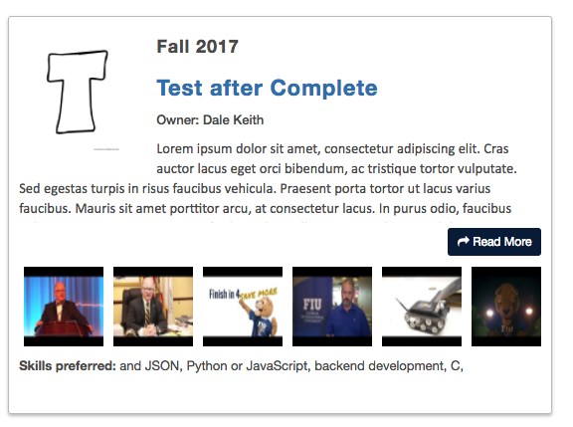

User Story #1351 - Redesigned Project Card

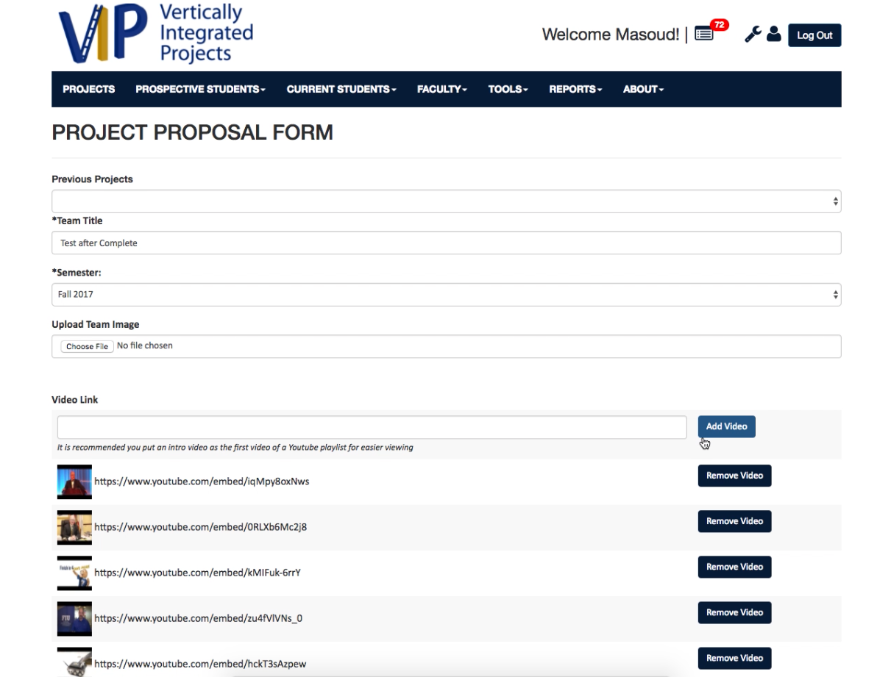

User Story #1329 - Add/Remove Videos from Project

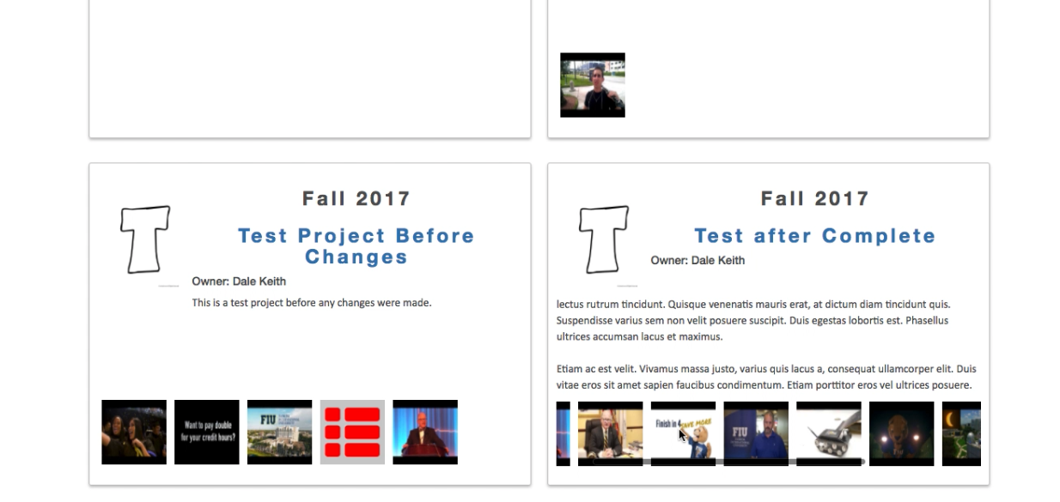

User Story #1329 - Video Thumbnails on Project Cards

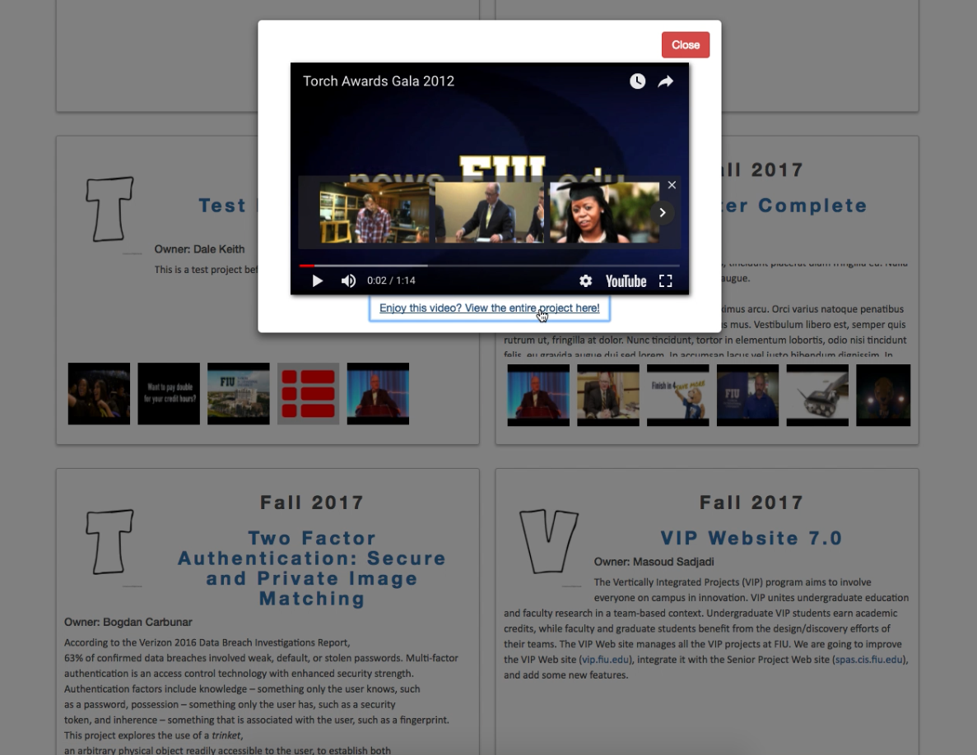

User Story #1329 - Interact with Video Thumbnails on Project Card/Modal Window for Video

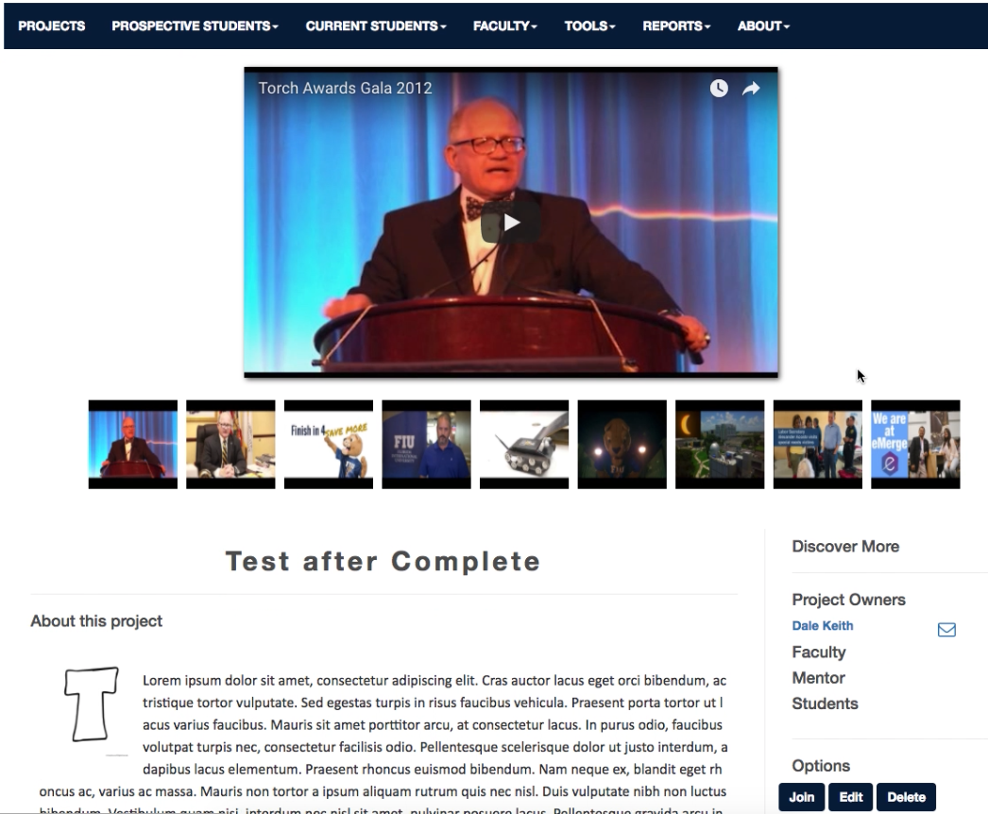

User Story #1329 - Multiple Videos on Project Details Page

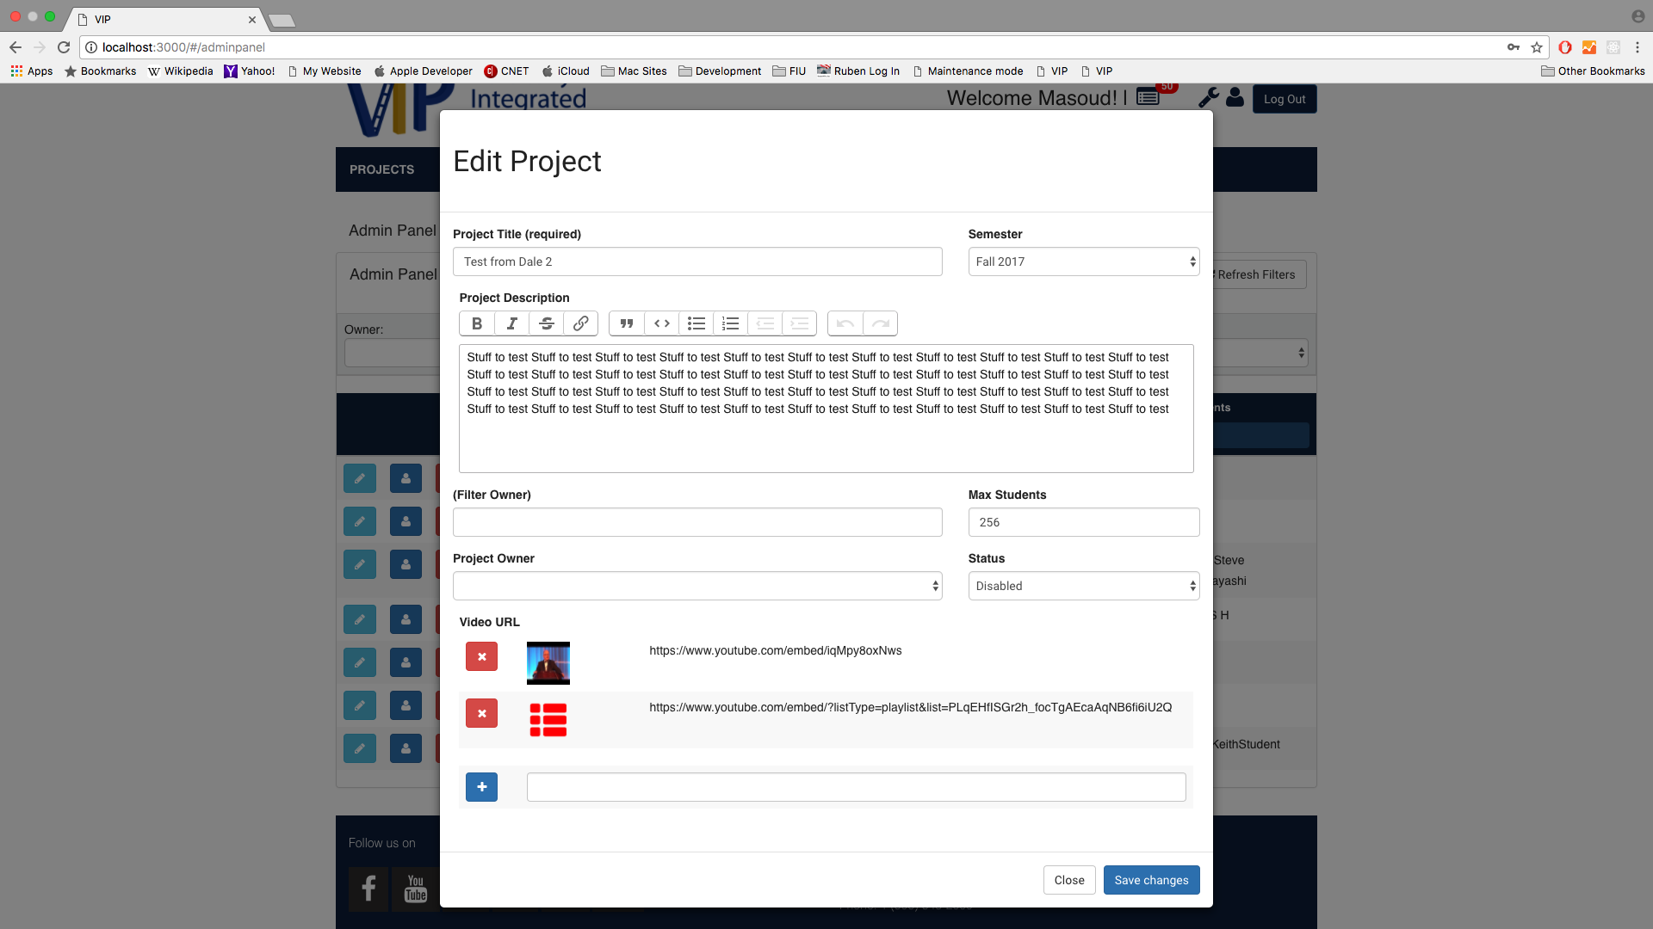

User Story #1301 - Set Project to Disabled to Trigger Email

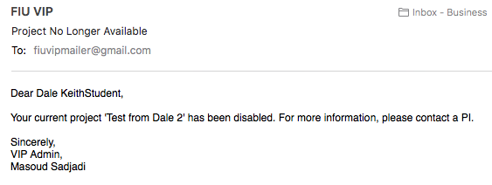

User Story #1301 - Email Sent to Participating/Enrolled Student

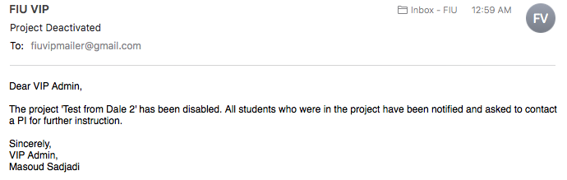

User Story #1301 - Email Sent to Website Administrator

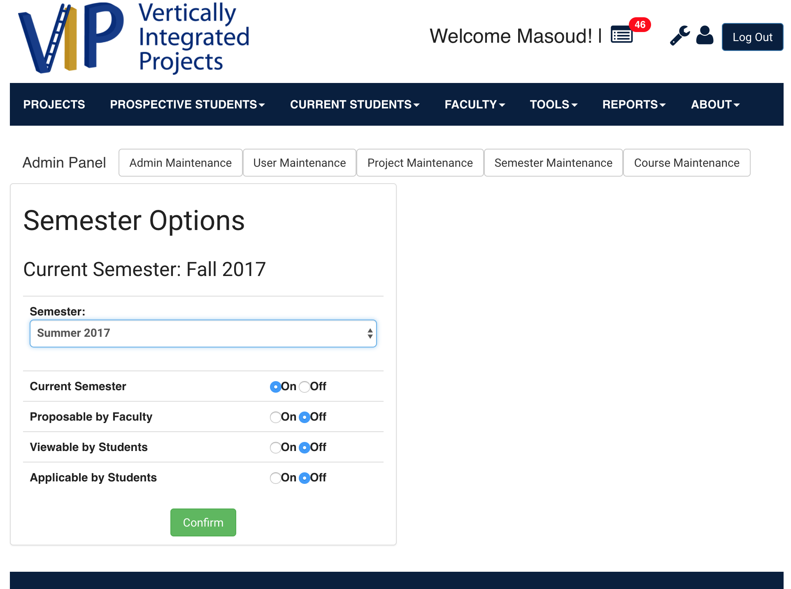

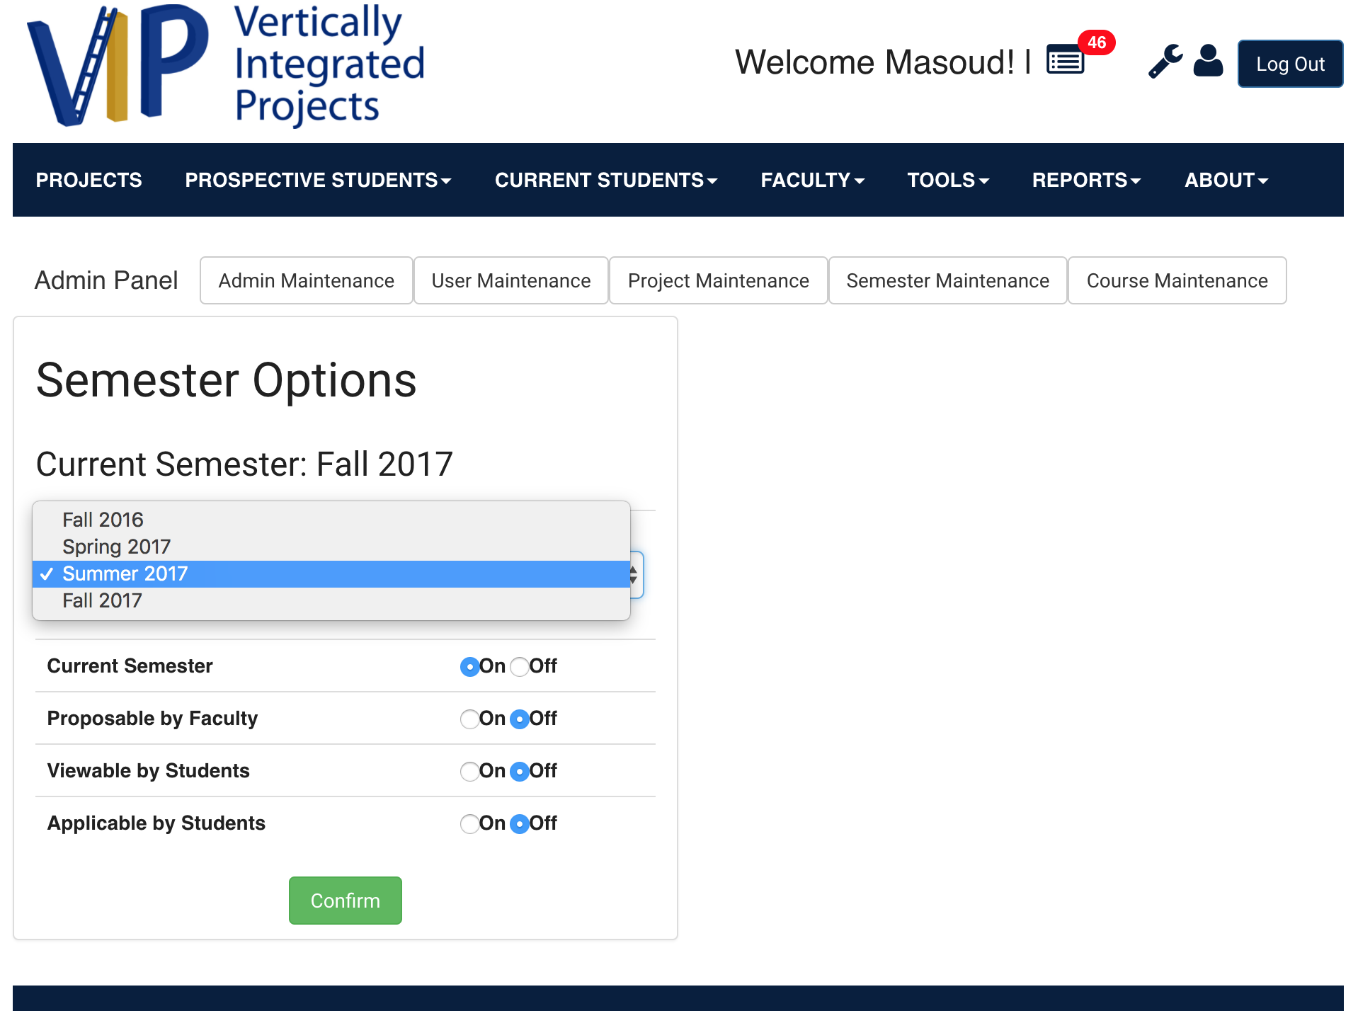

User Story #1298 - Edit Semester Properties

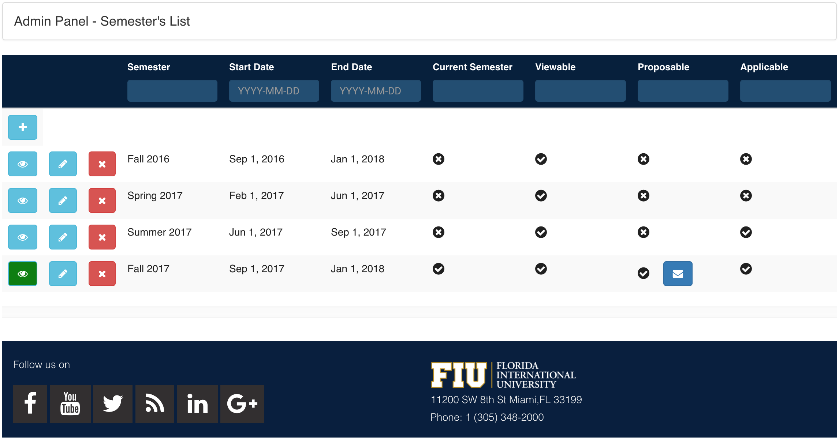

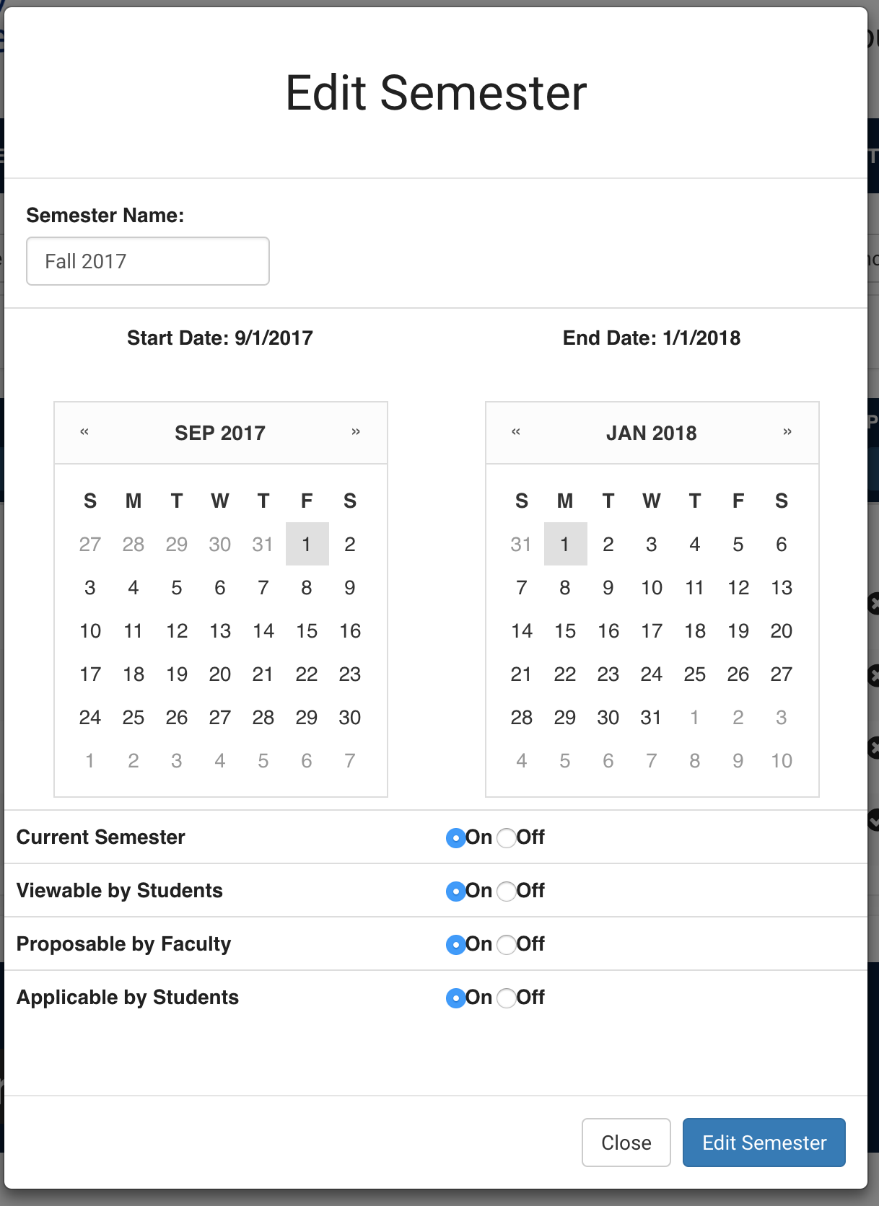

Edit Semester Properties After UI Changes

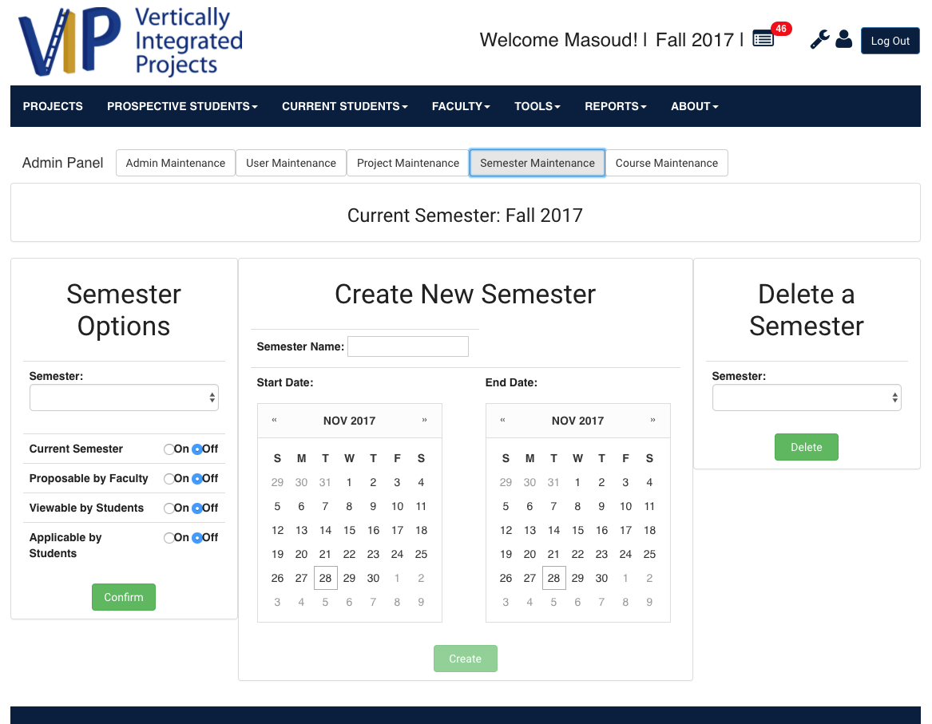

User Story 1302: Create New Semester and Delete Semester



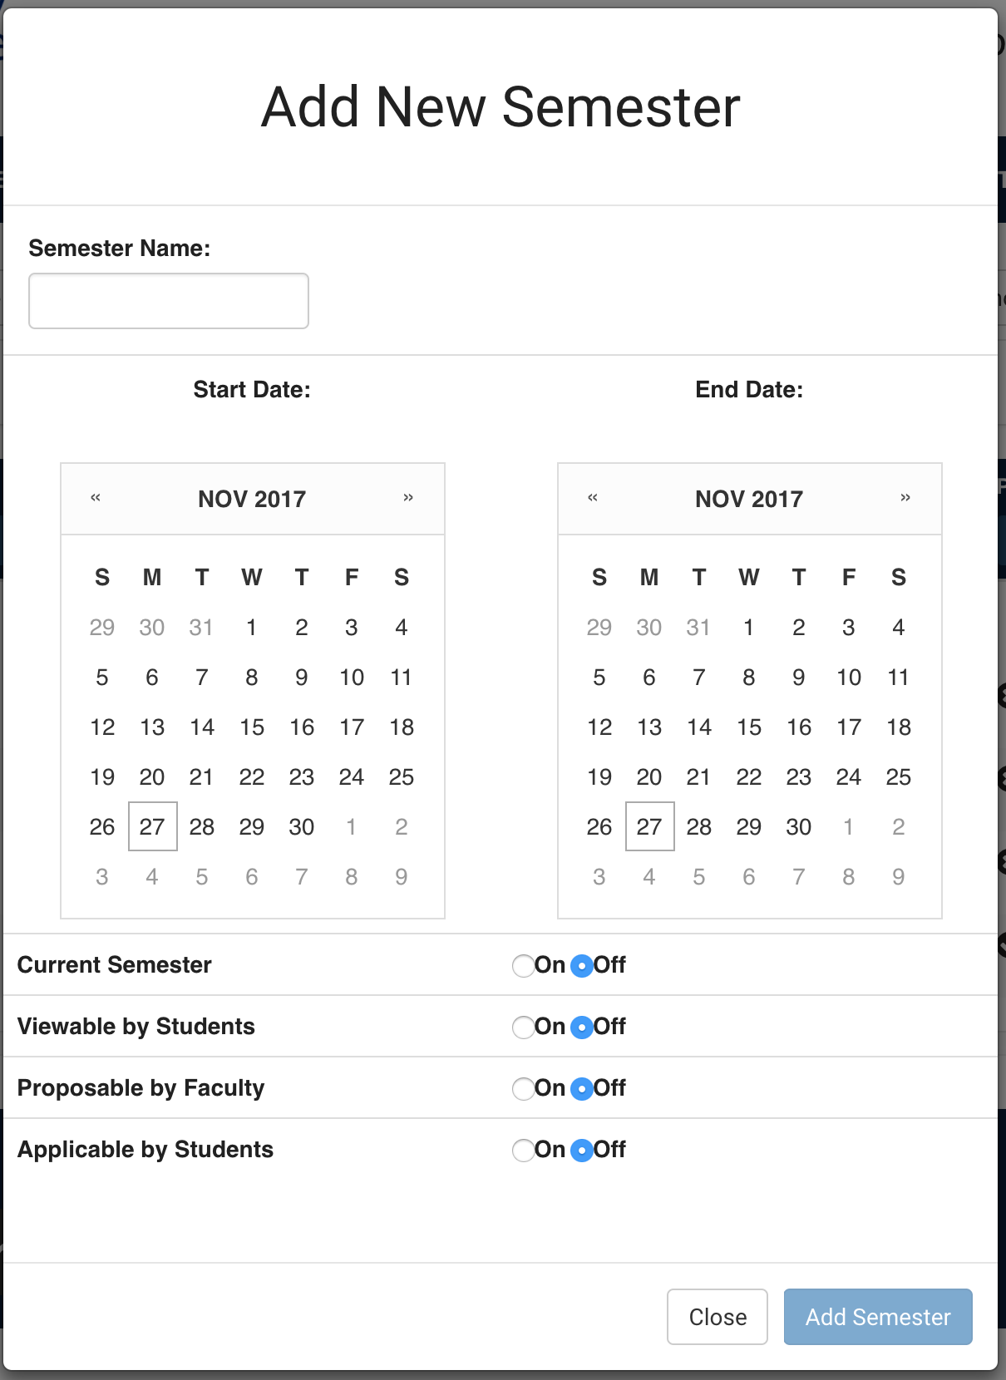

Add/Delete and Semester Maintenance after UI Update

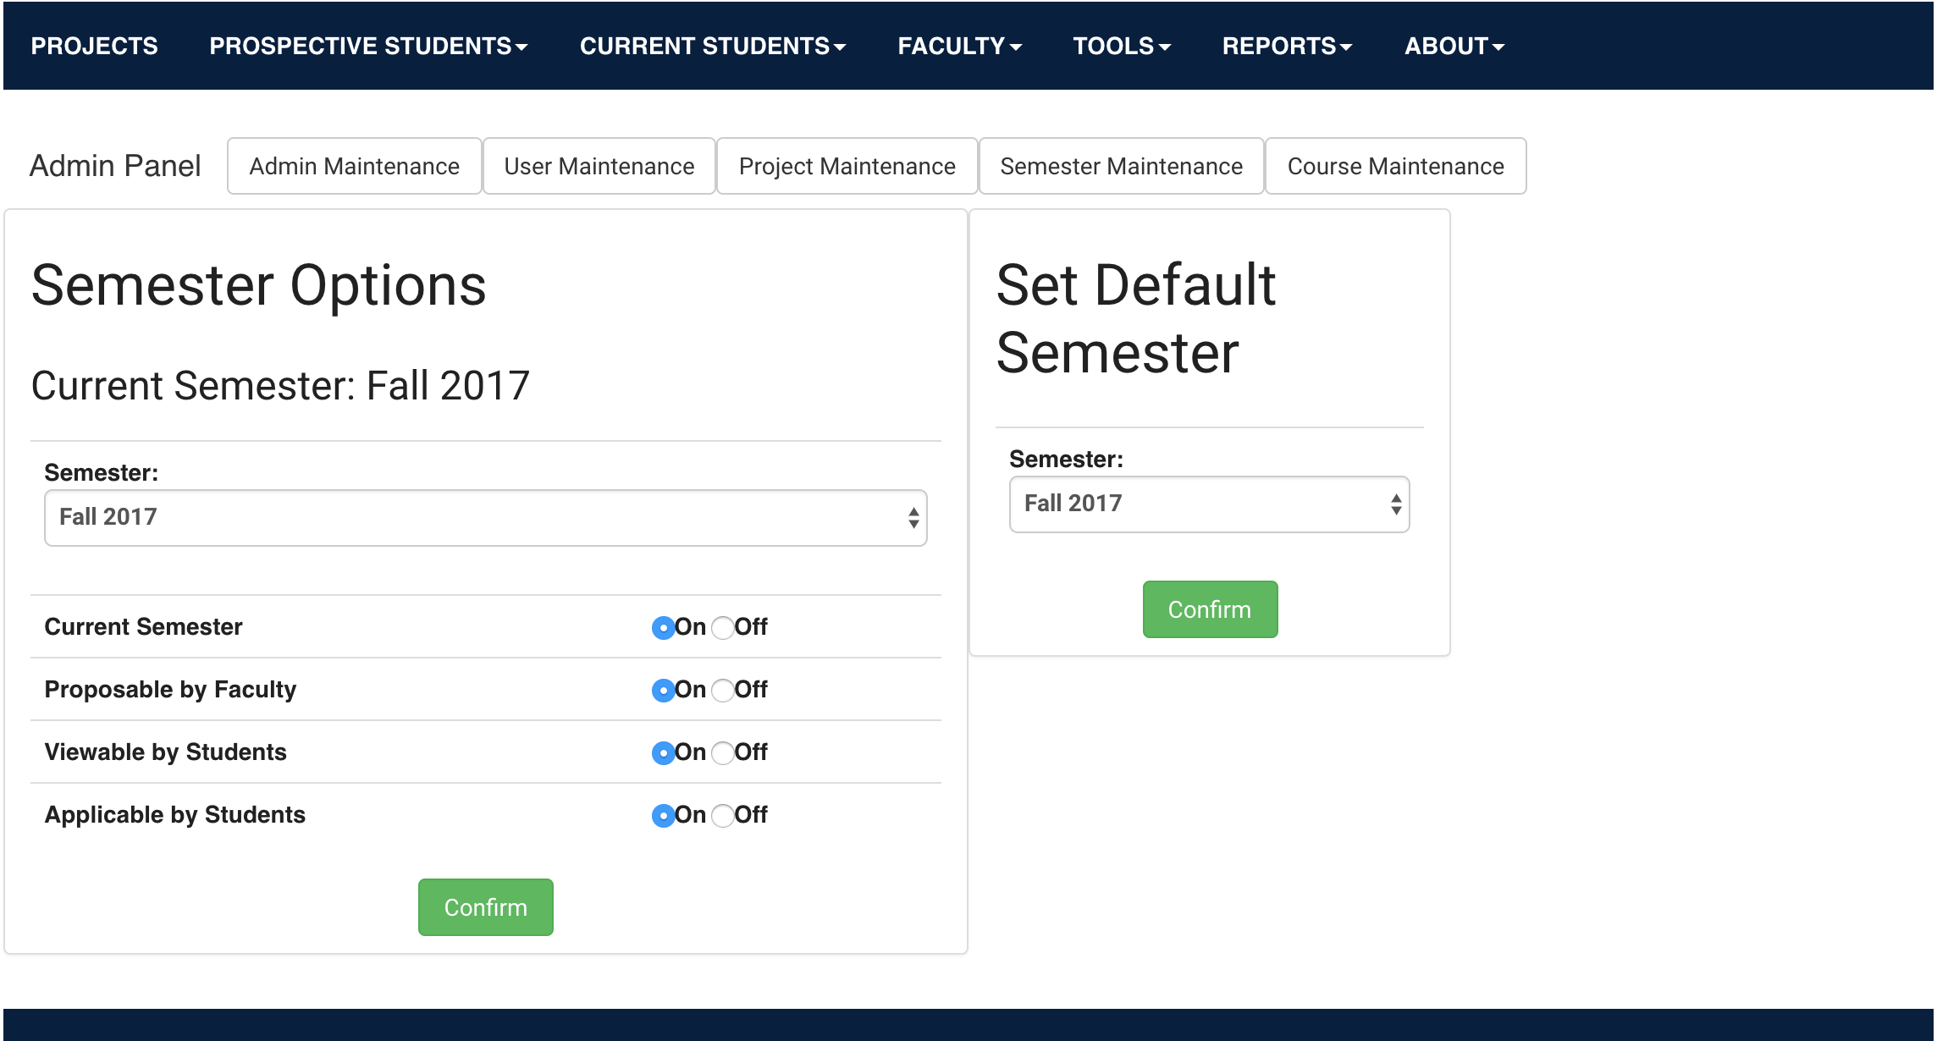

User Story 1360: Set Default Semester

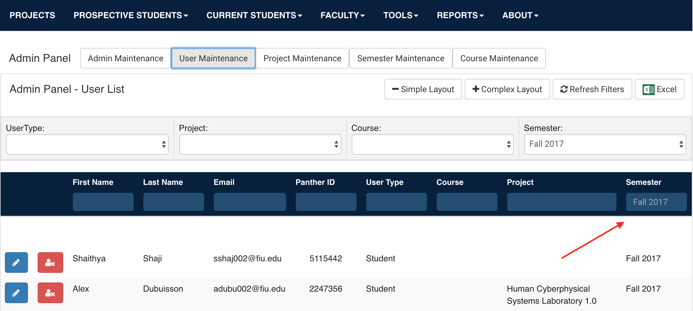

User Story 1360: Default Semester Filter

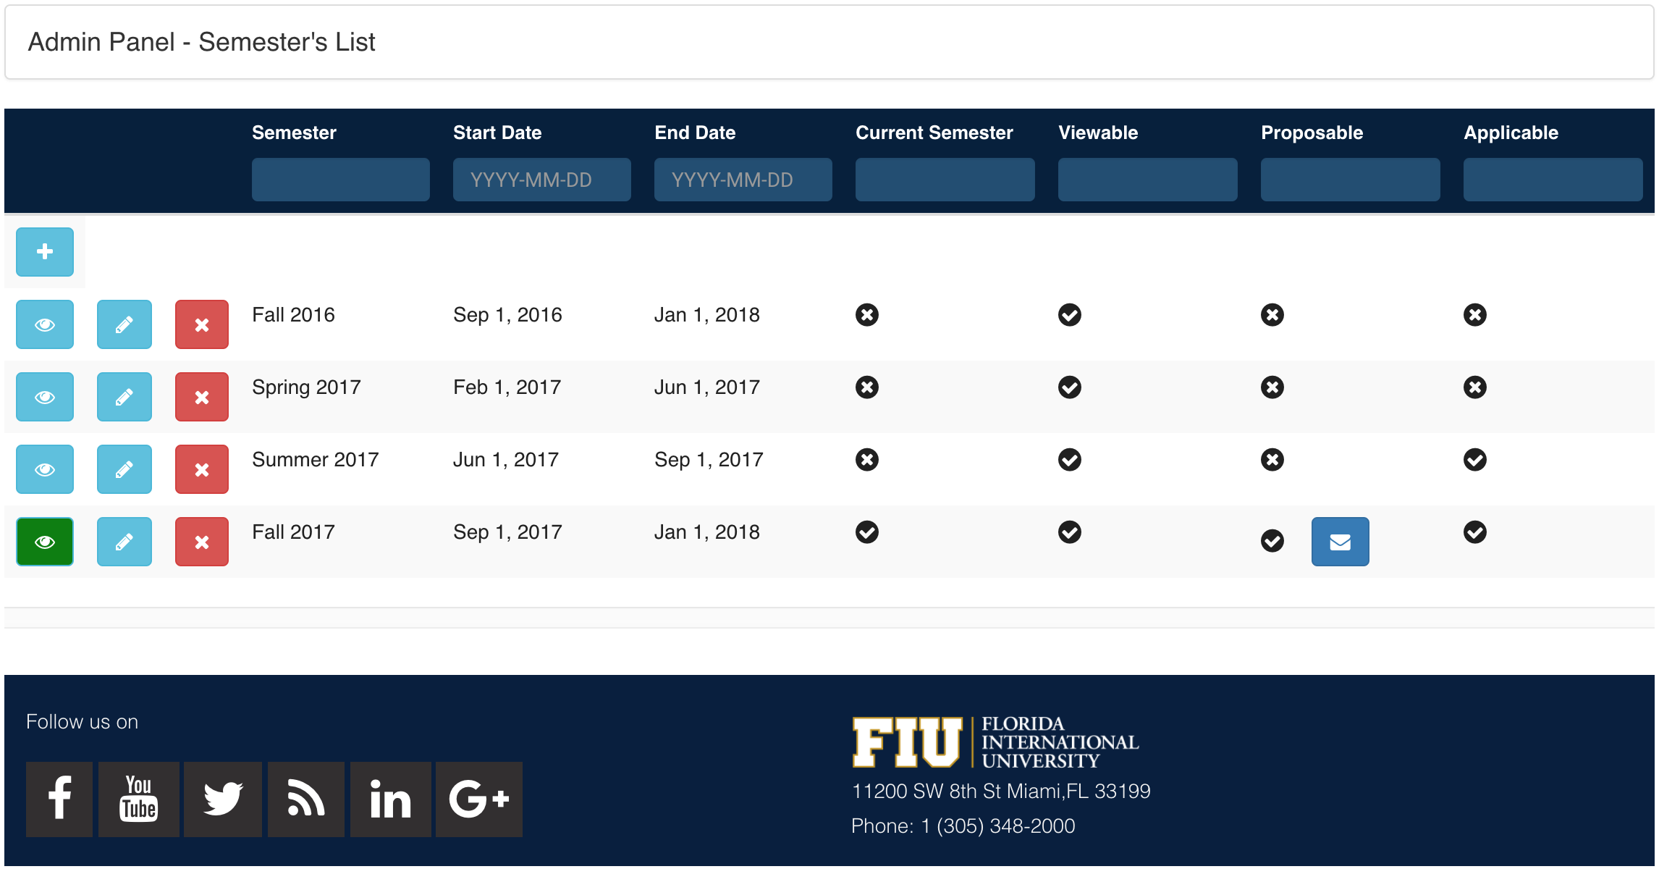

User Story 1371: Email Product Owners Button

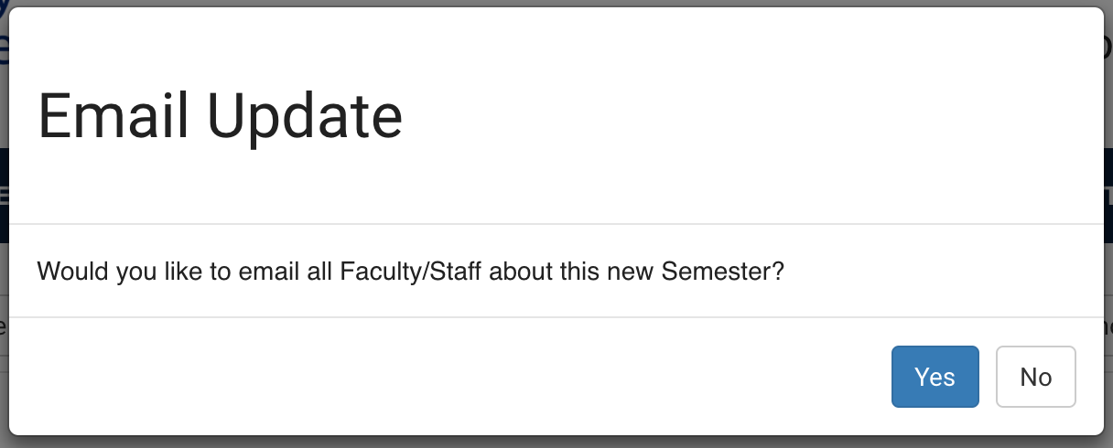

User Story 1371: Email Product Owners Confirmation

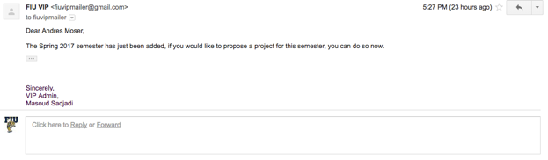

User Story 1371: Email Product Owner Sample Email

# 

# 

# 

# 

# 

# 

# 

# 

# 

# 

# 

# Appendix C - Sprint Review Reports

## **Sprint 2 Review Meeting Minutes**

Attendees: Leon Liang, Andres Moser, Dale Keith, Steve Hirabayashi, Adam Levy, Masoud Sadjadi, Fransisco Ortega

Start time: 3:00 PM October 2, 2017

End time: 4:00 PM October 2, 2017

After a show and tell presentation, the implementation of the following user stories were accepted by the product owners :

* User Story #1305 Re-propose projects from previous semester
* User Story [#1176](https://fiu-scis-seniorproject.mingle.thoughtworks.com/projects/vip/cards/1176) Search users and projects based on semester in the admin panel
* User Story #1299 Manage proposed projects
* User Story #1301 Notify members if a project is deactivated

The following ones were rejected and moved back to the product backlog to be assigned to a future sprint at a future Spring Planning meeting.

* User Story #1298 Set Active Semester
* How this should be reflected on the user story definition in Mingle:
  + This is being moved to Sprint 3 and continued to be worked on by Andres.
* User Story #1300 Manage students and projects in Admin Panel
  + How this should be reflected on the user story definition in Mingle:
    - This is being moved to Sprint 3 and will be split up into two user stories, will be continued to worked on by Steve
* User Story #1304 Review Projects Proposals By Semesters
  + This story is on hold due to possible overlap with changes being made to Admin Panel.
    - Product Owner prefers filtering functionality to be implemented in Admin Panel location making this story redundant.
    - Page may become obsolete.

## **Sprint 3 Review Meeting Minutes**

Attendees: Leon Liang, Andres Moser, Dale Keith, Steve Hirabayashi, Adam Levy, Masoud Sadjadi, Fransisco Ortega

Start time: 3:00 PM October 16, 2017

End time: 4:00 PM October 16, 2017

After a show and tell presentation, the implementation of the following user stories were accepted by the product owners:

* User Story #1300 - Manage Users in Admin Panel
* User Story #1313 - Manage Projects in Admin Panel
* User Story #1314 - Create Admin Panel Tabs
* User Story #1322 - Paginating tables

The following ones were rejected and moved back to the product backlog to be assigned to a future sprint at a future Spring Planning meeting.

* User Story <Enter the user story number and title>
  + How this should be reflected on the user story definition in Mingle:
    - …
* User Story #1298 - Set Active Semester
  + How this should be reflected on the user story definition in Mingle:
    - Small changes will be added to the requirement to finish the story
    - Points should change to 4-8 points
* User Story #1315 - View Past Projects
  + How this should be reflected on the user story definition in Mingle:
    - This is being moved to Sprint 4 and continued to be worked on by Adam
    - The portions of this story that were Dale’s responsibility will be split into smaller user stories for Sprint 4.

## **Sprint 4 Review Meeting Minutes**

Attendees: Leon Liang, Andres Moser, Dale Keith, Steve Hirabayashi, Adam Levy, Masoud Sadjadi, Fransisco Ortega

Start time: 4:00 PM October 30, 2017

End time: 4:30 PM October 30, 2017

After a show and tell presentation, the implementation of the following user stories were accepted by the product owners:

* User Story #1332 - Search functionality for inbox and reviews
* User Story #1328 - Update user and project updating features
* User Story #1345 - Manage Course Information
* User Story #1329 - Add infinitely many YouTube videos to a project
* User Story #1298 - Set Active Semester

The following ones were rejected and moved back to the product backlog to be assigned to a future sprint at a future Spring Planning meeting.

* User Story #1343 - Remove and Converge obsolete pages
  + How this should be reflected on the user story definition in Mingle:
    - This story is moved to sprint 5 to be continued by Leon Liang
    - User story will be broken into smaller user story

## **Sprint 5 Review Meeting Minutes**

Attendees: Leon Liang, Andres Moser, Dale Keith, Steve Hirabayashi, Adam Levy, Masoud Sadjadi

Start time: 4:00 PM November 13, 2017

End time: 4:30 PM November 13, 2017

After a show and tell presentation, the implementation of the following user stories were accepted by the product owners:

* User Story #1361 - Redesign review student applications page
* User Story #1356 - Approve user through admin panel
* User Story #1302 - Create/Delete Semester
* User Story #1360 - Choosing Selected Semester
* User Story #1331 - Add General Attachments to Projects
* User Story #1351 - Redesign Project Cards to show more information
* User Story #1355 - Connect Mobile Judge to VIP Website
* User Story #1352 - Add Enroll feature for Users and Semester for Courses
* User Story #1346 - Synchronize Users Database with Panthersoft Data
* User Story #1343 - Remove and Converge Obsolete Pages

The following ones were rejected and moved back to the product backlog to be assigned to a future sprint at a future Spring Planning meeting.

* None

## **Sprint 6 Review Meeting Minutes**

Attendees: Leon Liang, Andres Moser, Dale Keith, Steve Hirabayashi, Adam Levy, Masoud Sadjadi

Start time: 4:00 PM November 27, 2017

End time: 4:30 PM November 27, 2017

After a show and tell presentation, the implementation of the following user stories were accepted by the product owners:

* User Story #1362 - Add Edit Course Feature in Course Panel
* User Story #1363 - Sort tables by column header
* User Story #1364 - Add Deliverable Uploads on Project Details
* User Story #1365 - Manage Project's Faculty/Mentors in Projects Panel
* User Story #1368 - Fix MJ Route to Include ProjectID
* User Story #1369 - Add course functionality to VIP api endpoint for MJ
* User Story #1371 - Email Product Owners about New Semester

The following ones were rejected and moved back to the product backlog to be assigned to a future sprint at a future Spring Planning meeting.

* None

# 

# 

# Appendix D - User Manuals, Installation/Maintenance Document, Shortcomings/Wishlist Document and other documents

## **User Manuals**

**I.** **Student Manual:**

A. Logging In

1. Click on the “Log In” button on the right top corner of this website.

2. Students do not need to make an account and may login through google using their FIU email account. Click the red “G” button and follow the prompts.

3. If the user has cookies enabled, he / she will stay logged into the site on subsequent visits.

B. Editing Profile / Opt-out from Notifications

1. Log in to the VIP website (see IA).

2. Click on the user icon found on the page header. (Icon can be found directly left of the “Log Out” button).

3. Use the form and follow instructions to update profile information.

4. To disable e mail notifications, uncheck the “Allow Notifications” box found near the bottom of the form.

5. Press the “Update” button to commit changes.

C. Viewing Projects

1. Click on the “Projects” link on the header navigation.

2. To view more detail, click on the project’s name. This will allow you to see a project’s team members, as well as any associated videos and / or links.

D. Applying to Project

1. Log in to the VIP website (see IA).

2. To access a project application, you may…

a) Click on the “Apply For a Project” button

b) Use the header navigation. An application link can be found under “Prospective Students” >> “Apply”

c) Click the “Apply” button located on the right hand side while viewing a project detail page (IC).

3. Fill out the application form with the instructions provided.

4. Upon submitting the form, your application will be sent out for approval. Your application will be reviewed by staff. If accepted, you will be added to the project roster.

E. Leaving Project

1. Log in to the VIP website (see IA).

2. Go to the project’s detail page (IC).

3. Click the “Leave” button located on the right side of the projects detail page.

4. To finish, dismiss the dialog message by selecting the “I’m sure” button.

**II.** **Faculty Manual:**

A. Account Creation / Logging In

1. Click on the “Log In” button on the right top corner of this website.

2. To create an account, click on the “Create an account” link under the “Non-Student Login” section. Note that all faculty accounts MUST be associated with an fiu e-mail address.

3. On the “Log In” page, enter your email and password in the forms under the “Non-Student Login” section. Press the blue “Log in” button to submit.

4. If the user has cookies enabled, he / she will stay logged into the site on subsequent visits.

B. Editing Profile / Opt-out from Notifications

1. Log in to the VIP website (see IIA).

2. Click on the user icon found on the page header. (Icon can be found directly left of the “Log Out” button).

3. Use the form and follow instructions to update profile information.

4. To disable e mail notifications, uncheck the “Allow Notifications” box found near the bottom of the form.

5. Press the “Update” button to commit changes.

C. Proposing Project

1. Log in to the VIP website (see IIA).

2. To propose a project, you may…

a) Click on the “Propose a Project” button

b) Use the header navigation. A project proposal application link can be found under “Faculty” >> “Propose Project”

3. Fill out the project proposal form with the instructions provided.

4. Upon submitting the form, your project proposal will be sent out for approval. If accepted, the project will added to the website.

D. Editing Project

1. Log in to the VIP website (see IIA).

2. Click “Projects” on the navigation bar. Go to the projects details page by clicking the name of the project that you wish to edit.

3. On the projects detail page, click on the “Edit” button on the right hand side.

4. Fill out the project edit form. This process is identical to proposing a project (see IIC).

5. Upon submitting the form, your edits will be sent to admin for approval. The unedited project will still be available for viewing on the Projects page.

E. Applying to Project:

1. Log in to the VIP website (see IIA).

2. To join a project, you may…

a) Click on the “Apply For a Project” button

b) Click the “Join” button located on the right hand side while viewing a project detail page (IC).

3. Fill out the application form with the instructions provided. Form in similar to the one that students fill out when applying to join a project.

4. Upon submitting the form, your application will be sent out for approval. Your application will be reviewed by staff. If accepted, you will be added to the project roster.

F. Leaving Project

1. Log in to the VIP website (see IIA).

2. Go to the project’s detail page (IC).

3. Click the “Leave” button located on the right side of the projects detail page.

4. To finish, dismiss the dialog message by selecting the “I’m sure” button.

**III.** **Pi/CoPi Manual:**

A. Account Creation/ Logging in

1. Click on the “Log In” button on the right top corner of this website.

2. To create an account, click on the “Create an account” link under the “Non-Student Login” section.

3. On the “Log In” page, enter your email and password in the forms under the “Non-Student Login” section. Press the blue “Log in” button to submit.

4. If the user has cookies enabled, he / she will stay logged into the site on subsequent visits.

B. Project Proposal Review

1. Log in to the VIP website (see IIIA)

2. Access the review projects proposal page by going to “Faculty” >> “Review Project Proposals” on the header navigation menu.

3. Projects may be accepted by pushing the green “Yes” button, or rejected by pushing the red “No” button.

4. If you wish to put an accepted / rejected project back into review, find the appropriate project under “Review Project Proposal History” and press “Undo”.

C. Faculty Registration Review

1. Log in to the VIP website (see IIIA)

2. Access the user registration review page by going to “Prospective Students” >> “Review Faculty Registrations” on the header navigation menu.

3. Faculty account registration requests can be accepted by pushing the green “Yes” button, or rejected by pushing the red “No” button.

4. If you wish to move a faculty account back into review, locate it under “Review Faculty Application History” and press “Undo”. (*Note, this only works for previously-accepted users. To review a rejected account, please ask that user to attempt signing up again.)

D. Student Application Review

1. Log in to the VIP website (see IIIA)

2. Access the student application review page by going to “Prospective Students” >> “Review Student Applications” on the header navigation menu.

3. Student application requests can be accepted by pushing the green “Yes” button, or rejected by pushing the red “No” button.

4. If you wish to move a student application back into review, locate it under “Review Student Application History” and press “Undo”. (*Note, this only works for previously-accepted students. To review a rejected application, please ask the user to submit a new application.)

E. Admin Panel

1. Log in to the VIP website (see IIIA)

2. Access the admin panel by clicking the wrench icon on the top-right corner of the page header.

3. Select the requisite tab to access a different section of the admin panel:

4. Admin Maintenance:

1. Set the administrator email that will receive the notifications of the VIP Website by entering the desired email into the input box and selecting the ‘Add New’ button. Then select the newly created email and select the ‘change’ button.
2. Set the email signature for the administrator email by modifying the email signature input box and selecting the ‘change’ button.

5. Users Maintenance:

1. Toggle display of user’s information from partial to full using the ‘simple display’ and complex display’ buttons
2. Filtering users can be achieved by either using one of the selection boxes (i.e. select a semester in the Semester selection box and only users in that semester will appear) and/or using the input boxes below the column headers that will correspond to filtering based on that column
3. Filters can be quickly removed using the ‘Refresh Filters’ button
4. Select the title for a given column to sort the users in ascending or descending order by that property.
5. Add a user by selecting the ‘add user’ button (depicted with a user and plus icon), fill in the required information into the prompted modal and select the ‘Add User’ button. The new user will now be present in the User Panel
6. Edit a user by selecting the ‘edit user’ button next to the user you wish to modify (depicted with a pencil icon), modify the information in the prompted modal and select the ‘Save Changes’ button. The user will now be updated in the User Panel.
7. Impersonate a user by selecting the ‘impersonate user’ button next to the user you wish to impersonate (depicted with an eye icon), you will now be redirected to the home page as the impersonated user. Select the ‘logout’ button in the upper right corner to stop impersonating the user.
8. Remove a user by selecting the remove user’ button next to the user you wish to remove (depicted with a red X icon), select the ‘Yes’ button to confirm the removal. The user will then be removed from the system.
9. Approve/Unapprove a user by selecting the approve/unapprove user’ button next to the user you wish to Approve/Unapprove (depicted with either a blue thumbs up icon or red thumbs-down icon).The user will then be updated to be approved/unapproved.

6. Projects Maintenance:

1. Toggle display of project’s information from partial to full using the ‘simple display’ and complex display’ buttons
2. Filtering projects can be achieved by either using one of the selection boxes (i.e. select a semester in the Semester selection box and only projects in that semester will appear) and/or using the input boxes below the column headers that will correspond to filtering based on that column
3. Filters can be quickly removed using the ‘Refresh Filters’ button
4. Select the title for a given column to sort the projects in ascending or descending order by that property.
5. Edit a project’s properties by selecting the ‘edit project’ button next to the project you wish to modify (depicted with a pencil icon), modify the information in the prompted modal and select the ‘Save Changes’ button. The project will now be updated in the Projects Panel.
6. Edit a project’s members (students, faculty, and mentors) by selecting the ‘add/remove project users’ button next to the project you wish to modify (depicted with a user icon), to add a user, select that user in the selection box and selecting the ‘add user’ button (blue user with plus icon). To remove a user, select the ‘remove user’ button (red user with X icon). Then select the ‘Save Changes’ button. The project should now be updated in the Projects Panel.
7. Remove a project by selecting the remove project’ button next to the project you wish to remove (depicted with a red X icon), select the ‘Yes’ button to confirm the removal. The project will then be removed from the system.

7. Semesters Maintenance:

1. Filtering Semesters can be achieved by using the filters for Name/Start Date/End Date.
2. Selecting any of the Column TItles will sort based on the column in both ascending or descending order(click multiple times to switch between)
3. Before any rows of semesters you are given an Add Semester Button that will bring up a modal to create a new semester, with information that must be provided.
4. Each Semester will have 3 buttons on the left, Set Default, Edit, and Delete.
5. If a semester is open for project proposals, there will be a button active next to the checkmark icon for Project Proposals.
6. If a Semester is Applicable, than the Apply button will be visible for students, otherwise it will be hidden.
7. If a Semester is Proposable, then those semesters will be visible in the Semester dropdown for Faculty/Staff in the Project Proposal Form.

8. Courses Maintenance:

1. Filtering courses can be achieved by either using one of the selection boxes (i.e. select a semester in the Semester selection box and only courses in that semester will appear) and/or using the input boxes below the column headers that will correspond to filtering based on that column
2. Filters can be quickly removed using the ‘Refresh Filters’ button
3. Select the title for a given column to sort the courses in ascending or descending order by that property.
4. Add a course by selecting the ‘add course’ button (depicted with a blue plus icon), fill in the required information into the prompted modal and select the ‘Add Course’ button. The new course will now be present in the Courses Panel
5. Edit a course by selecting the ‘edit course’ button next to the course you wish to modify (depicted with a blue pencil icon), modify the information in the prompted modal and select the ‘Save Changes’ button. The course will now be updated in the Courses Panel.
6. Remove a course by selecting the remove user’ button next to the user you wish to remove (depicted with a red X icon). The user will then be removed from the system.
7. Synchronize the users database with course data from panthersoft by selecting the ‘Upload Course Data’ button. To add a file to the list of courses, follow these steps:
   1. Select the ‘Choose file’ button under the File column. Select a .xls file from the file dialog.
   2. If the file name refers to a course present in the system, just select the ‘add course file’ button and the file will either be accepted or rejected depending on the validity of the file’s formatting.
   3. If the file refers to a course not present in the system, the modal will prompt you to add a new course, after selecting the ‘add course’ button, select the ‘add course file’ button and the file will either be accepted or rejected depending on the validity of the file’s formatting.

To submit the list of process files to be uploaded to the system, select the ‘Sync Database’ button. The users database will be updated accordingly.

Alternatively, to clear the list of course files in one go, select the ‘Clear List’ button. To get a template for the required format of the file, select the ‘Download Template’ button.

## **Installation/Maintenance Document**

**I.** **Development Environment Installation:**

**A.** Prerequisites:

**1.** NodeJS(and npm) installed: Any version after the one mentioned in the “Hardware and Software Resources” section would be fine.<https://nodejs.org/en/>

**2.** MongoDB: You will need a MongoDB server to run this application, if you don’t have one, you can install and run it on your own development laptop/desktop, no special configuration is required. Any version after the one mentioned in the “Hardware and Software Resources” section would be fine.<https://www.mongodb.com/download-center#community>

**3.** Git:<https://git-scm.com/downloads>

**4.** An IDE is recommended: any IDE that can deal with NodeJS/HTML/CSS should do.

**B.** Execute:

**1.** Checkout the git repository for the project, if you don’t know where it’s located just ask your Product Manager. From here on i will refer to the folder where the code was checked out from git as {{gitCheckoutDir}}.

**2.** “Install” the application by running “{{gitCheckoutDir}}/Code/install.sh” for linux/MAC or “{{gitCheckoutDir}}/Code/install.bat” for windows. Note this only does an npm install in the “{{gitCheckoutDir}}/Code/” and “{{gitCheckoutDir}}/Code/Deployment/” folders. If you don’t understand what that means, you may want to research it. If this script fails, then there is a problem with your npm install.

**3.** Configure the application to run locally:

**a)** Make sure the host and protocol are correct in the “{{gitCheckoutDir}}/Code/server.js” file. You normally want that file to have two lines like this near the beginning of the file:

app.set("host", "localhost");

app.set("protocol", "http");

**b)** Make sure the “{{gitCheckoutDir}}/Code/config/config file looks like this:

module.exports = {

‘port':3000,

'externalPort':3000,

'database':'mongodb://localhost:27017/admin',

'secret':'whateveryouwant',

'secure':false

};

Adjust the mongo url if your mongoDB is not on your development machine.

**4.** Run the application by executing “node {{gitCheckoutDir}}/Code/server.js” into your terminal. If this fails, then there is a problem with your nodejs installation.

**5.** You can now access the website at “[http://localhost:3000](http://localhost:3000/)”

**6.** You can create a PI account with sadjadi’s email for testing purposes on your local environment since that account requires no verification.

**II.** **Running Selenium Tests:**

A. The Selenium tests are in a java maven project. You may either install maven and build it yourselves but it’s considerably simpler to have your IDE do that for you.

B. Once your ide can compile the project, which is under “{{gitCheckoutDir}}/Tests/SeleniumTests”, install the Firefox Selenium Driver as indicated in<https://developer.mozilla.org/en-US/docs/Mozilla/QA/Marionette/WebDriver>.

C. After that, use your test runner of choice to run the junit tests under “{{gitCheckoutDir}}/Tests/SeleniumTests/src/test/java/edu/fiu/vip_web/vip_r5_stories/tests”.

Note that most java IDEs can run junit tests without any work on your part so I recommend you use one.

**III.** **(IMPORTANT!) Adding javascript or css files to the website:**

**A.** **Background:**

If you look at the “{{gitCheckoutDir}}/Code/webapp/index.html” file you will see that almost the only javascript and css files referenced are “distrib/styles.css” and “distrib/scripts.js”. This is because all the js and css files are combined into one(one js and one css) so as to minimize the number of browser requests and therefore improve performance of the website. The files in the distrib folder are auto-generated whenever the web server starts(it’s triggered from server.js).

**B. Consequences:**

1. All js and css files added to the system will need to be added in the “{{gitCheckoutDir}}/Code/deployment/gulpfile.js”. See [this document](https://docs.google.com/document/d/1k8B7o3CNcZ6_--V0AZIpoperG9l19JnrivG545zHkhk/pub) for details on how to add them.

2. If changes are made to any of the js files(or css), the server has to be restarted for the changes to take effect.

Note that all of this means you will not add any link(for css) or script(for js) tags to the index.html file since adding the files to the gulpfile.js file mentioned above will take care of this files to be delivered to the browser/client.

**IV.** **Production Installation(this also includes the vip-dev server):**

** Note that it is very important that the deployment folder stays the same(/var/www/VIP-FINAL/) so that the certificate renewal process works automatically.

1. Stop the web server:

1. “sudo forever stopall” should work, if it doesn’t then execute “sudo kill $(pidof nodejs)” to force close/kill the process.

2. Copy the Code folder to the “/var/www/VIP-FINAL/” folder into the server(vip-dev or production):

1. Note it has to be this folder and not elsewhere, nor can this folder be renamed because there is a cron job in the server that will make sure the certificates are put there whenever they are renewed and this process would be broken/useless if you deploy elsewhere/rename the folder.
2. Note that if any changes to the certificateRenewal.bash file are to be really used, this file needs to be copied to the “/var/www/” folder and you have to execute “sudo chmod 711 /var/www/certificateRenewal.bash” afterwards to make the script executable.

3. Https/ssl certificate setup (copy certificates to the deployment folder):

1.Run

sudo cp /etc/letsencrypt/live/vip-dev.cis.fiu.edu/cert.pem /var/www/VIP-FINAL/Code/

2.Run

sudo cp /etc/letsencrypt/live/vip-dev.cis.fiu.edu/chain.pem /var/www/VIP-FINAL/Code/

3.Run

sudo cp /etc/letsencrypt/live/vip-dev.cis.fiu.edu/privkey.pem /var/www/VIP-FINAL/Code/

Note that in all of the above commands you need to change “vip-dev.cis.fiu.edu” by “vip.fiu.edu” when in the production server.

4. Configure /var/www/VIP-FINAL/Code/api/config/config:

1. Make sure /var/www/VIP-FINAL/Code/api/config/config looks like this(use your editor of choice, example, nano or emacs):

module.exports = {

'port':3000,

'externalPort':443,

'database':'mongodb://localhost:27017/admin',

'secret':'whateveryouwant',

'secure':true

};

Note this is different from the configuration on your local environment.

5. Configure /var/www/VIP-FINAL/Code/api/config/auth.js:

1. Make sure /var/www/VIP-FINAL/Code/api/config/auth.js looks like this:

module.exports ={

‘googleAuth': {

'clientID' : '1056710173783-00k7c8he5utpi75h8jtn3183cns3suq1.apps.googleusercontent.com',

'clientSecret': 'gqwU3jy3K-anElJ6Vf3j7Py6',

'callbackURL': 'http://vip-dev.cis.fiu.edu/auth/google/callback'

}

};

Note that in production you want vip-dev.cis.fiu.edu to be replaced by

vip.fiu.edu in the callbackURL.

6. Configure /var/www/VIP-FINAL/Code/server.js:

1. Make sure that the host and protocol are correctly set in the /var/www/VIP-FINAL/Code/server.js file. There should be two lines near the top of the file that start with app.set("host" and app.set("protocol" , make sure they say app.set("host", "vip-dev.cis.fiu.edu"); and app.set("protocol", "https"); respectively.

Note that when deploying to production(and not vip-dev) you want the host to be “vip.fiu.edu” instead.

7. Copy new database to server (if schema or other large changes were made):

**Note: Only perform this step if necessary (i.e. if schema/model changes were made in your local/dev environment)**

Copy the files from your local/dev database environment into the /var/lib/mongodb directory on the server. If write permission is denied on this directory, use sudo chmod to update the permissions. Do not forget to lower the permissions once the copy is complete.

8. Start the web server with forever:

Run sudo forever start /var/www/VIP-FINAL/Code/server.js

Note: If a mongodb instance does not start up with the server (this will be evident if a user cannot login or view projects), perform the following steps:

1. Stop the server with sudo forever stopall
2. Run sudo mongod --dbpath /var/lib/mongodb --fork --logpath /dev/null
   1. This will start mongoDB as a service
   2. This may not be necessary for the production server, as the config file for MongoDB appears to run automatically, but use these steps if necessary.
3. Verify a mongoDB instance is running using the ps aux| grep mongo command.
   1. If mongo is running, you should see something like this:

root mongod --dbpath /var/lib/mongodb --fork --logpath /dev/null

or any process that is run by mongodb.

1. Start the server again by running sudo forever start /var/www/VIP-FINAL/Code/server.js

9. Verify server is running:

1. Perform at least a student login through google+ and a regular login just to ensure the server is correctly configured and running.

**V. Understanding the certificate renewal cron job**

**A. High level overview of the process:**

From a high level the automated certificate renewal process for the vip website is

quite simple. The first step it to obtain/install the certbot-auto command line utility which we will use to obtain and manage our certificates(note most of the subsequent steps will use this tool). Then, we will obtain a new certificate for the domain you will be serving requests on. Once we have a certificate, we need a process to ensure that it is automatically renewed by having a cron job that executes monthly(it could be more often if you want). This cron job will execute the certificateRenewal.bash which it expects to be under the /var/www/ folder in your server. This bash script will then be the one to call the certbot-auto command line tool, which it expects to be under the /var/www/ folder in your server, to attempt to renew the certificates. If it is too early to renew your certificates(they have more than 30 days left until expiration), then nothing else is done by the script. However, if the certificates were close enough to the expiration date, they will be renewed and the new certificates will be placed in the /etc/letsencrypt/live/{{domain}}/ folder, where {{domain}} should be replaced by your domain. Once that the certificates have been renewed, the script will copy the new certificate files to the website’s root folder, which it will assume to be located at /var/www/VIP-FINAL/Code. Finally, the script will restart the web server so that it can start using the new certificates.

**It is important that you note that as a consequence of the above process, the**

**deployment folder for your code in the dev and prod servers has to be /var/www/VIP-FINAL**. If you violate this, the automated certificate renewal process will “fail”(technically it will work, it just won’t be useful since it will try to copy the new certificates to the wrong folder). It is recommended that you don’t change the deployment folder in the dev and prod environments. However, if you do change it, you will be responsible for updating the cron job and the certificate renewal script accordingly on both servers.

**B. Detailed explanation of the important steps:**

Note all of this has to be done in the hosting(dev or prod) server and some of this operations may need the web server to be restarted to take effect. Also note, that you should not have to do any of the below operations since they have already been performed by the VIP-6.0 team in both dev and prod servers. This is mostly for informational purposes so that future developers are aware of how it all works.

**To obtain a new certificate(linux):**

1. Get certbot if you don’t yet have it in the server:

a. cd /var/www/

b. wget<https://dl.eff.org/certbot-auto>

c. chmod a+x ./certbot-auto

2. Run certbot to get the certificate:

a. sudo /var/www/certbot-auto certonly --webroot -w /var/www/VIP-FINAL/Code/webapp/ -d vip-dev.cis.fiu.edu

i. Here -w is the location of your webapp folder and -d is the domain on which you are serving(the domain may be different from the one above)

ii. Note the web server needs to be running before this step, otherwise, you will be unable to “prove you own this domain”. See the documentation at<https://certbot.eff.org/docs> if you want to know what this means.

b. Reply to any prompts you get

1. Enter the vip admin email when prompted for an email address, if you don’t know it, ask your PM

3. Copy certificate files to the website root:

a. sudo su

b. cp /etc/letsencrypt/live/vip-dev.cis.fiu.edu/* /var/www/VIP-FINAL/Code/

i. Replace “vip-dev.cis.fiu.edu” by your domain.

4. Restart the vip website.

Note this requires the nodejs server to be running and serving on the domain you want to get the certificate for.

**To renew a certificate manually(linux, where the certificate was obtained through the process above):**

1. cd into the folder you previously downloaded certbot to.

2. ./certbot-auto renew

3. Restart the vip website.

Note this will only renew the certificate if it’s close to expiration(less than 30 days).

**Create a cron job to attempt certificate renewal weekly:**

1. Create cron job to run the script on a regular basis at a convenient time

a. cd /var/www/

b. sudo cp /var/www/VIP-FINAL/certificateRenewal.bash ./

c. chmod 711 certificateRenewal.bash

d. Open with your text editor of choice the certificateRenewal.bash file and make sure that this line VIP_WEB_DOMAIN="vip-dev.cis.fiu.edu" is correct, meaning that the domain is that of the server you are creating the cron job on.

e. sudo crontab -e

f. Scroll to the bottom of the file and type the following in a new line:

i. CronPattern /var/www/certificateRenewal.bash

1. Here replace CronPattern for an appropriate pattern, for example, ‘0 0 1 * *’ without the quotes will attempt renewing the certificates every month on the first day.

g. Save and Close the file

We got this certificate through Certbot from EFF. More documentation on Certbot is available at<https://certbot.eff.org/docs>.

Note the environment variables referred to in that document(the link) are no longer necessary since they are now found in the certificateRenewal.bash script itself(hardcoded).

**Shortcomings/Wish-list Document**   
  
This section will list, and offer a high level explanation of some of the main shortcomings of the system as of the end of release 7.0; as well as a list of potential features to implement for future versions of the system.

* **Improved Mobile Support:** The current web application is responsive to mobile devices, but this could be greatly improved to enhance the user’s experience. Specifically, the project cards could be updated to show as much additional information as possible (videos, skills, etc - like on the desktop site) on a mobile device. This will only get more important as students use tablets and phones to complete academic tasks.
* **Update Database Schemas:** Even though we store our databases in MongoDB database, the schemas we enforce are still relational in nature. The problem lies that foreign keys within a schema are not tied to the ID of the document, meaning that relational integrity can be easily broken without proper attention. Since this was present from the previous version of the website, we chose to avoid changing this shortcoming, as it would involve sweeping changes across the website.
* **Update Synchronization of Users in Course Panel:** A new feature added in this version of the website is the option to upload Panthersoft data that contains the enrolled students in a course, and synchronizing the user's data to that information. Panthersoft has just changed the format of their files to no longer contain the user’s email, which makes the feature unusable. Update the feature to account for the new formatting of the data.

# **References**

* “Agile Tutorial for the Senior Project Class School of Computing and Information Sciences Florida International University” (Adapted from *Agile!: The Good, the Hype and the Ugly* by Bertrand Stabley (ISBN 978-3-319-05154-3).
* Driessen, Vincent “A Successful Git Branching Model” <<http://nvie.com/posts/a-successful-git-branching-model/>>
* Florida International University, WReSTT-CyLE <<http://wrestt.cis.fiu.edu/about-wrestt-com>>
* VIP-Website-7.0 Github Repo <https://github.com/FIU-SCIS-Senior-Projects/VIP-Website-7.0>